Alternation of Generations WS
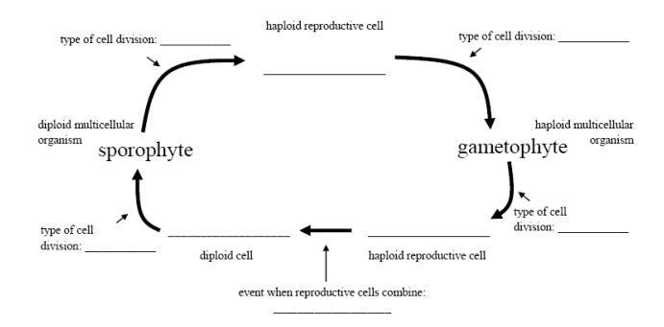
Read pages 440 – 441 to label the diagram and answer the questions.

- Define the following:
a) Alternation of generations:

b) Gametophyte:

c) Sporophyte:

- What is the advantage of Alternating Generations?

- Is the alternation of generations unique to plants? Explain.

- Which generation is a pine tree? (sporophyte or gametophyte?)

- Which generation is a pinecone? (sporophyte or gametophyte?)

- Which generation is a deciduous (leafy) plant? (sporophyte or gametophyte?)

- Which generation is a flower? (sporophyte or gametophyte?)

- Why are non-vascular plants small?

- Why is reproduction on land challenging for non-vascular plants?

