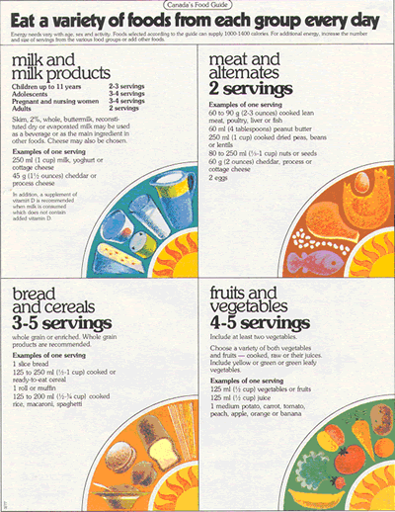
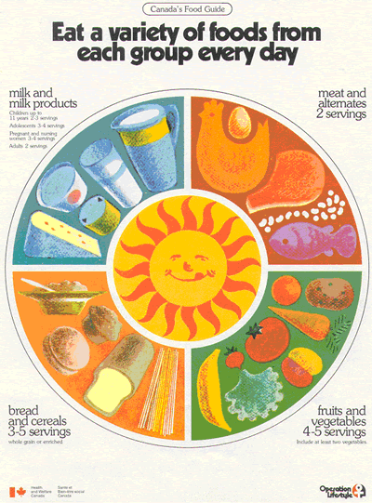
Canada’s Food Guide
Canada first introduced a guide to healthy eating 1942. The “Canada Nutrition Program” was billed as a long-term and comprehensive approach to help everyone in Canada toward the health that comes from eating the right foods. It was very specific (one serving of potatoes every day, 3-4 eggs weekly, etc).
As food preservation and availability improved over the years, so did Canada’s food guide. Here is a poster of Canada’s Food Guide from 1977 which remained unchanged until 2019.
Why change again?
Many Canadians found the previous food guide challenging to use in their daily lives. For this reason, the new food guide has moved away from recommendations based on the number and size of servings. According to the US National Library of Medicine, “Approximately 65 percent of the human population has a reduced ability to digest lactose after infancy. “

New Food Guide, 2019 https://food-guide.canada.ca/en/

Questions
- What are the four main food groups in Canada’s old Food Guide poster?

- What’s different about the food categories in terms of number and content?

- Why do you think fruit juice was taken out of the new food guide?

- What influence, if any, do you think the dairy and meat industries had on the old food guide?

- Healthy eating is more than just the food you eat. What 7 ideas have been added to the new food guide other than food? Use the link: https://food-guide.canada.ca/en/

- Other than being hungry, there are other reasons why some people eat. Come up with a good reason why “being mindful of your eating habits” is important.

- List some benefits (at least 3) you can think of that would come from eating healthy.

