Science 8 Course Outline 2021 -22 Byrne Creek Secondary
Ms. Wilson: tammy.wilson@burnabyschools.ca
Website: https://www.wilsonswebpage.com
Room: B108
Textbook: BC Science 8

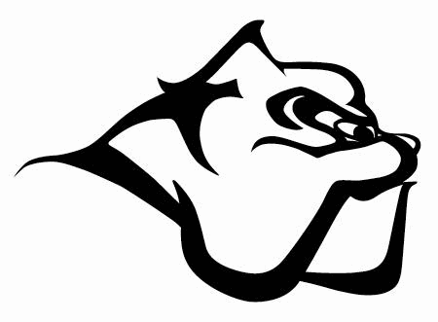

SKILLS YOU WILL BE DEVELOPING:
- QUESTIONING AND PREDICTING
- PLANNING AND CONDUCTING collaboratively plan investigations. Measuring and recording data. Use appropriate SI units and perform unit conversions.
- PROCESSING AND ANALYZING Data and Information
- EVALUATING sources of error and suggesting improvements. Identifying bias. Identifying social, ethical, and environmental impact.
- APPLYING AND INNOVATING new ideas when problem solving. Co-operative design projects
- COMMUNICATING ideas using correct scientific language
TOPICS WE WILL BE EXPLORING:
- Chemistry: The behavior of matter can be explained by the kinetic molecular theory and atomic theory
- Biology: Life processes are performed at the cellular level
- Physics: Energy can be transferred as both a particle and a wave
- Ecology: The theory of plate tectonics is the unifying theory that explains Earth’s geological process.
HOW YOU WILL BE ASSESSED:
Emerging (EMG) | Developing (DEV) | Proficient (PRO) | Extending (EXT)
With support, I can understand the basic ideas of this course. | I can understand the basic ideas of this course and have some basic skills | I fully understand the bid ideas of this course and can explain concepts and problem-solve with ideas. | My work is exceptional and detailed. I can demonstrate high level of critical thinking and analysis, and make meaningful connections between ideas.

MARKS BREAKDOWN:
Tests and Quizzes | 65%
Projects | 15%
Assignments (labs and homework) | 10%
CLASSROOM EXPECTATIONS:

- SOCIAL RESPONSIBILITY:
- Treat others and your environment with kindness, dignity and consideration. Be kind. Be helpful. Be safe.

- PERSONAL RESPONSIBILITY:
- Be present: Attend class, be on time, ready to learn, with all necessary materials, engage in the lessons.

- Follow all safety procedures.

- Be responsible for your learning: Stay on top of your work, recognize when you need to ask for help, and do your best.

- Absences must be excused by a parent/guardian who calls the office before school starts on the day you are absent. Students who miss a class are responsible to find out what was missed and get caught up in a timely fashion by checking the schedule at http://www.wilsonswebpage.com.

- Cell phones: Cell phones are not permitted during instructional time and are expected to be left in your backpack and turned off during class time. Students caught using a device during instruction may have it removed from their person and placed on the white board ledge until the end of class. Students may use cell phones to listen to music during independent work time only after asking for teacher permission

