Learning Activity 3D: ORGANELLE STRUCTURE AND FUNCTION

ORGANELLE | STRUCTURE | FUNCTION
CYTOSKELETON | MICROFILAMENTS
 | INTERMEDIATE FILAMENTS
 | MICROTUBULES
RIBOSOMES

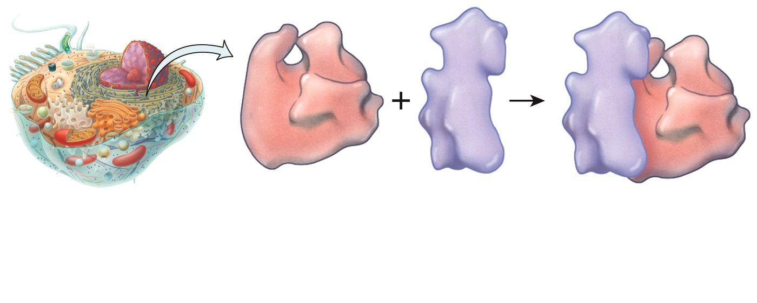
ENDOPLASMIC RETICULUM (ER)  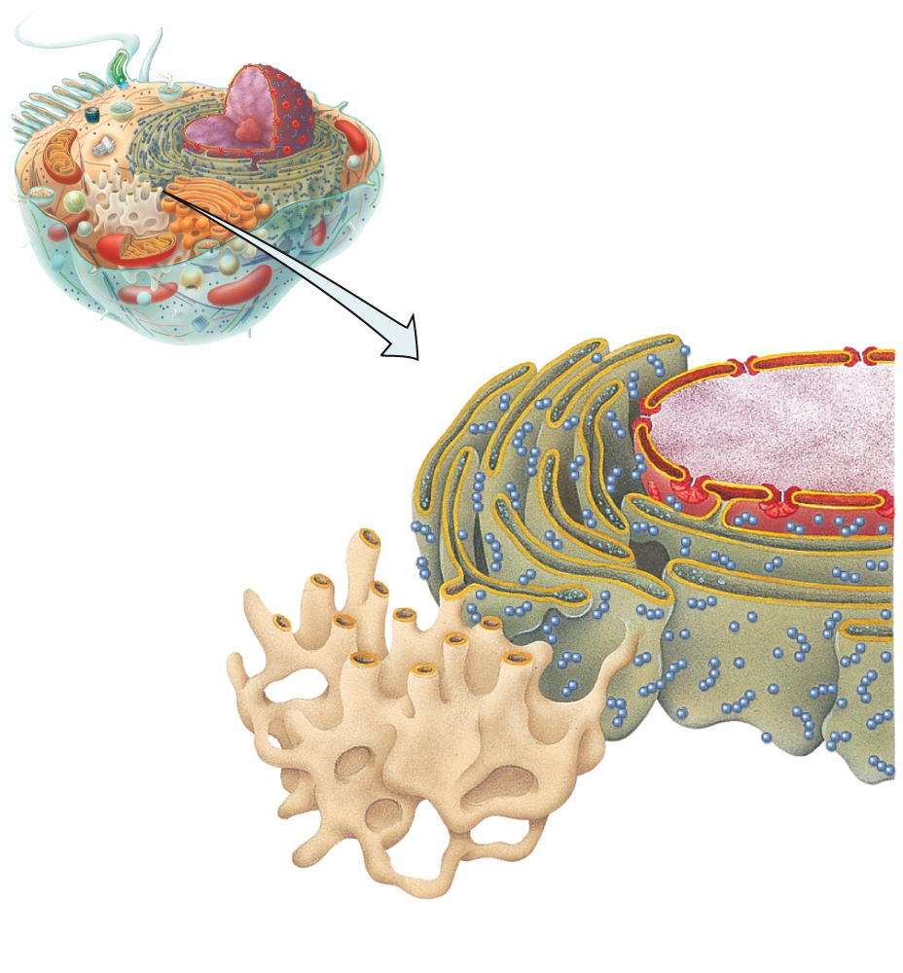 | ROUGH ER (RER)  - a network of folded membranes that form flat sacs arranged in parallel and connected by tubules  - studded with ribosomes  - continuous with the nuclear membrane | - processes (e.g. folds, combines) and sorts proteins synthesized by ribosomes  - proteins are destined to leave the cell via the Golgi apparatus or are incorporated into the plasma membrane
 | SMOOTH ER (SER)  - lack ribosomes  - usually an extension of the rough ER | - function depends on cell type  - synthesis of steroid hormones (cells of the adrenal gland synthesize cortisol and androgens)  - inactivation and degradation of drugs (liver & kidney cells)  - calcium storage (skeletal & cardiac muscle)
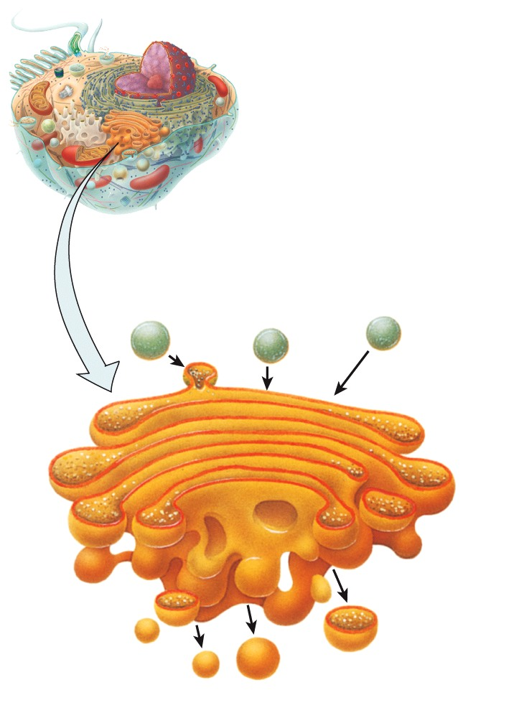
GOLGI APPARATUS

LYSOSOMES

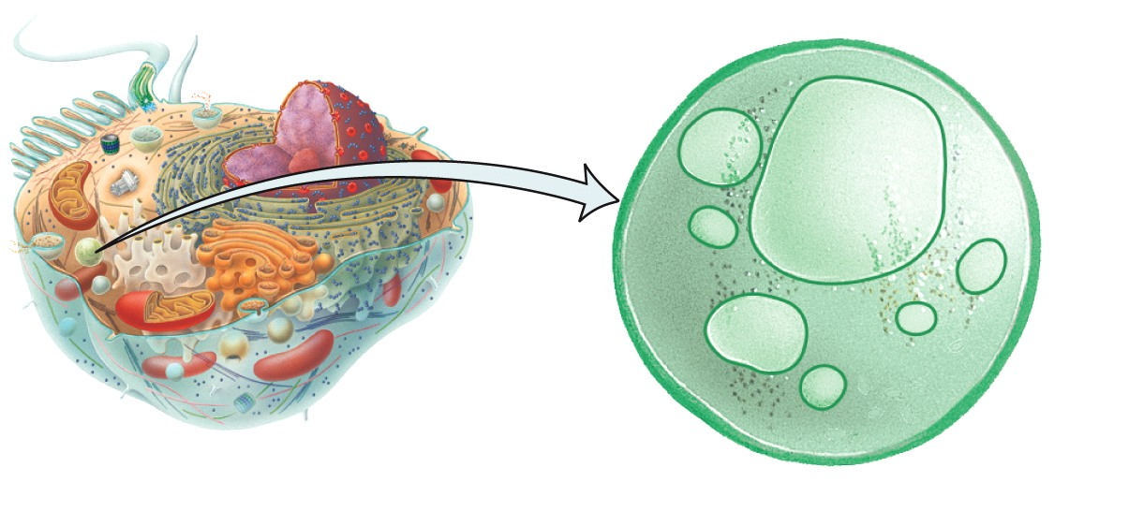

PEROXISOME

PROTEASOME

MITOCHONDRIA
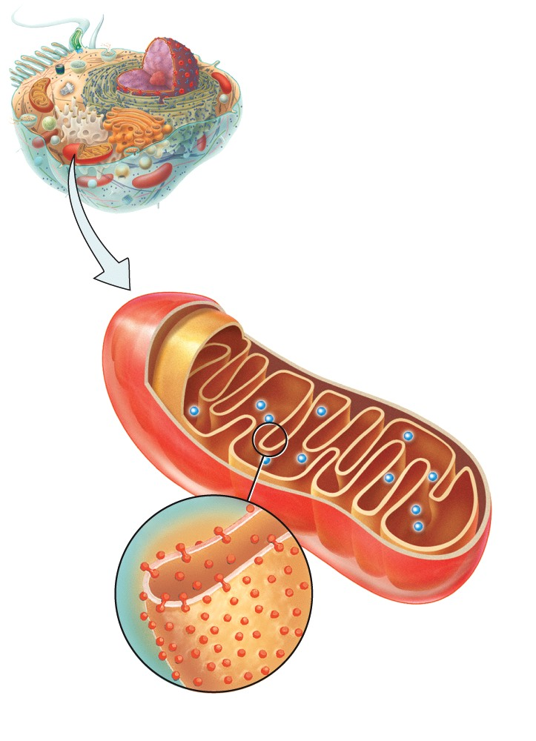
NUCLEUS

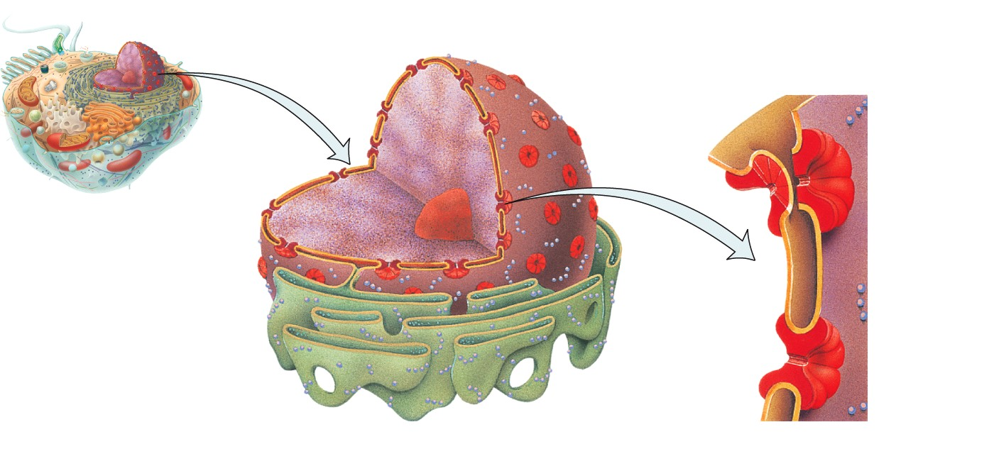

CENTROSOME

