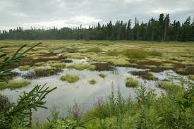
The Role of Wetlands in an Ecosystem
Wetlands are areas consisting of marshes or swamps (areas heavily saturated with water) and are a critical part of our natural environment.
They protect our shores from wave action, reduce the impacts of floods, absorb pollutants and improve water quality. They provide habitat for animals and plants contributing to increased biodiversity (variety of life) by supporting plants and animals that are found nowhere else.
Wetlands maintain relatively consistent water levels. They prevent flooding by holding water much like a sponge. By doing so, wetlands help keep river levels normal and filter and purify the surface water. Wetlands accept water during storms and whenever water levels are high. When water levels are low, wetlands slowly release water.
Wetlands also release vegetative matter into rivers, which helps feed fish in the rives. Wetlands help to counter balance the human effect on rivers by rejuvenating them and surrounding ecosystems.
Many animals that live in other habitats use wetlands for migration or reproduction. For example, herons nest in large old trees, but need shallow areas in order to wade for fish and aquatic life. Amphibians often forage in upland areas but return to the water to mate and reproduce.
Unlike most other habitats, wetlands directly improve other ecosystems. Because of its many cleansing benefits, wetlands have been compared to kidneys. The analogy is good one. Wetlands and kidneys both help control water flow and cleanse the system. No other ecosystem is as productive, nor as unique in this conversion process. In some places artificial wetlands were developed solely for the purpose of water purification.
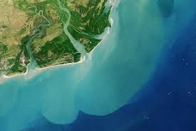
Erosion Control
Looking at a picture of the delta on the right, one can tell that rivers deposit a lot of sediment into the ocean. The sediment is from top soil that has been eroded and washed away.
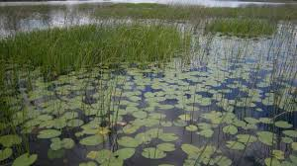
Emergents (plants firmly rooted in the muddy bottom but with stalks that rise above the water surface) can slow the flow of water. As a result, they reduce the amount of erosion caused by water flowing from lakes and rivers, and in rolling agricultural landscapes.
Wetlands and Water Purification
Wetlands also clean the water by filtering out sedimentation, decomposing vegetative matter and converting chemicals into useable form.

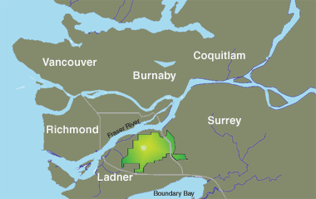
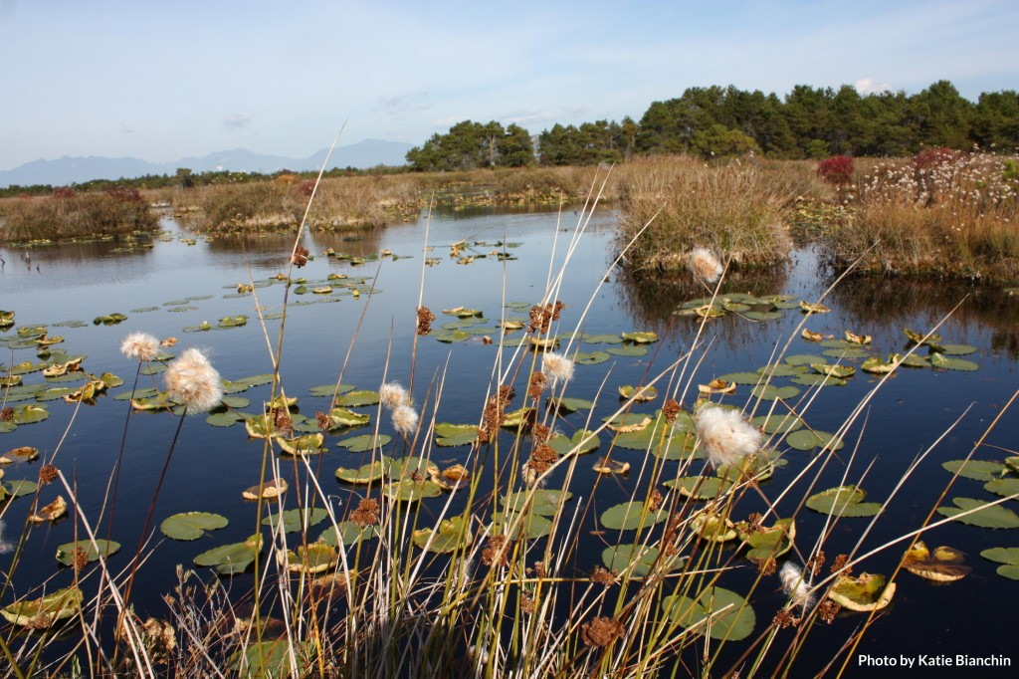
Burns Bog: Lungs of the City:
Burns Bog is an important local wetland located in Delta, British Columbia at the mouth of the Fraser River.

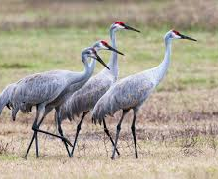
Plant and Animal Biodiversity
Burns Bog is home to more than 300 plant and animal species that include 14 different plant communities, 11 amphibian, 41 mammal, 175 bird, and six reptile species, as well as over 4,000 invertebrates. And is a major migratory stopover for birds on the Pacific Flyway.
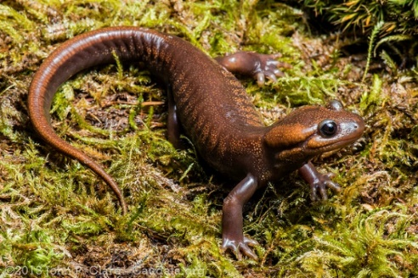
Examples of mammals include: Black-tailed deer, snowshoe hare, coyote, red-backed vole, Pacific water shrew, beavers, birds found here are greater sandhill cranes, barred owl, great blue heron, geese, and woodpeckers. Reptiles and amphibians include northwestern salamanders, painted turtle, red-legged frog, many of which feed on the dragonflies. Fish are found in adjacent streams, but do not live in the bog due to the water’s high acidity and low oxygen content.
Lungs of the Lower Mainland
Burns Bog plays an important role in climate regulation. As a peatland, it stores large amounts of carbon and methane, preventing these greenhouse gases from being emitted into the atmosphere. The bog helps to maintain the health of nearby creeks and their salmon populations: peat cools and filters rainwater which then leaches into critical salmon-bearing creeks, providing optimal conditions for salmon rearing.

First Nations Land Use
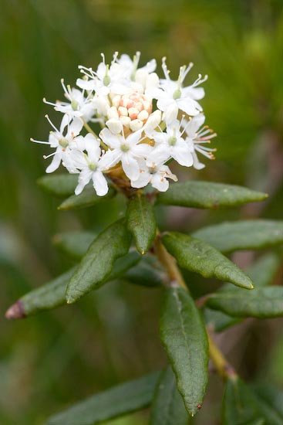
The Katzie, Masqueam, Semiahmoo, Tsawwassen, and Sto:lo First Nations used Burns Bog’s resources for thousands of years. Cloudberries, cranberries, and blueberries found there were an important part of their diet. Black-tailed deer, black bears, and ducks were another food staple. The oldest known fishing archaeological site near Burns Bog is an estimated 4,500 years old.
Infrastructure, clothing, transportation, and totem poles were constructed using cedar trees. Plants, such as sundews, sphagnum mosses, and Labrador tea, helped to treat different medical conditions for these First Nations peoples. Labrador tea
Bog Characteristics
Bogs have very few minerals available for plant growth. This poor growth condition limits the growth of plants that are common elsewhere in the region. Lodgepole pine, a tree which normally grows to be several meters tall, would usually only grow to only one meter in height here.
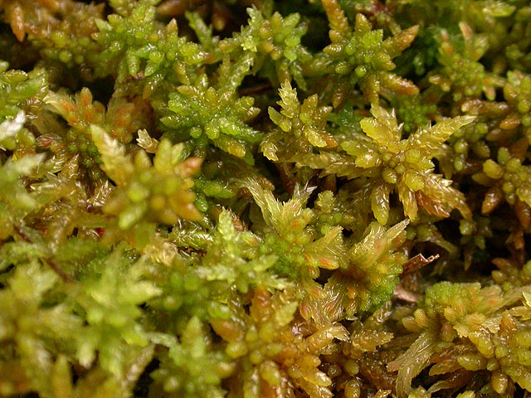
Burns Bog is wet, acidic, and peat-forming. Peat is a heterogeneous mixture of more or less decomposed plant (humus) material that has accumulated in a water-saturated environment and in the absence of oxygen. Sphagnum moss, which grows in wet, nutrient-poor, and acidic environments and makes up the bulk of the peat. It is also important for other forms of life due to its high nitrogen content. Sphagnum can hold up to 20 times its weight in water.
Due to the presence of molecules that prevent breakdown of organic matter and discourage microbial growth, decomposition of organic matter is very slow.
Sphagnum Moss

Development & Burns Bog
Gardeners use peat moss mainly as a soil amendment or ingredient in potting soil. It has an acid pH, so it's ideal for acid loving plants, such as blueberries and camellias. Historically peat was also harvested as an important source of fuel for cooking and heating. Peat harvesting began in the 1930s in Burns Bog. Although this practice ended in 1984, the damage is still felt today.
Draining and filling in the bog for agricultural, industrial and urban development have also damaged the bog’s ecological integrity.
Highways and buildings have isolated Burns Bog from other natural areas. Such construction has caused a dramatic shrink in Burns Bog’s size. The smaller a peat bog gets, the lower are its chances of survival.
The Vancouver Landfill poses risks to Burns Bog. Not only might contaminated water leach into the bog, the breakdown of garbage creates a more nutrient-rich environment – the opposite of what a peat bog needs.
Protection and Restoration
The Corporation of Delta and Metro Vancouver are working to recover as much of Burns Bog as possible. Drainage ditches are being blocked with peat and wood dams and steel weirs, enabling the bog to retain more precipitation in the summer season.
Beavers play an important role in obstructing many ditches throughout Burns Bog. Their dams work like human-made ones, allowing the bog to store rainfall.

Sci 9 Burns Bog WS Name: _____________
- Name 5 ways wetlands are important to ecosystems.

- How do wetlands regulate water levels?

- Why are wetlands called the “kidneys of the earth”?

- How do wetlands reduce soil erosion?

- Name a plant, bird, mammal and amphibian that can be found in Burns Bog.

- Why aren’t fish found living in Burns Bog?

- Describe two ways in which Burns Bog plays a role in climate regulation.
- Why wouldn’t you find many large trees in a bog?

- What type of plants grow in bogs that allow them to retain so much water?

- What is an abiotic factor that is the rate of decomposition so slow in bogs. What is the biotic factor in this scenario?

- What is peat and what are two main uses?

- Name three types of human activity that is currently threatening Burns Bog and how each poses a risk.

- What is being done to recover Burns Bog?

- IN YOUR OWN WORDS, summarize what you have learned about how a small wetland ecosystem can be so important. Include abiotic factors and biotic factors that affect each other and list how all four spheres interact.

