Science 8 Unit 3 Pack:

Name________________

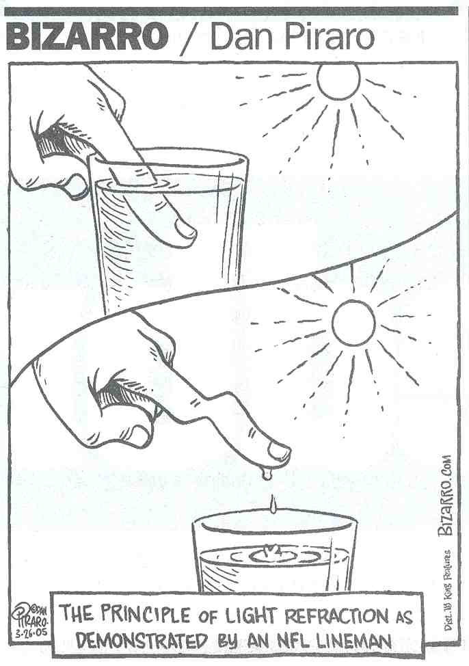
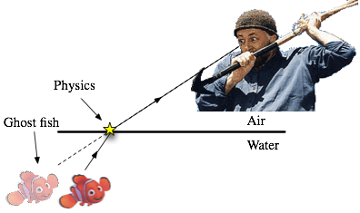
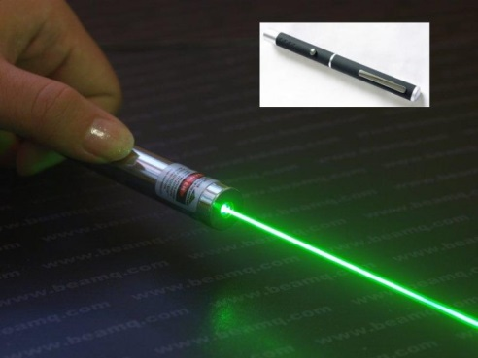
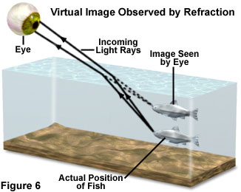

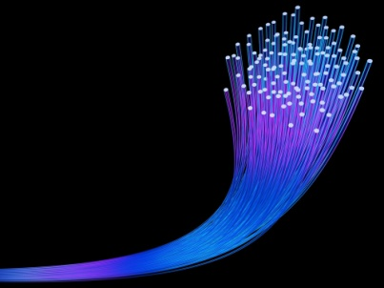
In this unit you will know the following content:
- types of electromagnetic radiation: the electromagnetic spectrum consists of radio, microwave, infrared, light, UV, X-ray, and gamma rays
- effects of electromagnetic radiation: positive effects include cancer treatments; negative effects include sunburns
- properties of light
  - acts like both a wave and a particle
  - wavelength, amplitude, frequency
- behaviours of light:
  - reflection, refraction, absorption, transmission, scattering
  - images formed by lenses and mirrors
  - effects of translucent, transparent, and opaque objects
- ways of sensinglight: human vision, optical instruments, cameras

3.1: Electromagnetic Radiation
Term | Definition |  |  | 3 examples
Electromagnetic Spectrum
Term | Definition |  | 3 Uses | 3 Technologies that use this wavelength
Radio waves
Microwaves
Infrared
Visible light
Ultraviolet
X-Ray
Gamma Ray
What are two NATURAL sources of electromagnetic radiation? Explain how the radiation is produced for each.
What are two MAN-MADE sources of electromagnetic radiation?Explain how the radiation is produced for each.

For each of the types of electromagnetic spectrum,

a) describe a specific situation in which they can be dangerous.

b) Describe ways in which these wavelengths can be safely dealt.

