Name: _________________________________

Date: __________________________________

LAB EQUIPMENT – PART 2

DIAGRAM Crossword



**ACROSS**

1. Identify B in the diagram.

5. Identify U in the diagram.

7. Identify H in the diagram.

8. Identify N in the diagram.

10. Identify D in the diagram.

11. Identify Q in the diagram.

12. Identify R in the diagram.

14. Identify O in the diagram.

17. Identify V in the diagram.

21. Identify P in the diagram.

22. Identify T in the diagram.

**DOWN**

2. Identify F in the diagram.

3. Identify L in the diagram.

4. Identify E in the diagram.

6. Identify K in the diagram.

9. Identify M in the diagram.

13. Identify G in the diagram.

15. Identify I in the diagram.

16. Identify J in the diagram.

18. Identify A in the diagram.

19. Identify C in the diagram.

20. Identify S in the diagram.

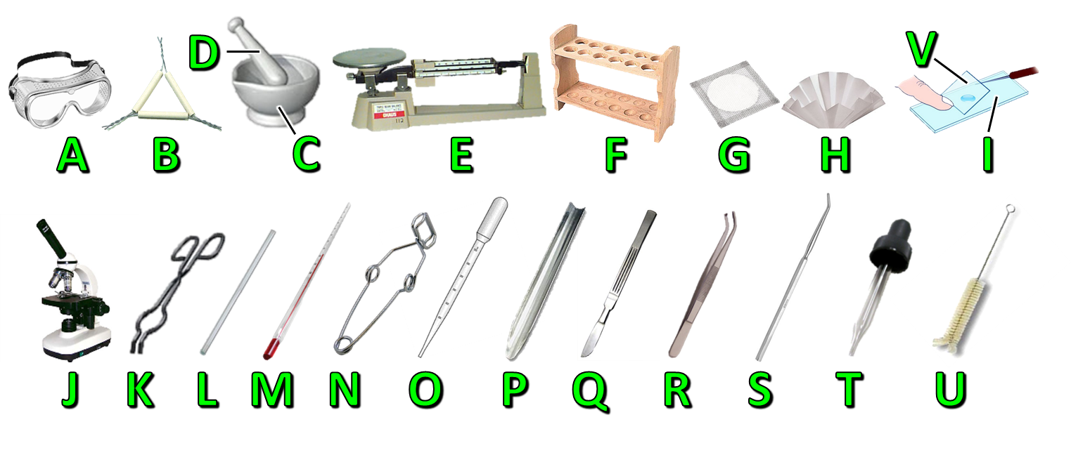

**ANSWER KEY**

Name: _________________________________

Date: __________________________________

LAB EQUIPMENT – PART 2

DIAGRAM Crossword



E

**ACROSS**

1. Identify B in the diagram.

5. Identify U in the diagram.

7. Identify H in the diagram.

8. Identify N in the diagram.

10. Identify D in the diagram.

11. Identify Q in the diagram.

12. Identify R in the diagram.

14. Identify O in the diagram.

17. Identify V in the diagram.

21. Identify P in the diagram.

22. Identify T in the diagram.

**DOWN**

2. Identify F in the diagram.

3. Identify L in the diagram.

4. Identify E in the diagram.

6. Identify K in the diagram.

9. Identify M in the diagram.

13. Identify G in the diagram.

15. Identify I in the diagram.

16. Identify J in the diagram.

18. Identify A in the diagram.

19. Identify C in the diagram.

20. Identify S in the diagram.





**Created by Anh-Thi Tang – Tangstar Science**

**Copyright © 2014 Anh-Thi Tang (a.k.a. Tangstar Science)**

All rights reserved by author.

**TERMS OF USE:** This document is for your personal use only and may only be used by the original purchaser. Copying for more than one teacher, classroom, department, school, or school system is prohibited. Additional licenses can be purchased at a discount for others to use in your department. This entire document, or any parts within, may not be displayed for public viewing. You may not electronically distribute or post this product online including to teacher blogs or classroom websites. Failure to comply is a copyright infringement and a violation of the Digital Millennium Copyright Act (DMCA).

**http://www.teacherspayteachers.com/Store/Tangstar-Science**