Sci 8 Matter WS Name:
- Define the following
- Matter
- Mass
- Volume:
- Which has more mass? Circle your choice.  - A basketball or a bowling ball  - A helium balloon or a glass marble  - A kitten or a german shephard | - Which has more volume?  - A basketball or a bowling ball  - A helium balloon or a glass marble  - A kitten or a german shephard

- Think of 2 examples of each state of matter at HOME. Write them in the space below
SOLIDS AT HOME | LIQUIDS AT HOME | GASES AT HOME

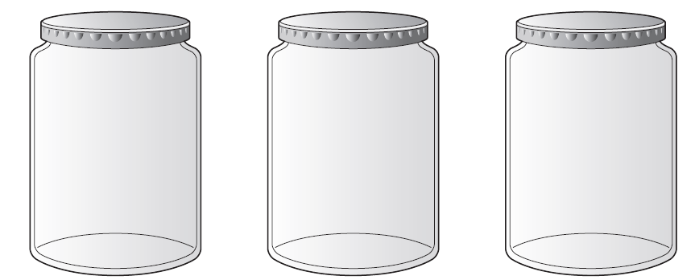
- In each of the jars below, draw the particles in a solid, liquid, and gas. Make sure to indicate whether the particles are moving or vibrating in your diagrams. Complete the corresponding chart below the jars.

 | Solid | Liquid | Gas
Attractive forces between particles | strong
Movement of particles |  |  | Can move freely and quickly in all directions in the container

- What is Kinetic Energy?

- What are the three main points of the Kinetic Molecular Theory?

