The universe is made up of two things: **_____________ and ________________.**

**MATTER** is made up of **__________________.**

* These particles are made up of elements from the periodic table:

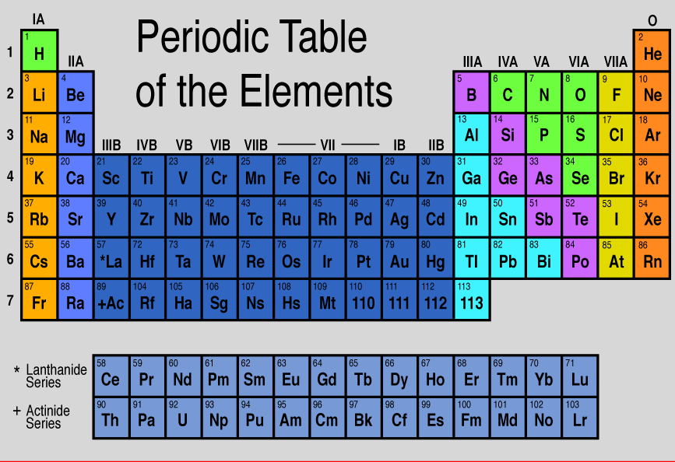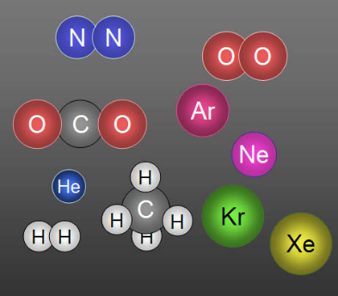

**ENERGY** is the different _________________ that make particles do something

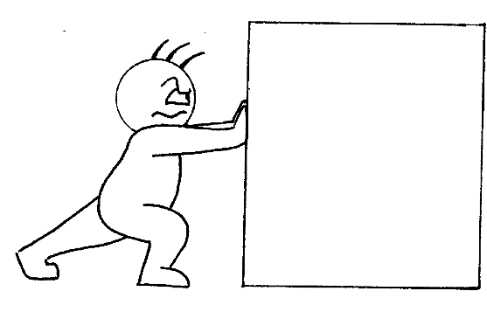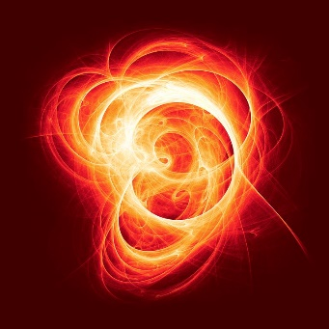i.e. fusion (stars), electromagnetic fields, fission (atomic bombs), a push or pull

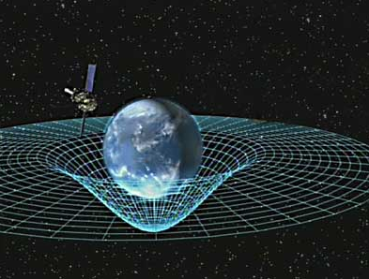

**WHAT IS MATTER?**

MATTER is anything that ________________________________________________.

Mass is the amount of ______________________________________ in an substance.

Volume is the amount of ____________________ occupied by a substance.

______________________is the study of matter.

**What is NOT matter?**

Energy (heat, light) because it has no _______________.

**PARTICLE MODEL OF MATTER (kinetic theory of matter)**

Kinetic Molecular Theory:

1. All matter is made of _________________________________.
2. There is _____________________________ between particles.
3. Particles are constantly ________________ and __________________ with each other.

**Kinetic energy** is the energy of __________________.

Particles make up solids, liquids and gasses and are too small to be seen with the naked eye!

There are three ways we can describe matter:

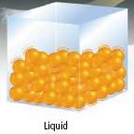

As particles gain energy they move _________________.

Particles at _____________ temperature move ______________than particles at lower temperatures.

|  |  |  |  |  |
| --- | --- | --- | --- | --- |
|  | **DISTANCE** | **MOTION** | **ENERGY** | **SHAPE** |
| **Solid** | **Picture 2**Packed closely together, spaces between are small |  |  |  |
| **Liquid** | Picture 3Particles have enough space between them to slide past each other. |  |  |  |
| **Gas** | Picture 4Particles are far apart, mostly space |  |  |  |

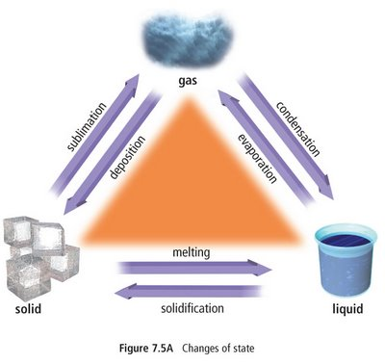

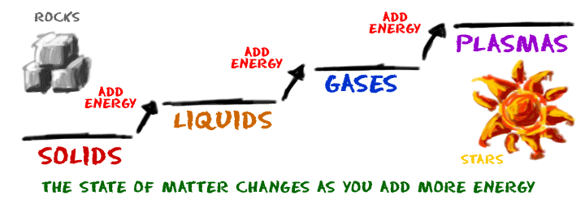**CHANGES OF STATE**

**PROPERTIES OF MATTER**

**Physical Properties:** _________________________ or ____________________that can be **______________________or _____________________** without changing it. **eg color**

|  |  |
| --- | --- |
| **PHYSICAL PROPERTY** | **DEFINITION** |
| **States of Matter** | solid, liquid, and gas.  When a substance changes its ___________, it does not _____________________________________________.  *Eg. ice (solid), water (liquid), and steam (gas) are all the same compound* |
| **Melting and**  **Boiling points** | MP = temperature a substance turns from _________to _____________  BP= ______________________________ |
| **Malleability** |  |
| **Ductility** | Eg. Copper, aluminum |
| **Solubility** | How well a substance __________________________  _________________________________________  Eg. Salt is sluble in water (it dissolves in water) |
| **Conductivity** | Ability to ______________________________________ |
| **Density** | How ____________________ or “heavy” something is. |

**Chemical Properties:** a **characteristic** of a substance observed during a reaction in which the **chemical** composition or identity of the substance is changed:

|  |  |
| --- | --- |
| **CHEMICAL PROPERTY** | **DEFINITION** |
| Flammability | Rapid reaction of substance with _____________ 🡪 releases _________________(burning/ cumbustible)  Eg. “burning” gas in car engines |
| Corrosion (Rusting) | Slow reaction of ______________ with _______________to form metal oxides  Eg. Rusting of iron 🡪 iron oxide |
| Reacts with Acid | Reaction of some mteals…often produces ______________  Eg. CO2 or H2 gas |

**How can you tell if it’s a PHYSICAL or CHEMICAL change?**

**In a physical change** the object retains __________________________________.

Eg. a cut strawberry is still as sweet

* A __________________________________ is a physical change.
* _____________________ is a physical change: when salt dissolves in water, the crystals disappear but the salty taste of water proves that the salt is still there. The salt can be re-crystallized by evaporating the water.
* A ___________________________ (phase change): water boiling to steam.

**Evidence of a chemical change**: One or more _____________ substances is formed.

* The change is irreversible (you can’t “go back” to the original starting material)
* New __________________ formed (bubbles produced)
* New __________________ are observed (change in colour, odour)
* ___________________________ (heat or light given off or absorbed)

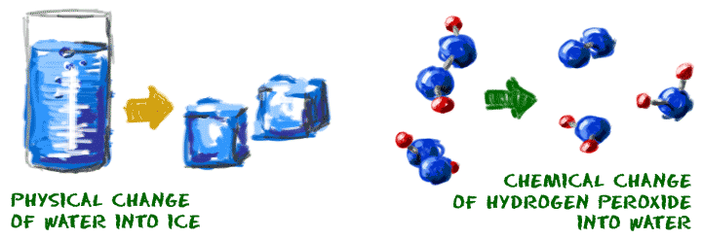

**Chemical Change POE**

|  |  |  |  |
| --- | --- | --- | --- |
|  | **Element** | **Element** | **Compound** |
|  | **iron** | **sulphur** | **iron sulphide** |
| colour |  |  |  |
| is it attracted to a magnet? |  |  |  |
| reaction with hydrochloric acid |  |  |  |

**There are TWO types of Matter:**

**PURE SUBSTANCES**

A pure substance is matter that contains ___________________________________. Pure substance can be further classified as either:

______________________ - pure substance that cannot be changed into anything simpler.

Copper - an example of an element

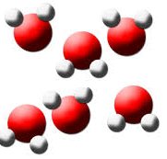_____________________ pure substances that consist of two or more elements

Water - an example of a compound

**How can we tell the difference between elements and compounds?**

Compounds **can be ______________________________ into simpler units** by __________________and/or _____________________.

Elements **_________________** be broken down chemically into simpler units by heat or electricity

**MIXTURES**

A mixture contains __________________ pure substances ___________ chemically joined.

There are two types of mixtures:

* A _________________________________ mixture is a mixture that is
  + made of substances that are _________________ and _____________________________mixed together.
  + The components are ___________________ but ______________________ from each other.
  + Has the same _________________________ throughout.
  + Usuall one phase
  + Ex. Salt dissolved in water, air
* A _____________________ mixture is a mixture that is ________________________ in its composition. 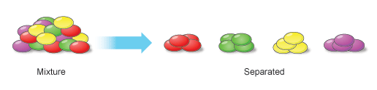
  + The components can be _____________________________________.
  + _____________________properties throughout
    - Ex. Granola, sulfur and iron, sand and marbles, salsa

**How can we separate an insoluble substance from mixture?**

Eg: Sand and water 🡪 __________________________

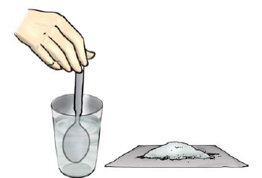

**How can we separate a soluble substance from a solution?**

________________________________________

**Why do we care?** ________________________________

What happens in a chemical reaction?

DENSITY

Density: ____________________________________________________________________

Density is a _______________________________ property.

You can calculate density this way:

Symbols: Volume: _________ Mass: ___________ Density: __________

Units: Volume: _________ Mass: ___________ Density: __________

When you are comparing densities of a substances, you are comparing _______________

Comparing densities enables us to predict whether a substance will _______________or __________________ in its surroundings.

When something floats in water, it is because it is _____________________ than water.

When something sinks in water, it is because it is ______________________ than water.

POE: A grape is more/less dense than water because it sinks/floats.

**PRACTICE CALCULATIONS**

1. A substance weighs 0.56 grams. It has a volume of 3cm3. Calculate the density.

2. After each class, Ms. Wilson eats a chocolate bar that weights 12.5 grams. She measures its volume to be 6cm3. Calculate the density of the chocolate bar.

3. A crystal is found that has a volume of 1.5 cm3. If the crystal weighs 4 grams, what is its density?

4. You place a piece of wood in a graduated cylinder. The level of the water in the cylinder moves from 98 mL to 125 mL.

a) What is the volume of the piece of wood?

b) If the piece of wood weights 72 grams, what is its density?

5. A graduated cylinder is filled with water to the 55 mL mark. The graduated cylinder with water weights 132 grams. A piece of metal is placed in the water. The water rises to the 105 mL mar. When you re-weigh the cylinder, it now weighs 225 grams. Calculate the density of the metal.

6. How does the density of a cup of water compare to the density of a bathtub of water?