Assignment – Science Lab Safety Comic Strip /10

Name: ___________________ Date: ____________________ Block: ____________

Purpose: To make a comic strip that illustrates a safety rule in science.

What to do…
In a comic strip template, create a comic strip that illustrates an accident taking place in the lab. You will need to answer the following four questions in your cartoon.
  - What was happening before the accident took place?
  - What accident occurred when the lab safety rule was not followed properly?
  - How was the accident resolved? (What was done to fix the problem?)
  - What precautions should be taken in the future to avoid this type of accident?

Format for the comic strip

Use a character from your favorite comic strip or create and draw your own character(s).
Arrange them with captions (or word/thought bubbles) that illustrate a science safety lab rule:

Drawing 1  Before the accident | Drawing 2  Accident | Drawing 3  Resolution | Drawing 4  Precaution

- Try online: http://www.toondoo.com/
http://comiqs.com/
http://pixton.com/ca/
http://bitstrips.com/

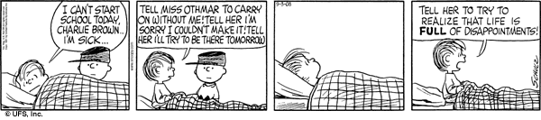

CHECKLIST (your comic has the following):

- Answers/illustrates the questions outlined in "What to Do…"

- Neat and coloured

- Has a title

- Uses four boxes minimum

- Has an illustration in each box

- Has a caption in each box

Rubric:
 | 4 | 3 | 2 | 1
Content | Images clearly identify what safety rule is demonstrated.  Danger clearly identified.  Characters correctly use the protective equipment and emergency response procedures are correct  Captions describe what is happening. | Images depict a safety rule.  Danger identified.  Proper use of equipment or procedure identified.  Captions describe what is happening. | Safety rule may be unclear.  Danger not clearly identified.  Some effort to demonstrate proper use of equipment or procedures  Captions unclear. | Unclear what safety rule is depicted.  Character does not demonstrate proper safety procedures or use of equipment  No captions dialogue to describe what is happening.
Effort | Excellent use of colour and space  Neat, tidy, easy to read | Good use of colour and space.  Neat and easy to read | Some effort to fill space or use colour.  Readable | Poor use of colour and space  Difficult to read

