LS11 Virus Worksheet 1
- What is the definition of a virus?

- There is some debate about whether viruses are living or not. Name some characteristics of living things that viruses exhibit.

- Circle the letter of each reason why some biologists do not consider viruses to be alive:
- They can’t infect living cells
- They can’t evolve
- They can’t regulate gene expression
- They can’t reproduce independently

- Do all viruses cause disease? What is the name given for this?

- True or False: Most viruses are so small that they can be seen only with the aid of a powerful electron microscope.

- Convert 200 nm to mm. ___________mm. Convert 40 um to _________nm

- Draw and label the general structure of a typical virus:

- Name these basic viral shapes:
A _________________
B __________________
C __________________
D ___________________

Definitions:
- Bacteriophage -
- Prion -
- Viroid -
- Retrovirus -
- Specificity -

- Briefly describe the three theories of how viruses came to be.

- Label the following parts a typical bacteriophage: Head, Tail, Capsid, Genetic Material, Tail Fibers.
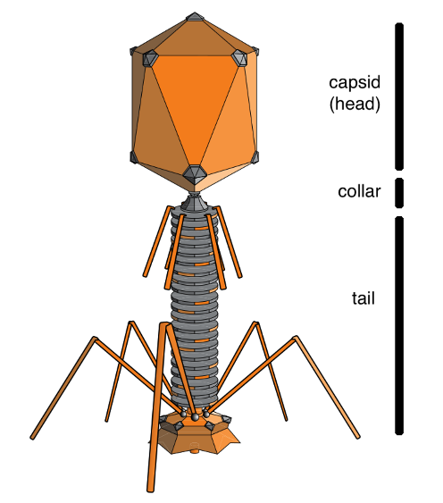

- . Complete the chart below comparing viruses and cells.

Characteristic | Virus | Cells
Structure | DNA or RNA core, capsid | Cell membrane, cytoplasm. Eukaryotes also contain nucleus and organelles
Reproduction |  | Independent cell division either asexually or sexually
Genetic Material |  | DNA
Growth and Development | No
Obtain and use Energy |  | Yes
Response to environment |  | Yes
Change over time

