Name: _______________
Albedo lab Partner: ____________
Introduction:
Albedo is a measure of how much light is reflected back from a substance. It usually refers to Earth and the amount of sunlight that's reflected back into space. Earth's average albedo is 35, which means approximately 35% of the sunlight is reflected back into space. Lighter surfaces, like ice, tend to reflect more light (and thus absorb less) than darker surfaces, like land.

Question:
How will temperature change in containers of different colored surfaces?

Hypothesis: If with dark colours are heated by radiation from a light bulb, then the temperature of the water will increase ______________(faster/slower) than the temperature of light coloured cup.

Materials: thermometers (2), beakers/cups (2), heat lamp, lab stand, clamp, dark paper, foam lids/caps, timer

Procedure:
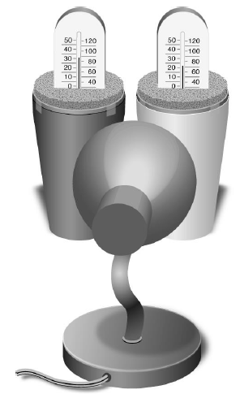
- Place one thermometer through the lid of each cup, one covered with dark construction paper, the other covered with light. Make sure you can see the liquid in the thermometers.
- Place the cups side by side on a flat surface, 10-15 cm in front of the bulb of the lamp, but don’t turn on the lamp yet. Make sure the distance to each cup is equal.
- Record the starting temperature of each cup in your data table at “0 minutes”.
- Start the timer and turn on the light simultaneously. Record the temperature of each cup every minute until 20 minutes have passed.
- At the 10 minutes mark, TURN OFF the light and move it away from the bottles (it will continue to generate heat even when turned off).
- Continue to record temperatures every minute for another 10 minutes.
- Plot your data on the graph. Connect the points for the two sets of data, and label one “dark” and the other “light.” (Or use two different colors and complete the legend key.)

Data Table 1: Light Bulb on (radiation simulating daylight hours)
Time (min) | 0 | 1 | 2 | 3 | 4 | 5 | 6 | 7 | 8 | 9 | 10
Dark (˚C)
Light (˚C)

Data Table 2: Light Bulb Off (radiation simulating nighttime hours)
Time (Minute) | 11 | 12 | 13 | 14 | 15 | 16 | 17 | 18 | 19 | 20
Dark (˚C)
Light (˚C)

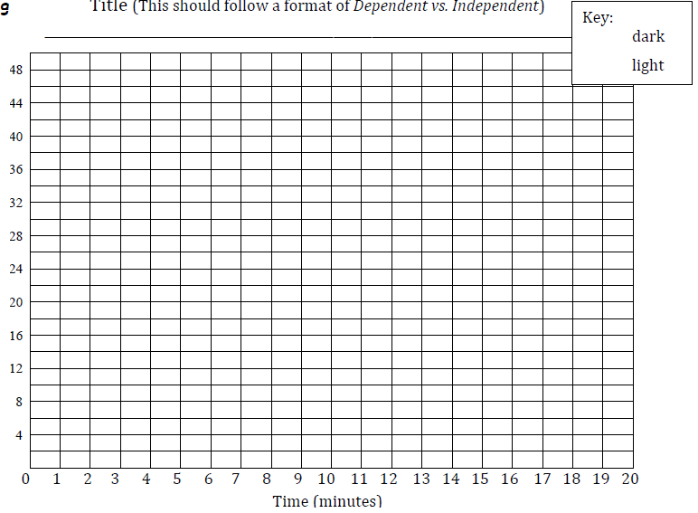
Title:

Analyze and Conclude
- Calculate the total change in temperature in each cup.
Dark | Light:
heated by ________ degrees in 10 min  cooled by ________ degrees in 10 min | heated by _________ degrees in 10 min  cooled by _________ degrees in 10 min

- Did the temperatures rise at the same rate? Did they cool at the same rate? Explain.

- Identify the variables in this experiment:
- Independent Variable (what are you manipulating?)__________________
- Dependent Variable (what are you measuring?______________________
- Control variables (name 2 that stayed the same) ____________________ ____________________________
- Based on this data, what would the best color of roof be if you wanted to keep your house warmer? Cooler? Explain.

- How does soot from pollution and coal burning affect the albedo of ice?

- Suppose a large area of ice melts, exposing a large patch of darker land underneath. Use what you know about the albedo effect to suggest what will happen to the surrounding atmosphere in terms of overall temperature. How will this affect overall climate?

- Put it all together and describe how melting of polar ice caps and climate affect each other.

