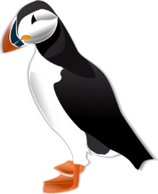
Interpreting Graphics - Taxonomy
True or False:
1. _____ Dogs belong to the order Felidae.
2. _____ A fox belongs to the phylum Arthropoda.
3. ____ Snakes belong to the phylum Reptilia.
4. _____ Lions belong to the class Mammalia
5. _____ All arthropods belong to the Class Insecta
6. _____ All rodents belong to the phylum Chordata.
7. _____ All amphibians belong to the class Reptilia.
8. _____ All primates are mammals.
9. _____The class Mammalia includes dogs, cats and rats.
10. _____A lion belongs to the genus Felis.
11. _____All mammals are primates.
12. _____ Insects and lobsters are arthropods.
In each set, circle the pair that is most closely related.
13. snakes & crocodiles | snakes & frogs
14. rats & cats | cats & dogs
15. insects & lobsters | insects & birds
16. lions & tigers | lions & cougars
17. foxes & rats | foxes & dogs
18. cats & dogs | cats & lions
19. List all species pictured that belong in the Felidae family:

20. Create an addition to the image given the following information:
- Mollusks are divided into three classes: Class Cephalopoda (squids), Class Gastropoda (snails), Class Bivalve (clams and oysters)
- Cephalapods have a few orders, one of which is Octopoda (octopus) and another is Teuthida (squids)
- The scientific name for the common octopus is Octopus vulgaris.
- The scientific name for the common European squid is Loligo vulgaris.

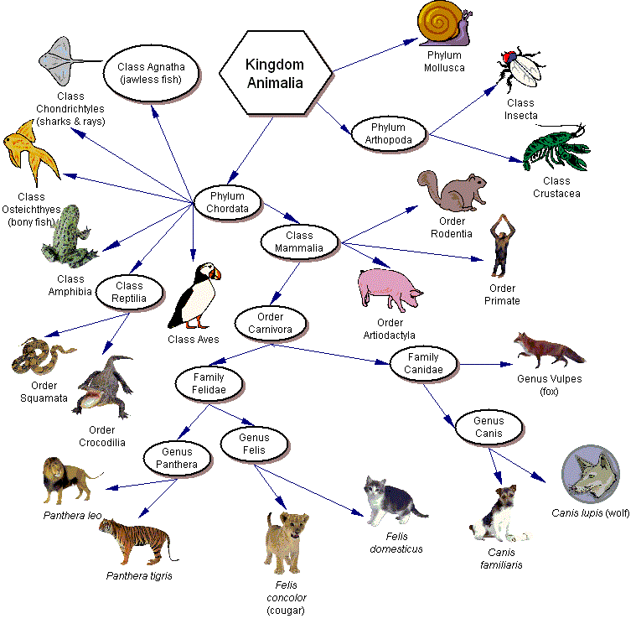
20. The image does not show orders of insects. Suggest three categories of insects that would likely be grouped into orders. Hint: think about what kind of insects there are. Add your three categories to the image.

