Virus Life Cycle Worksheet
- The ______________ is the reproductive cycle of most viruses. In this cycle, the virus ______________ to the cell and ___________it’s __________________________ into the cell. The host cell makes viral parts and ______________ them. The cell then _____________, releasing viral particles.
- The ________________ is the alternate reproductive form of viral replication. During this process the viral DNA attaches itself to the cell’s DNA, becoming a _____________and can remain ____________ until something like a change in temperature or nutrients ____________ it.

- Label the diagram of a viral Life Cycle. Lytic
Attachment, Injection, Replication, Assembly, Lysis.
Refer to Fig 17-4 on p358 (or Fig 19-10 p481 new text).
Lytic Cycle, Lysogenic Cycle, Bacteriophage, Attachment, Entry, Synthesis, Lysis, Replication, Integration, Prophage, Host DNA, Virus DNA,

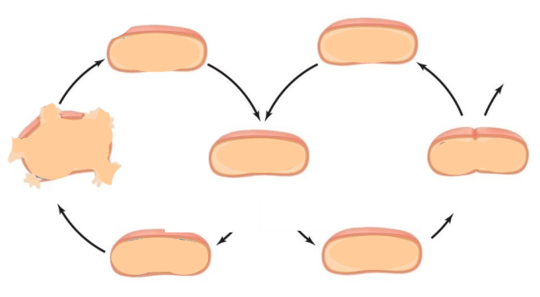

- What is the advantage of a virus using the lytic cycle?

- What is an advantage of using the lysogenic cycle?

- Individuals with the herpes virus often go long periods of time where they are asymptomatic, then will experience an outbreak and develop symptoms. Explain why this occurs, making reference to the life cycles of viruses.

- List some examples of viruses that use the lytic cycle. | - List some examples of viruses that use the lysogenic cycle.

- What type of replication pathway would you expect to find in a virus that is very virulent?

