Vegetative Propagation Investigation Name:
Skills: Planning and Conducting. Draw conclusion with evidence Partner:
Introduction:
Artificial Vegetative Propagation is a method of generating a new plant from a fragment of the original. Not all plants can be propagated the same way. Some garden plants can be propagated by “splitting” (separating the roots). Some by “layering” (a part of the plant is pegged into the ground and the shoot becomes a separate plant). Grafting is common practice to propagate fruit and nut trees with desirable traits. Many house plants can be propagated from a stem or leaf cutting placed in water or soil, some from putting a leaf in soil.
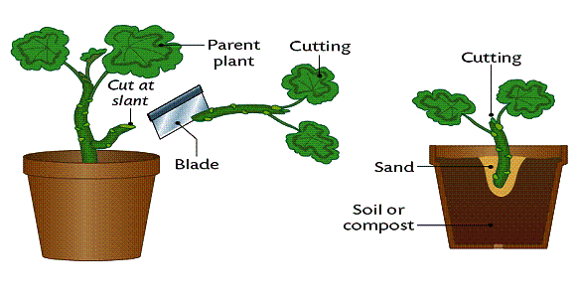
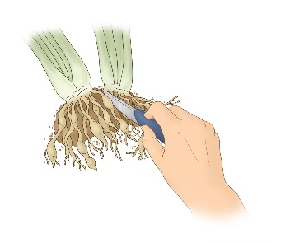

Which house plants can be propagated by which methods? How can you find out? How will you know it worked? You may try two different propagation methods from the same plant.
Question: Which method of vegetative propagation can be used to propagate a house plant?
Plant: ________________________________
Claim: (Which propagation method do you think will work? ) ______________________________________________________________________________
Independent Variable: ____________________Dependent Variable: ____________________ Controlled Variables (3) _________________________________________________________
Procedure:
1. Take a LEAF or STEM from parent plant.
2. Place one leaf/stem directly into SOIL, the other into WATER.
3. Record both qualitative observations and quantitative observation (if possible) each week for 3-4 weeks.

Observations:
Day 0 - Qualitative and Quantitative observations. Describe the colour, feeling, thickness, etc. of your plant. Take pictures for comparison.
_____________________________________________________________________________________
Day 7: _______________________________________________________________________________
Day 14: ______________________________________________________________________________
Day 21: ______________________________________________________________________________
Day 28: ______________________________________________________________________________
Analysis:
- Which propagation method worked best on this plant (name both your type of plant and method)?

- What is your EVIDENCE that it worked/didn’t work?

- Report any difficulties or problems you encountered during your experiment.

- Do you think your method of propagation will work with any plant? Justify your answer.

- Do you think a propagated plant has the same qualities as the original plant?

- Why do you think vegetative propagation is important to an apple orchard farmer?

- Compare using artificial vegetative propagation (a form of asexual reproduction) to starting a new flowering plant vs using seeds. List advantages of each.

