Claim, Evidence, Reasoning (CER)

Start with a question based on a phenomena or lab experience.

Claim
- A claim is a statement that answers the question. It will usually only be one sentence in length. The claim does not include any explanation, reasoning, or evidence so it should not include any transition words such as “because.”
Evidence
- The evidence is the data used to support the claim. It can be either quantitative or qualitive depending on the question and/or lab. The evidence could even be a data table the student creates. Students should only use data within their evidence that directly supports the claim.
Reasoning
- The reasoning is the explanation of “why and how” the evidence supports the claim. It should include an explanation of the underlying science concept that produced the evidence or data.

- Ameba Sisters video
- https://www.youtube.com/watch?v=15aWaGYheJs

Practice:
1. Watch Doritos commercial: Dog buries cat
file:///C:/Users/e19705/OneDrive/ALL/CER/Dorito%20commercial.html

2. Work in pairs to write a CLAIM that answers the question, “What happened to the cat?”

3. What is your EVIDENCE?

4. What is your REASONING? Write “why” and “how” the evidence supports the claim.

Claim, Evidence, Reasoning (CER)
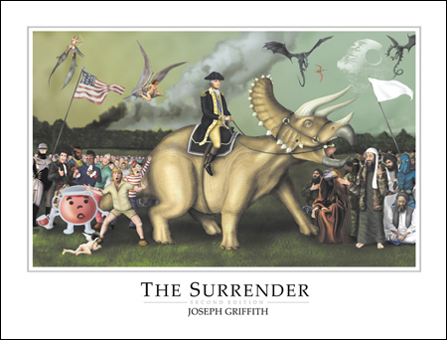
Joseph Griffith’s, ‘The Surrender,” was painted for the 225th anniversary of the Battle of Yorktown. The Battle of Yorktown ended with British forces surrendering to American and French forces. It was the last major engagement of the Revolutionary War.
Data (Observations) What do you observe in this painting?

Claim: What is the meaning of this picture?

Evidence (from your data) | Evidence (from your data) | Evidence (from your data)
Reasoning  (connect evidence to claim) | Reasoning  (connect evidence to claim) | Reasoning  (connect evidence to claim)

http://img220.imageshack.us/img220/9972/washingtontriceratops15dy3.jpg
