Sci 8 Density Worksheet Name:

Answer these questions after you have read page 265 of BC Science 8.
1. A student measures the mass of an 8 cm³ block of brown sugar to be 12.9 g. What is the density of the brown sugar?
2. A chef fills a 50 mL container with 43.5 g of cooking oil. What is the density of
the oil?
3. Calculate the mass of a liquid with a density of 2.5 g/ml and a volume of 15ml.
4. Calculate the volume of a liquid with a density of 5.45g/ml and a mass of 65g.
5. A machine shop worker records the mass of an aluminum cube as 176 g. If one side of the cube measures 4 cm, what is the density of the aluminum?

6. A teacher performing a demonstration tells the class a piece of cork has a density of 0.024 g/ml and a mass of 5.7g. How much water will it displace if push all the way into water?

7. A carver begins work on a block of granite below. If the block of granite has a mass of 2700 g, what is the density of the granite?
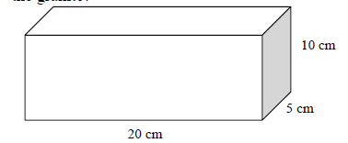
8. A graduated cylinder has a mass of 50 g when empty. When 30 ml of water is added, the graduated cylinder has a mass of 120g. If a rock is added to the graduated cylinder, the water level rises to 75 ml and the total mass is now250g. What is the density of the rock?

9. A student performs an experiment with three unknown fluids and obtains the following measurements:
Fluid A: Mass = 2060 g, Volume = 2000ml
Fluid B: Mass = 672g , Volume = 850 ml
Fluid C: Mass = 990g, Volume = 1100ml

Draw how the fluids would be layered if they
were combined in a beaker.

11. Use your density skills to find the identity of the following mystery objects:
