Sci 8 Immune System Study Guide
- Describe the four ways germs are spread. Give an example of each. What is considered risky behavior?

- Describe the body’s first line of defense. Give some examples and how they would work.
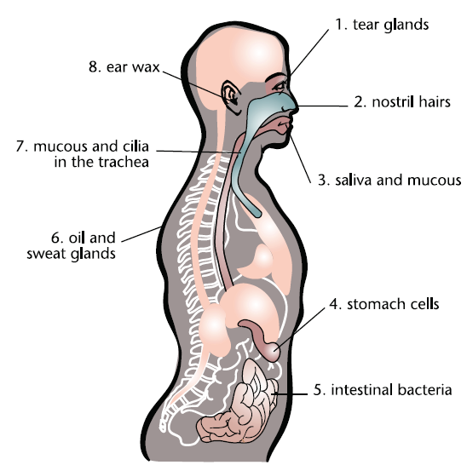

- What is inflammation?

- Why do our tissues swell?

- Why do we get fever?

- Compare Innate vs Acquired Immune Response in terms of response time, specificity (specific or general), whether you are born with it or get it later in life, after an infection, and what cells are involved.

- What’s the definition of Antibody, Antigen, Pathogen.

- Know the brief function of each cell type in the 3rd line of defense.

- What is traditional knowledge?

- Be able to compare antibiotics and vaccines in terms of how they work (or why we take them), when we take them, and what sort of pathogen do they work against.

- Be able to distinguish between endemic, epidemic or pandemic.

- Be able to identify social vs economic impacts of outbreaks.

