PHET Simulation Name: ______________
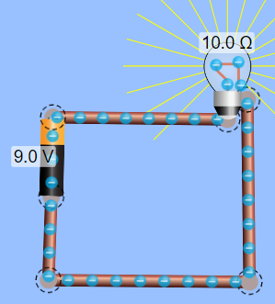
Purpose: To demonstrate the relationship between Voltage, Current, and Resistance in Ohm;s Law.
Procedure: Google: Circuit Construction Kit DC. Select Lab.
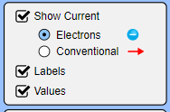
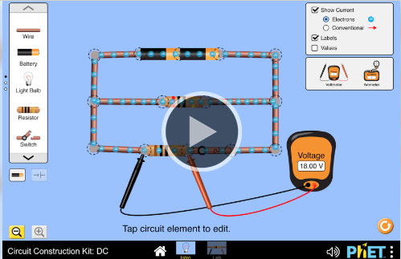
On menu at top right, check the boxes:
Show Current (electrons), Labels, Values.

Drag components of a circuit from left side bar until you can light up a light bulb. Join components together by joining the circuits. Light bulbs have 2 circles, both must be connected. Make a circuit so the electrons are flowing. You can disconnect components by clicking on the circles then the scissors icon. Play around until you are able to check off the following:
- I can build a complete circuit that makes electrons flow
- I can disconnect wires (use the scissors)
- I can change the resistance of a resistor or bulb
- I can change the voltage of a battery
- I can use the voltmeter to measure the voltage of the battery
- I can use the non-contact ammeter to measure the current anywhere
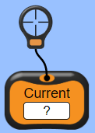
SERIES CIRCUITS
- Construct a circuit with one cell, one light bulb in series. Drag the ammeter to measure current at various spots: ______________
- Add 2nd bulb. Measure current in various spots. _______________
- What happened to bulb brightness? ________________________________________
- Add 3rd bulb. Measure current in various spots. ____________________________
- How does the current compare to when you had one bulb? _______________________
Summary
In series, the current (stays same/decreases/increases) ______________ across each component.
When adding more in series, bulb brightness will (increases/ decreases/stays the same) ___________________
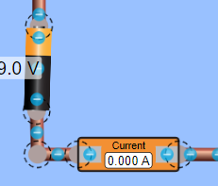
Voltage
- Construct a circuit with one 9V cell, wires, 1 bulb, the and in line ammeter. Place the inline ammeter near the battery. This measures total current: _____
- Use the voltmeter to measure voltage by placing each electrode on either side of a component. Voltage across bulb: ___________
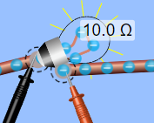
- Add another bulb in series. Voltage across 1st bulb:_________, 2nd bulb: ______
- Add a 3rd bulb: voltage across 1st bulb:_________, 2nd bulb: ______, 3rd ____
- What happens to the brightness of the bulb? ____________
- How does voltage across each component in series compare to total supply of voltage? _________________________________________________________
- Add a second cell in series. What happens to total current? _______________________
- What happens to the other bulbs when you cut one bulb out but don’t reconnect the circuit? ___________________________________. Does it matter which bulb is disconnected? ________________________________
SUMMARY of SERIES CIRCUITS:
- the total voltage is (same/shared) _____________ between components.
- The sum of the voltages across components in series is (greater/less/ equal) _________________to the total voltage supplied.
- If total voltage increases, total current (increases/decreases/stays same) ________________
- If voltage is increased in series bulbs become (brighter/dimmer) ____________
- If one bulb breaks, the others will (go out/ continue to work) ________________

Circuit Diagram:
- In the space below, draw a circuit diagram using appropriate symbols of one 9v cell and 3 lamps in series.
- Beside each lamp, write both the voltage across AND the current through each one.
- Total Voltage: ________ V Total Current: ________ A

PARALLEL CIRCUITS
CURRENT IN PARALLEL
- Construct a circuit with one cell, and two bulbs in parallel. Use the inline ammeter and place it near the cell. Leave it there. This will measure total current: ________________
- Measure current after each bulb: ________, _______. How does this compare to total current? __________________________________________________
- Add a 3rd bulb. Total Current (before the branches) : _______________. After each bulb: ________, _________, __________.
- Disconnect one bulb. What happens to the others? ____________________________
VOLTAGE IN PARALLEL
Use the same circuit as before: one cell, and three bulbs in parallel.
  - Measure voltage around cell: _____________
  - Voltage around 1st bulb: _________, 2nd bulb: ________, 3rd bulb: _______

SUMMARY OF PARALLEL CIRCUITS
- When components are added in parallel the current (splits up, stays the same) ________________.
- Current through each component (add up/ be equal) ________________ to total current.

I_{T} = I₁ + I₂ + I₃ +….

- All resistors (bulbs) experience (the same/greater/less) voltage drop or potential difference.
- The voltage across each component will (add up to /stay same as) ________________ the total voltage supplied:

V_{T} = V₁ = V₂ = V₃ =V_{n}
- If one bulb breaks, the others will (go out/ continue to work) ________________

Circuit Diagram: In the space below, draw a circuit diagram using appropriate symbols of one 9v cell and 3 lamps in parallel. Beside each lamp, write both the voltage across AND the current through each one. Total Voltage: ________ V Total Current: ________ A

Make your own summary about how current and voltage behave in both series and parallel:
Series | Parallel
Current

Voltage

Resistance

Why do bulbs dim in series?
Bulbs dim for two reasons: The current going through them is smaller because two bulbs in series have a higher resistance than a single bulb. Each charge only gives up some of its energy in each bulb, i.e. the potential difference across each bulb is smaller.
In a series circuit, adding more resistors increases total resistance and thus lowers current.
Why does total current go up in parallel?
Adding more parallel resistances to the paths causes the total resistance in the circuit to decrease. As you add more and more branches to the circuit the total current will increase because Ohm's Law states that the lower the resistance, the higher the current.
Ohm’s Law: V = I x R

