Circuits in Series and Parallel PHET Simulation

In this activity, you will be working with a simulation from the Phet Website to connect resistors in series and parallel arrangements in a circuit to see what happens to current and voltage in the circuit.
- Google: PHET & click on first link
- Click ‘Play with simulations’ and then click ‘Physics’
- Scroll down and click on ‘Circuit Construction Kit: DC’
- Click on ‘►’ and choose ‘Lab’

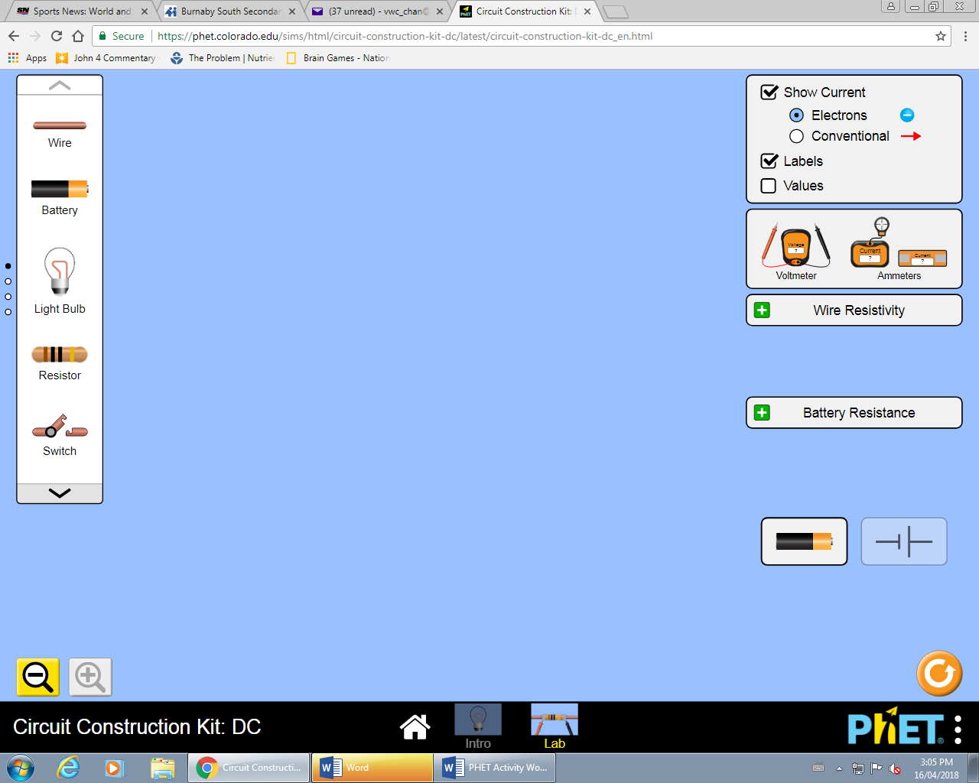
Objective
To determine the effect on the voltage and current in a series and parallel circuit.

Description
The simulation consists of creating a circuit board (see Fig. 1).
Using the different electrical components found along the side, you will be asked to construct a variety of circuits to see the effects of adding lamps (aka. resistors or loads) in series or in parallel on the circuit. Figure 1

General Instructions
For each circuit that you build, record the voltage and current readings in the data table.
- To connect the different parts of the circuit, make sure the dotted circles overlap.

- To disconnect, place the mouse over the dotted circle connection, click and then click the scissors icon.

- Check off the ‘Values’ button to see the voltage on the battery

Part I – Lamps in Series
- Trial #1: Build a series circuit with one cell, one lamp, an ammeter placed right beside the battery and voltmeter whose connections are on the junctions of the lamp (aka…the dotted circles).

Screen Diagram Schematic Diagram

Battery Voltage (V) | V
Voltage of Lamp (V) | V
Measured Current (I) | A

- Look at your results in Trial #1 between the battery voltage and the voltage of the lamp. What do you notice about the values? Why do you think this occurs?

- Trial #2: To the circuit you built in trial #1, add a second lamp directly beside the first lamp (aka in series). Arrange the voltmeter to measure the voltage of the light bulb

Screen Diagram Schematic Diagram

Battery Voltage | V
Voltage of Lamp 1 (V) | V
Measured Current (I) | A

- Rearrange the circuit so that wires of the voltmeter are measuring the voltage of the second lamp (called Lamp 2). Record your results. Repeat for the second lamp
  - Voltage of Lamp 2 :
- Use the other ammeter (see picture) and place it on the wire between the two lightbulbs. Record the reading of this ‘Non-Contact Ammeter’ in the space below.
  - Non-Contact Ammeter Reading:

Questions
- In Trial #2, when you added a second lamp, what happened to the voltage of each lamp? Why do you think this occurs?

- Look at your results for Trial #2 between the ammeter in the circuit and the ‘non-contact ammeter’. What pattern do you see for series circuits? Why do you think this occurs?

Lamps in Parallel
- Trial #3: Rebuild the same circuit that you used in trial #1. But this add another lamp in parallel to the circuit. The current should split up as it goes through the lamp, such as a stream of water divides at a junction in a river. Place the ammeter right beside the battery (either side) to measure the total current in the circuit.

Screen Diagram Schematic Diagram

Battery Voltage (V) | V
Measured Current (I) | A

- Place the voltmeter in the circles of the first lamp and record your results. Repeat for the second lamp
  - Voltage (Lamp 1) :
  - Voltage (Lamp 2) :

- Place the ‘Non-Contact Ammeter’ on the wire beside the first lamp and record your results. Repeat for the second lamp
  - Current (Lamp 1):
  - Current (Lamp 2):

- For Trial #3, look at your results between the voltage of the battery and the voltage of each lamp. What general relationship do you see for parallel circuits? Why do you think this occurs?

- Look at your results between the total current through the entire circuit and the measured current of each lamp (Rounded to the nearest whole number). What general pattern (if any) do you see for parallel circuits? Why do you think this occurs?

Connecting it all Together
Look at the measured current for a series and parallel circuit (Trial #2 vs. Trial #3) in this activity. What did you notice about the current in the circuit when you added more lamps in series? How about more lamps in Parallel? Why do you think occurs?
Lamp in series:
Why?
Lamps in Parallel:
Why?

Challenge
Set up the circuit as shown below and using the equipment from before, determine what the values would be at each location:
A B C D
Battery Voltage:
Voltage A:
Voltage D:

Total Current:
Current B:
Current C:
Current E:
Current F:

F E

- Compare the voltage at point D vs the voltage at point A. What did you notice about the voltage between the two points (did the voltage double?? Was it half??) Why do you think this occurred?

- Compare the current at point C vs the current at point E. What did you notice about the current (Was the current double?? Half??) Why do you think this occurred?

- Looking at your results for the current (Total current vs. C, E, & F), what general rule can you state about calculating the total current of a parallel circuit.

