Circuits in Series and Parallel PHET Simulation

Purpose: Build virtual circuits in series and parallel to see what happens to current and voltage and light bulb brightness.
Go to: https://phet.colorado.edu/sims/html/circuit-construction-kit-dc/latest/circuit-construction-kit-dc_en.html

Or
- Google: PHET simulations
- Click on ‘Circuit Construction Kit: DC’
- Click on ‘►’ and choose ‘Lab’

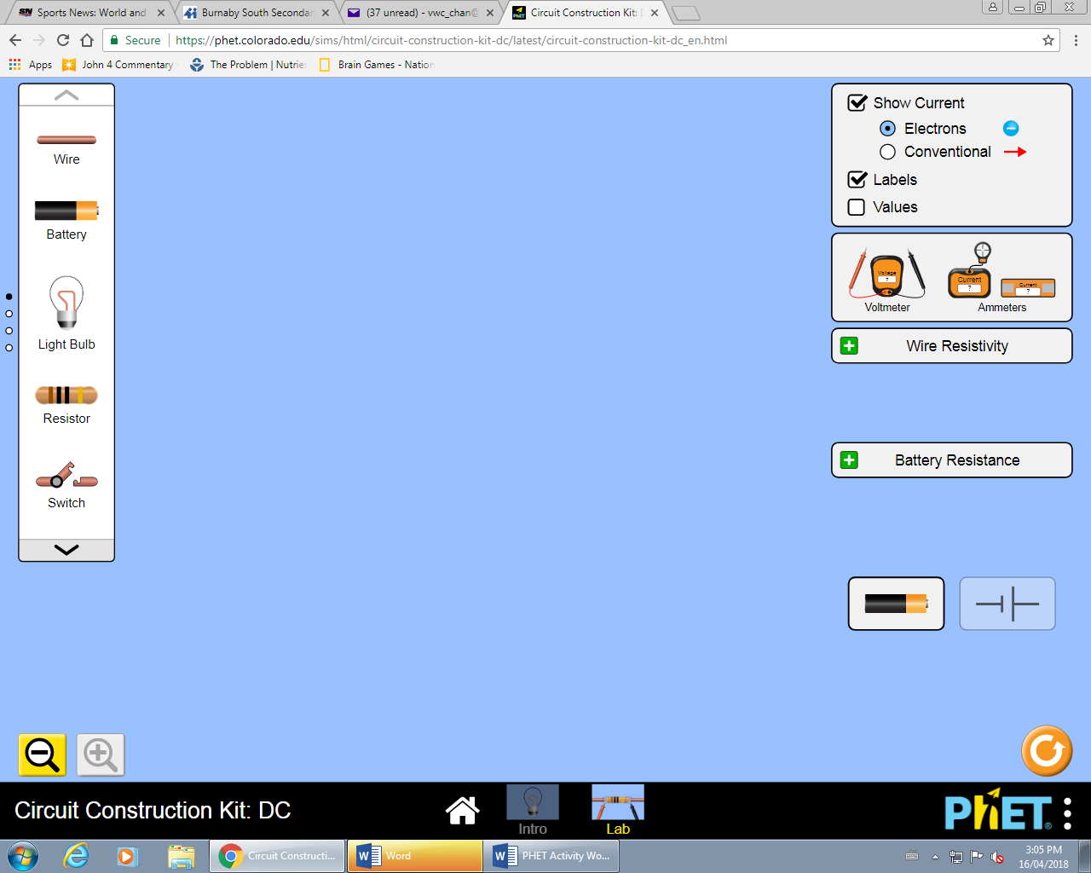
You should see this the image on the right. You will use the electrical components found along the sides, to construct a variety of circuits. Figure 1

How to start:
- Drag some wires onto the screen.
- Connect the different parts of the circuit by overlapping the dotted circles. Circle will turn black when connected.
- Disconnect components by clicking on the dotted circle then click the scissors icon.

- Check off the ‘Values’ button to see the voltage on the battery

Part I –Lamps in Series
- Trial #1: Build a series circuit with one 9V cell, one lamp, an ammeter placed right beside the battery and voltmeter whose connectionsare on the junctions of the lamp (aka…the dotted circles). Draw a circuit diagram of your set up below:

Screen Diagram Schematic Diagram

Battery Voltage (V) | V
Voltage of Lamp (V) | V
Measured Current (I) | A

- Complete the chart:

- How does the voltage of the lamp compare to the total voltage of the cell?

Add a second lamp to this circuit directly beside the first lamp (in series). Arrange the voltmeter to measure the voltage of the first light bulb. Draw the circuit diagram:

Screen Diagram Schematic Diagram

- Complete the chart

Battery Voltage | V
Voltage of Lamp 1 (V) | V
Measured Current (I) | A

- What happens to the voltage of the Lamp 1 after adding a second lamp? ______________
Rearrange the circuit so that wires of the voltmeter are measuring the voltage of the second lamp (called Lamp 2).
- What is the voltage of Lamp 2? ______________
- How does the voltage of Lamp 2 compare to Lamp 1? _____________________________
- How does the combined voltage of both lamps compare to the total voltage (of the cell). You can always put the ends of the voltmeter around the battery. ____________________________.
- Use the other ammeter (see picture) and place it on the wire between the two lightbulbs. Try in many different spots. How does the current anywhere in the circuit compare to the total current read by the first ammeter you placed? _______________________________

- Add a third bulb after the second, also in series. Check voltage of the new bulb. How does it compare to the others? __________________.

- Add up the voltage across each bulb. How does it compare to the total voltage across the cell? ___________________________________

- If you were to add another bulb, would the voltage increase, decrease or stay the same? __________________

- What happens to the brightness of the bulb when you add more in series? If you are not sure, go ahead and add a bunch. ___________________________________________________

- What generalization about VOLTAGE IN SERIES can you come up with when adding bulbs in series? _______________________________________________________________________.

- Check the current in various places throughout the circuit. What generalization about CURRENT IN SERIES can you come up with? _____________________________________ __________________________________________________________________________

- What happens to bulb one if you disconnect the last one? ____________________________

- Does it matter which bulb is disconnected? ________________________________________

Lamps in Parallel
- Rearrange your circuit using same cell and ammeter but this time the wire from the cell branches before reaching first bulb so the 2 lamps are in parallel. This will split the current, like a stream of water divides at a junction in a river. Place the ammeter right beside the battery (either side) to measure the total current in the circuit.

Screen Diagram Schematic Diagram

- Complete the chart:

(Total) Battery Voltage (V) | V
(Total) Measured Current (I) | A

- Place the voltmeter in the circles of the first lamp and record your results. Repeat for the second lamp
  - Voltage (Lamp 1) :
  - Voltage (Lamp 2) :

- How do the voltages of each lamp compare to the total voltage? ____________________
- What do you think the voltage would be if you added a third bulb in parallel? __________
- What generalization about VOLTAGE IN PARALLEL can you come up with? _______ ____________________________________.

- Place the ‘Non-Contact Ammeter’ on the wire after the cell. Then After Lamp 1, Then Lamp 2:
  - Total Current: _____________
  - Current at Lamp 1:
  - Current at Lamp 2:

- How does the current at each lamp compare to the total current? _____________________
- Predict what you think the current would be at a third lamp if placed in parallel. __________
- What happens to lamp 1 if you disconnect lamp 2? ________________________________
- Does it matter which lamp is disconnected? _____________________________________
- What happens to the brightness of the bulb if you add more in parallel? _________________
- What general pattern do you see about CURRENT IN PARALLEL? ____________________ Why do you think this occurs?

Connecting it all Together
Look at your recorded values for both series and parallel circuits.
- What did you notice about the current in the circuit when you added more lamps in series?
Lamp in series:
Why? _____________________________________________________________________
- How about more lamps in Parallel? Why do you think occurs?
Lamps in Parallel:
Why?

Challenge (Optional)
Set up the circuit as shown below and using the equipment from before, determine what the values would be at each location:
A B C D
Battery Voltage:
Voltage A:
Voltage D:

Total Current:
Current B:
Current C:
Current E:
Current F:

F E

- Compare the voltage at point D vs the voltage at point A. What did you notice about the voltage between the two points(did the voltage double?? Was it half??) Why do you think this occurred?

- Compare the current at point C vs the current at point E. What did you notice about the current (Was the current double?? Half??) Why do you think this occurred?

- Looking at your results for the current (Total current vs. C, E, & F), what general rule can you state about calculating the total current of a parallel circuit.

