Sci 8 Measuring Matter Study Guide

- Draw the following:
- Beaker c) graduated cylinder

- Test tube d) Flask

- Write the definitions for
- Mass
- Volume
- Density
- Write the units for
- Mass
- Volume
- Density

- List the equipment used to measure:
- Mass
- Volume
- How would you measure:
- mass of solid object like a wood block
- mass of 10 ml liquid
- volume of rectangular block
- volume of a rock
- Convert:

23 kg = _____________g
103 g = ____________kg
1.2 L = ___________ ml
- l = ___________L

- Think of the lab when you measured out different amounts of water:
- How is density affected when mass is increased?

- How is density affected when volume is increased?

- Knowing what you know about KMT and Thermal Expansion, describe how temperature can affect the density of a substance.

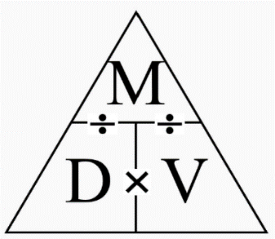
- Be able to manipulate the Density triangle to calculate Mass or Volume or Density from word problems. For each questions you should write the formula and show your work. Try questions from Density worksheet or some of these. For each one you should write the formula and put the variables in the correct spot.

- A block of aluminum occupies a volume of 15.0 mL and weighs 40.5 g. What is its density?

- Mercury metal is poured into a graduated cylinder that holds exactly 22.5 mL. The mercury used to fill the cylinder weighs 306.0 g. From this information, calculate the density of mercury.

- What is the weight of the ethanol that exactly fills a 200.0 mL container? The density of ethanol is 0.789 g/mL.

- A rectangular block of copper metal weighs 1896 g. The dimensions of the block are 8.4 cm by 5.5 cm by 4.6 cm. From this data, what is the density of copper?

- A stone is put in a graduated cylinder of 50 mL of water. The volume rises to 70 mL. If the stone has a density of 2g/cm³, what is its mass?

