LS 11 Cell Cycle Worksheet (Chapter 8)
Use your notes, textbook p166-170) and the diagram below to complete the chart and answer the questions.
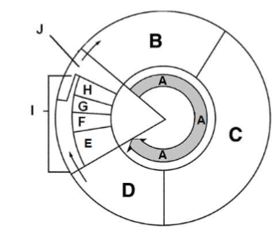

Area | Phase | What’s happening
A | Interphase | Growth and replication of DNA
B | G1 | Growth (G1 checkpoint – cell size, growth, environment indicates that cell is ready to start replicating its DNA
C
D
E
F
G
I

Questions
- Label each phase and place them in order beginning with interphae:
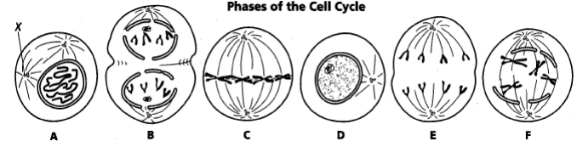

- What structure forms in prophase along which the chromosomes move?

- What are three reasons cells divide?

- Why are cells so small?

- What is the difference between chromatin and chromosomes?

- What’s the difference between a centromere and a centriole?

- Distinguish between cell division in an animal vs a plant cell.

- A student counted 180 cells under a microscope. 165 of them were in interphase. If the whole cell cycle is 24 hours, how long do mitosis and cytokinesis take?

