Sci 9 Sexual Reproduction in Plants WS Name:
- Using your text book page 88, complete the life cycle of a tomato.
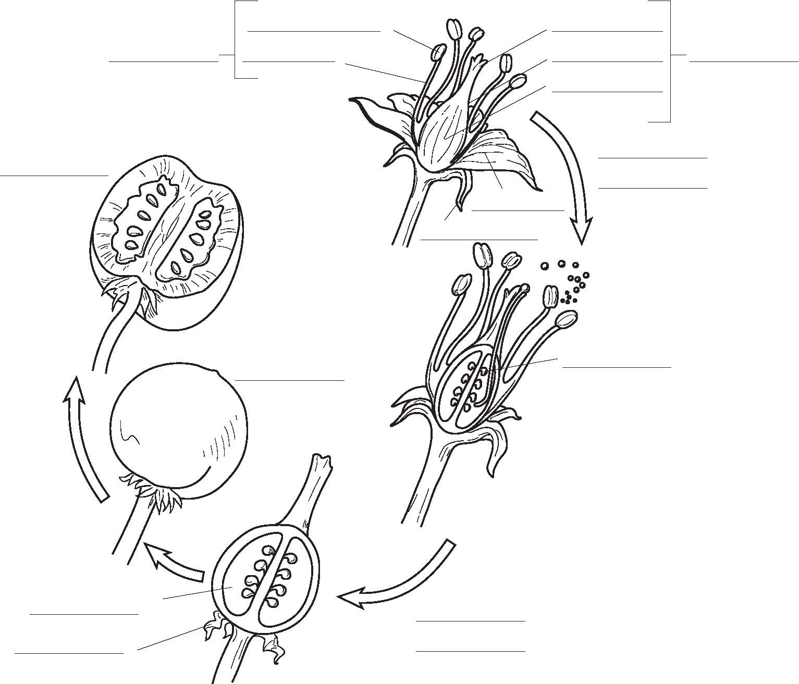
- Label the diagram of the flower and complete the chart.
Term | Definition/ Function
Stamen
Anther
Pollen
Pistil
Style
Stigma
Ovary
Sepals
Pollination
Self-Pollination
Cross-Pollination

- Why are flowers often brightly coloured?

- Name at least three different types of pollinators.

- If the petals of a flower are reduced or absent, how do you think the plant is pollinated?

- Some flowers are not brightly colored at all, but have a very pungent odor that smells like rotting meat. How do you think these flowers are pollinated?

- What part of the flower becomes the fruit?

- Why would a plant invest so much energy into making fruit?

