Meiosis Worksheet
Sketch the Phases of Meiosis – use two different coloured pencils.

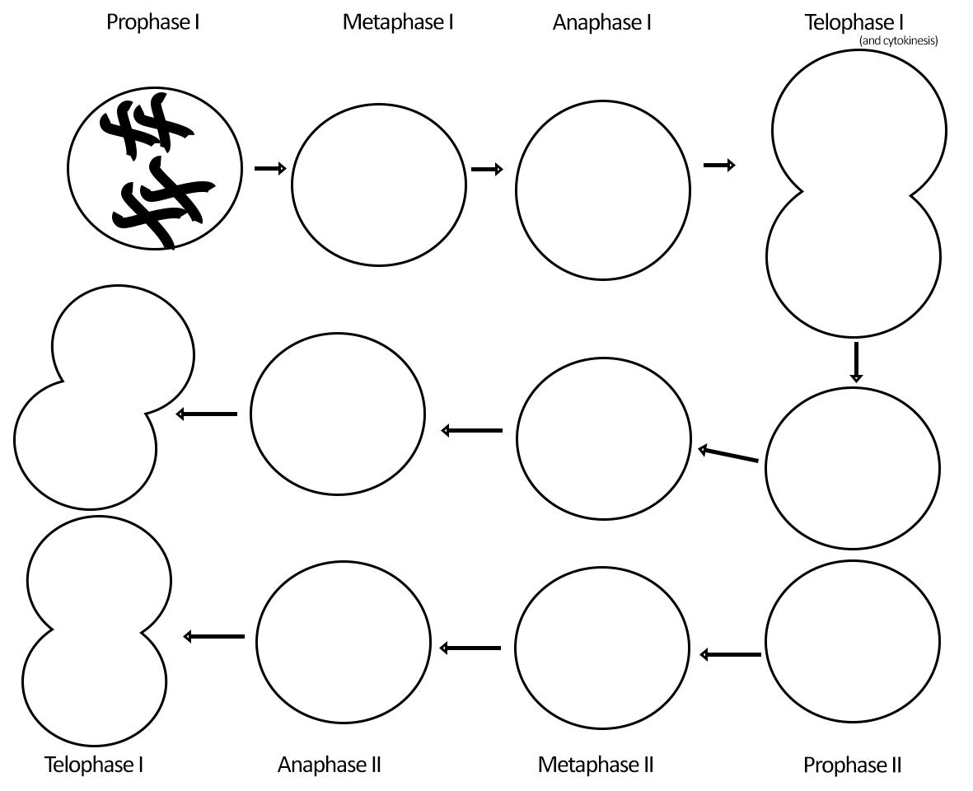

1. What is the diploid number for this cell? ______ haploid number? _____

2. How many daughter cells are produced at the end of meiosis 1? _____ meiosis 2? ______

3. During what phase do homologous chromosomes separate? _______________
During what phase do individual chromatids separate? _____________________

4. During which phase do homologous pairs line up in the center of the cell? _______________

5. During which phase does crossing-over occur between homologous pairs? ______________

6. Draw and label the parts of a tetrad: sister chromatids, homologous chromosomes, centromere:

7. The main advantage of Sexual Reproduction is that it enhances genetic diversity. Why is genetic diversity a good thing?

8. Using 3 different colours to represent three different pairs of chromosomes, draw all possible combination of chromosomes the gametes could end up with after undergoing meiosis. How many different combinations were there? Imagine the possibilities for 23 pairs.

