What about Hershey Chase?

What is DNA?
- _____________________________
- Genetic ________________
  - responsible for all our inherited ___________________ and
  - controlling the production of __________________
- Rosalind Franklin produced an x-ray photograph, allowing James Watson and Francis Crick to work out the 3D structure of DNA.
http://ed.ted.com/lessons/rosalind-franklin-dna-s-unsung-hero-claudio-l-guerra

DNA Structure
- _____________________
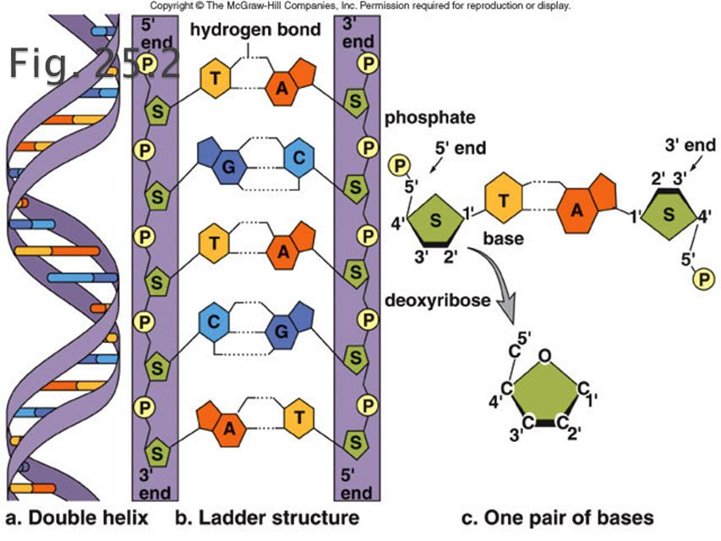
- Polymer of repeating units _____________
  - consisting of:
- ___________________
- ___________________
- ____________________, 4 kinds:
______________ (A), _____________(G), ___________ (C), and ____________ (T)
  - two types of bases: ______________and _____________________
  - purines – A, G have a double ring structure
  - pyrimidines - have a single ring structure (thymine, cytosine, uracil)
  - four different kinds of bases so there are four different kinds of nucleotides
twisted ladder:
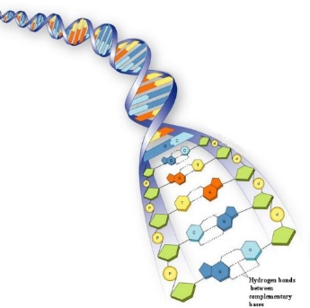
- ________________ bases, (rungs) held together by __________________
- ___________________ base pairing:
- Sequence of bases makes up our genetic code

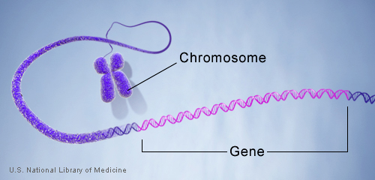
GENES are segments of DNA that code for a particular function
- basic units of _______________: determine our traits and protein production
- Humans have about ____________________.
- About 175,000 genes compose the DNA molecule of a single human chromosome.
- Genes always occur in ______________.
- ________ are forms of the same gene with small differences in their sequence of DNA bases.

Where is DNA?
- DNA is found in the _______________
- Nucleosome – basic unit of DNA packaging – segment of DNA wound around ____________ histone protein cores.
- chromatin condenses to form ________________ during ______________________.
More info: http://www.nature.com/scitable/topicpage/dna-packaging-nucleosomes-and-chromatin-310
http://www.hhmi.org/biointeractive/dna-packaging
https://www.youtube.com/watch?v=0_b80fHmuWw&list=UUsooa4yRKGN_zEE8iknghZA&index=1097
https://youtu.be/aeAL6xThfL8?list=UUsooa4yRKGN_zEE8iknghZA

How many chromosomes do people have?
- Humans have ___________________ of chromosomes (________________) for a total of 46 (________________ number).
- 22 of these pairs are ______________,
- 23rd pair, the __________________
  - Females have ____________
  - Males have ______________
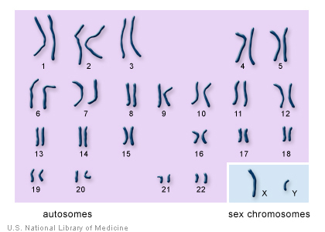

Karyotype.

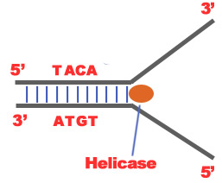
DNA REPLICATION:
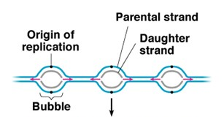
- Initiation Phase
helicase unwinds the DNA helix,
initiation point is called “origin of replication”
replication fork

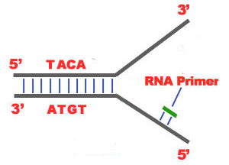
- Elongation Phase
- RNA Primase binds to initiation site
  - RNA primer (nucleotides)
  - replaced by DNA nucleotides.
- strands run anti- parallel: 5’ to 3’
- Daughter Strands: Leading Strand and Lagging strand
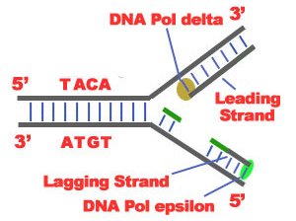
  - The 3'-5' daughter strand -that uses a 5'-3' template -leading
- DNA Polymerase
  - Adds complementary nucleotides
  - moves toward replication fork in the 5’ to 3’ direction of new strand.
- Leading strand is synthesized continuously as one long strand
- Lagging strand synthesized discontinuously: Okazaki fragments.
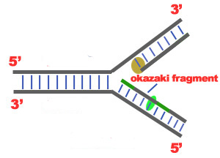
- Each Okazaki fragment begins with an RNA primer, which DNA polymerase can attach a nucleotide to.
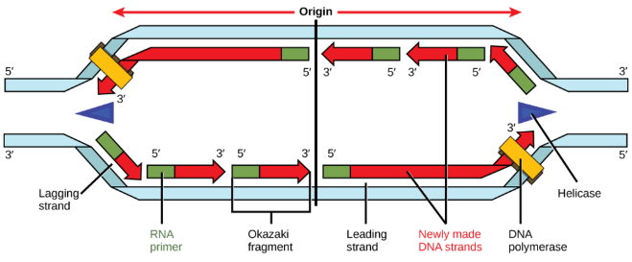
- As replication fork moves along additional RNA primers are needed to allow for synthesis of Okazaki fragments in the 5’ to 3’ direction.
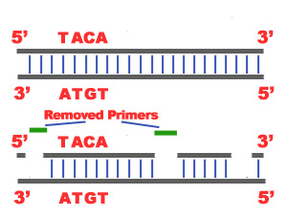
- DNA ligase links Okazaki fragments to form a completed lagging strand.

3. Termination Phase:
- termination sequence in the DNA
- two new DNA molecules
- Nucleases repair wrong nucleotides
- Semi Conservative
- Ensures ___________________
- in the last section of the lagging strand, when the RNA primer is removed, it is not possible for the DNA Polymerase to seal the gap (because there is no primer). So, the end of the parental strand where the last primer binds isn't replicated. These ends of linear (chromosomal) DNA consists of noncoding DNA that contains repeat sequences and are called telomeres. As a result, a part of the telomere is removed in every cycle of DNA Replication.
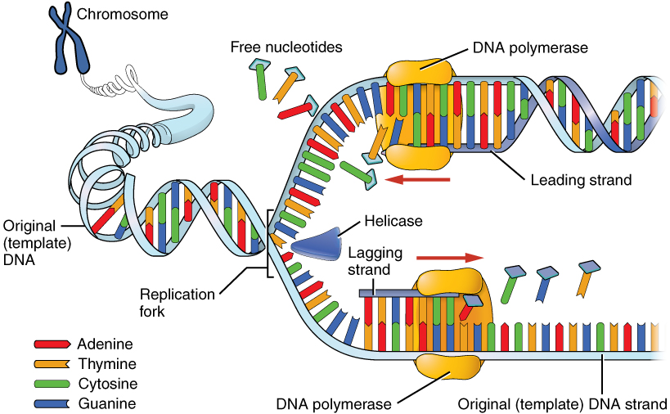
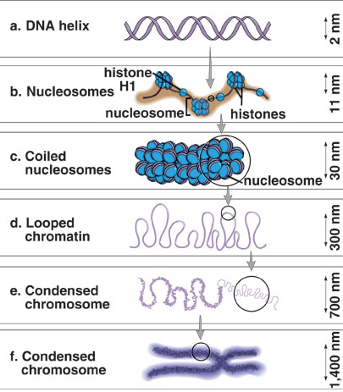

Levels of Structure of DNA pg 84

Structure https://www.youtube.com/watch?v=dKubyIRiN84
Crash Course: https://www.youtube.com/watch?v=8kK2zwjRV0M
https://www.youtube.com/watch?v=5VefaI0LrgE

interactive
http://www.wiley.com/college/boyer/0470003790/animations/replication/replication.htm
http://www.wiley.com/college/pratt/0471393878/instructor/animations/dna_replication/index.html

