**What is DNA?**

* **deoxyribonucleic acid**
* DNA is the **genetic code** that is responsible for
  + **inherited traits.**
  + production of **proteins**
* Exact copy in nearly every cell
* located in the **cell nucleus**
* In the early 1950s two scientists, Rosalind Franklin and Maurice Wilkins, studied **DNA** using x-rays. Franklin produced an x-ray photograph that allowed two other researchers, James Watson and Francis Crick to work out the 3D structure of **DNA**. The structure of **DNA** was **found** to be a double helix.

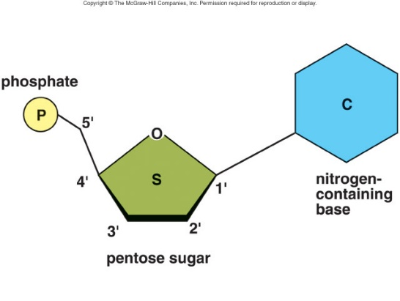**DNA Structure**

* **double helix**
* deoxynucleic acid is made up of repeating building blocks called **nucleotides** consisting of:

**Phosphate group**

**Sugar (5 C monosaccharide: deoxyribose)**

**Nitrogenous base, 4 kinds:**

adenine (A), guanine (G), cytosine (C), and thymine (T).

* + **two types of bases: purines and pyrimadines**
  + **purines** – A, G have a ***double ring structure***
  + **pyrimidines** - have a ***single ring structure*** (thymine, cytosine, uracil)
  + **four** different kinds of bases so there are **four** different kinds of nucleotides



Adenine Guanine Thyamine Cytosine



* *DNA molecule consists of* ***two strands, with crossbars***
* *Strands are twisted to form a* ***double helix*** *(****twisted ladder****).*
* 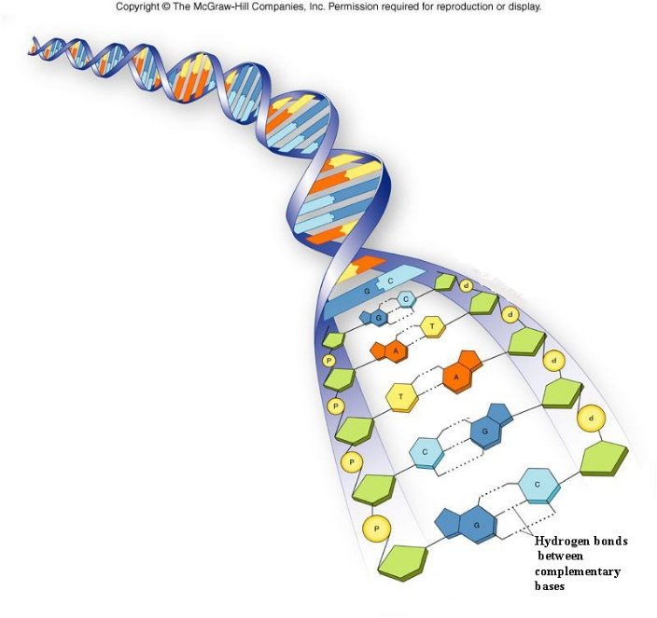**Sugar phosphate backbone**: Upright strands of DNA ladder consist of alternating phosphate groups and deoxyribose portions of the nucleotides
* Rungs of the ladder contain **paired nitrogenous** bases, held together by **H bonds**.
* **Complementary bases pairing**:
  + always a **purine** with a **pyrimidine**.
  + A binds with T
  + C binds with G
  + RNA **Uracil instead of Thymine**
* *Sequence of these bases is what makes up the genetic code.*

*DNA strands are* ***extremely long****, each one containing* ***millions*** *of atoms. Every human cell contains about one meter of these twisted strands. (about* ***4 billion pairs*** *of bases).*

*Human DNA consists of about* ***3 billion bases****, and more than 99 percent of those bases are the same in all people.*

**GENES** are segments of DNA that code for a particular function (***instructions to synthesize a particular protein celluar reactions by coding for enzymes).***

* basic units of **inheritance**: determine our traits, and protein production (enzymes)
* *consists of a sequence of about* ***1000******DNA base-pairs****.*
* Humans have about 30,000 genes.
* About **175,000** genes compose the DNA molecule of a single human chromosome.
* *Genes**control* ***Cellular chemical reactions****, by directing the formation of* ***enzymes****.*
* Genes always occur in **pairs**. Half of each person's genes come from the mother and half from the father. Most ordinary characteristics like height and eye color are determined by **combinations** of several different genes.
* Each of us has enough DNA to reach from here to the sun and back, more than 300 times.
* 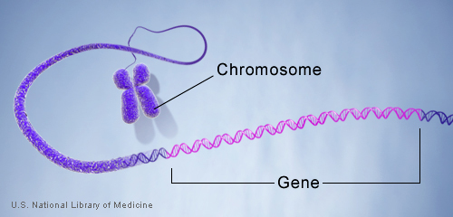**Most genes are the same in all people, but a small number of genes (less than 1 percent of the total) are slightly different between people.**
* **Alleles** are forms of the same gene with small differences in their sequence of DNA bases. **These small differences contribute to each person’s unique physical features.**

**Where is DNA?**

* DNA is found in the **nucleus**
* packaged by special proteins (**histones**) to form a complex called **chromatin*.***
* **nucleosome** is a basic unit of DNA packaging in eukaryotes, consisting of a segment of DNA wound around **eight** histone protein cores.
* Chromatin is **not visible** even with a microscope.
* **chromatin** condenses to form **chromosomes** during **cell division**.

<http://www.nature.com/scitable/topicpage/dna-packaging-nucleosomes-and-chromatin-310>

* <http://www.hhmi.org/biointeractive/dna-packaging>
* <https://www.youtube.com/watch?v=0_b80fHmuWw&list=UUsooa4yRKGN_zEE8iknghZA&index=1097>
* <https://www.youtube.com/watch?v=aeAL6xThfL8&index=1063&list=UUsooa4yRKGN_zEE8iknghZA>

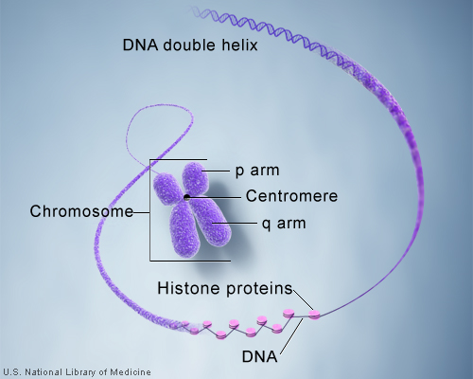**How many chromosomes do people have?**

* Humans have **23** **homologous pairs** of chromosomes (**haploid number**) for a total of 46 (**diploid** number).
* 22 of these pairs are **autosome**s,
* 23rd pair, the **sex chromosomes**
  + Females have two Xs,
  + Males have X and Y.

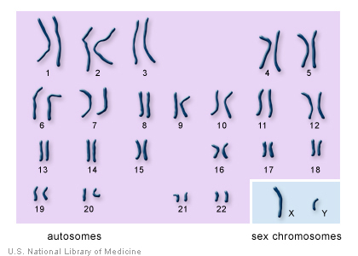

🡨 Karyotype.

**DNA REPLICATION**

* *Each new cell created has the same copy of DNA as its parent. Before a cell can divide, all of the DNA must be* ***duplicated****.*
* **DNA replication** is the process of producing **two identical replicas** of **DNA** from one original **DNA** molecule.

**DNA REPLICATION:**

1. **Initiation Phase**

* 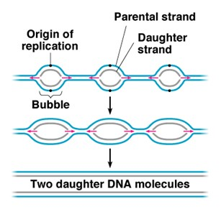Initiator proteins bind to DNA at the **origin of** **replication** while **helicase** unwinds the DNA helix,
  + Replication bubble forms where the strands have separated,
  + **Replication fork** at each end of the replication bubble.

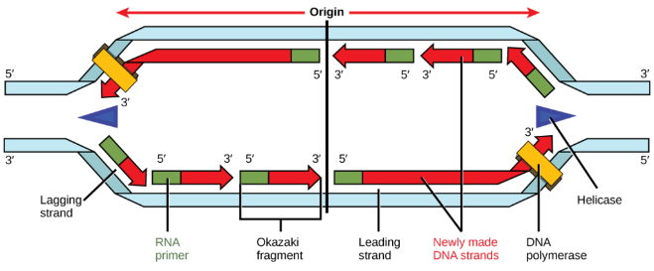

1. **Elongation Phase**

* a primer sequence is added with complementary RNA nucleotides, which are then replaced by DNA nucleotides.
* DNA Polymerases III moves toward replication fork in the 5’ to 3’ direction of new strand.
* Leading strand is synthesized continuously as one long strand
* Lagging strand synthesized discontinuously in small segments called Okazaki fragments.
* 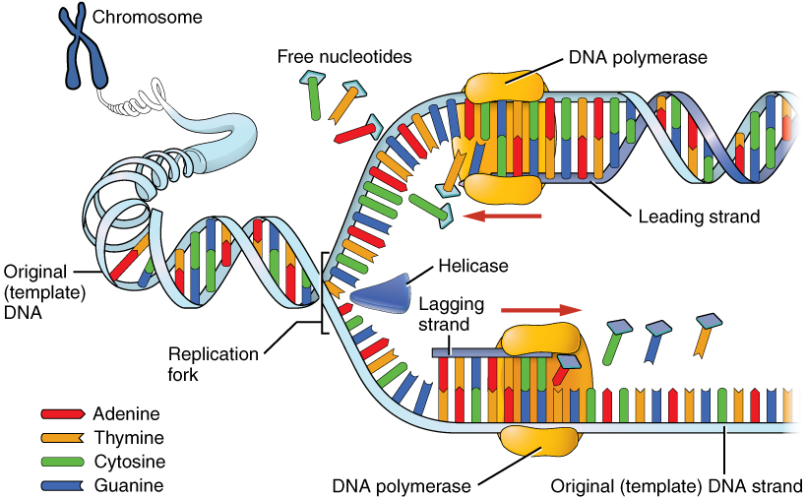Each Okazaki fragment begins with an RNA primer, which DNA polymerase III can attach a nucleotide to.
* As replication fork moves along additional RNA primers are needed to allow for synthesis of Okazaki fragments in the 5’ to 3’ direction.
* DNA polymerase I removes the primers and fills in the gaps between Okazaki fragments.
* DNA ligase links Okazaki fragments to form a completed lagging strand.

**3. Termination Phase**:

* termination sequence in the DNA
* two new DNA molecules (each composed of one original and one newly syth strand) wind into a double helix
* Replication machine comes apart.

Semi Conservative

<https://www.youtube.com/watch?v=8kK2zwjRV0M> Crash course

<https://www.youtube.com/watch?v=dKubyIRiN84>

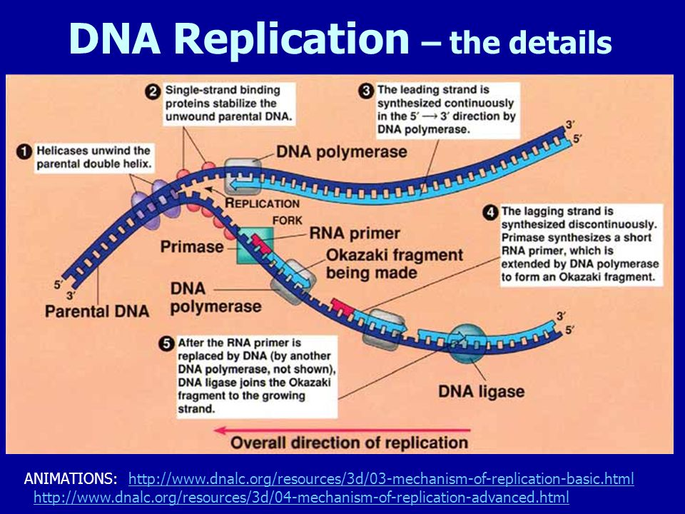

* **Ensures ________________________**
* But Changes in DNA can occur in cell division:

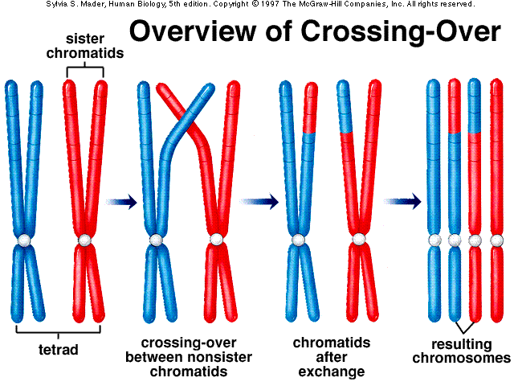

Chromosomes are also capable of exchanging genetic information with one another. This process, diagramed on the left, is known as **“Crossing Over.”** Crossing over helps to contribute to genetic diversity in sexual reproduction.

<https://www.youtube.com/watch?v=5VefaI0LrgE>

interactive <http://www.wiley.com/college/boyer/0470003790/animations/replication/replication.htm>

<http://www.wiley.com/college/pratt/0471393878/instructor/animations/dna_replication/index.html>

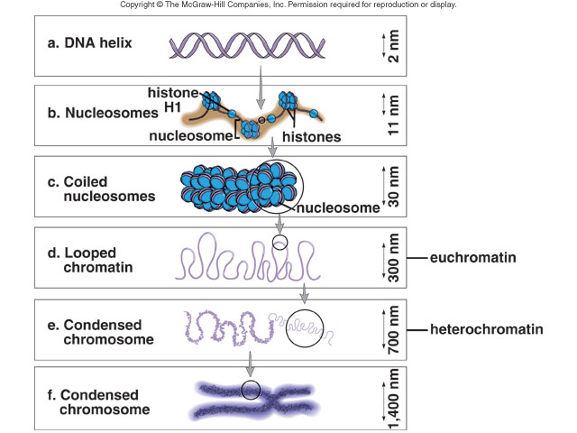Levels of Structure of DNA pg 84