Microorganisms and their Relationship with Living things
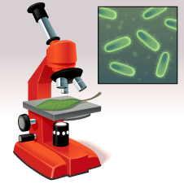
What are Microbes?
Microorganisms are very tiny living things. They are so small that you need a microscope to see them. Another name for a microorganism is a microbe. Eg: probiotic bacteria, yeast, paramecium in pond water.
Where can microbes be found?
Microorganisms are all around us:
- in the air,
- in water
- In soil
- in our bodies
There are three types of microorganisms:
- Bacteria
- Fungi
- Viruses
Ways that Microbes are Important to Living things:
- They play a key role in nutrient cycling in the environment
- They are used to help make food and beverages
- They are an important part of our digestive system
- They are used in Biotechnology: eg Genetic Engineering, bioremediation
- They can be used in medicine to make antibiotics
- They can be Pathogenic – cause disease

Seven wonders of microbes video:
https://www.youtube.com/watch?v=XuZQUEFD52I

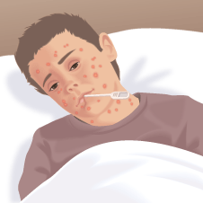
Harmful microorganisms

Microorganisms that cause diseases are often called germs.
Some diseases, like chickenpox, are caused by viruses. Diseases caused by viruses usually spread easily from one person to another.
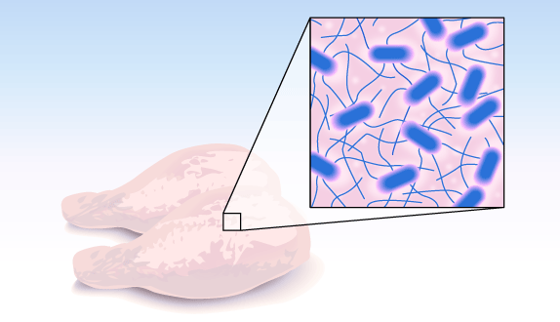
Uncooked foods (especially meat) can contain bacteria. The bacteria are killed when the food is cooked properly. But if you eat food that has not been cooked properly, the bacteria may survive and make you feel very ill.
Bacteria left in your mouth by not brushing your teeth properly can cause a tooth infection. Bacteria left in your mouth could also cause an infection in your ear.

Mould is a type of microorganism that grows on decaying food. It can make you ill if you eat it.

Helpful microorganisms
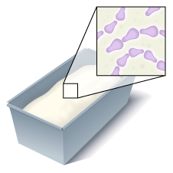
Here are some examples of useful microorganisms.
- When bread is made, a microorganisms called yeast is added to the dough to make the bread rise.

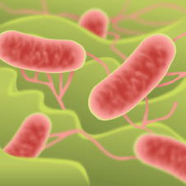
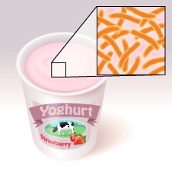
- Yoghurt is made by boiling milk and adding special bacteria to it. The bacteria turn the sugar in the milk into acid. The acid makes the milk go thick and stops any harmful bacteria growing.
- Inside a pile of dead leaves are millions of tiny bacteria. These bacteria feed on the leaves and break them down into nutrients. The nutrients go back into the soil where they can be used by plants.

- What is foodborne illness? (A disease transmitted to humans by food.)
- What sorts of foods are "hotbeds" for foodborne pathogens? Why? (Moist, high-protein and/or low acid foods; these foods can support rapid growth of infectious or disease-causing microorganisms.)
- Who is at highest risk for foodborne illnesses? Why? (Elderly people, infants, unborn fetuses, and people with weakened immune systems may not have strong enough body systems to ward off foodborne illness.)
- How do foods become contaminated?(Chemically, such as by cleaning supplies getting into food; physically, such as by pieces of glass getting into food; and biologically, for example microorganisms growing in food.)
Continue the discussion of microorganisms by asking how microorganisms could cause contamination. Have students come up with cross-contamination scenarios; e.g., making meatballs with raw hamburger then touching lettuce for a fresh salad with unwashed hands. Follow this with more of the guiding questions:
- What are the four main types of microorganisms? (They are viruses, parasites, fungi, and bacteria.)
- What type of microorganism is the greatest threat to food safety? (Bacteria.)
- Name some foods that "good" bacteria are used to make. (Cheeses, buttermilk, sauerkraut, pickles, yogurt.)
- Under what conditions do bacteria thrive?(Warm, moist, protein-rich environments. Ask students to discuss scenarios that would create environments for bacteria to grow; e.g., milk left out on a counter [the milk is protein-rich and would get warm].)
- What is the most important thing you can do to prevent foodborne illness? (Practice good personal hygiene, including washing your hands.)
n addition, you could have students make flyers that promote the prevention of foodborne illness. The flyers should be creative yet based on the science learned in the lesson. Students could choose to address one of the following three topics, as they're related to foodborne illness:
Temperature
Students should demonstrate an understanding that storing food at proper temperatures can prevent spoilage. One example of a flyer would be one titled "Refrigerate Food"; the flyer would explain that because bacteria like to grow in warm, moist conditions, foods should be stored in cool temperatures to prevent the growth of bacteria (particularly high-protein foods like milk and eggs).
Personal hygiene
Students should demonstrate an understanding of the importance of hand washing. They should explain why hand washing is important in the prevention of foodborne illness, as well as give examples of what can happen when this is not done.
Cross-contamination
Students should demonstrate an understanding of cross-contamination and give examples of how this can happen (e.g., when hands touch raw meat that has bacteria on it, and then touch other foods, like salad that will not be cooked).

Biotechnology is the use of living systems and organisms to develop or make products, or "any technological application that uses biological systems, living organisms or derivatives thereof, to make or modify products or processes for specific use" (UN Convention on Biological Diversity, Art. 2).^{[1]} Depending on the tools and applications, it often overlaps with the (related) fields of bioengineering, biomedical engineering, biomanufacturing, molecular engineering, etc.
Biotechnology has applications in four major industrial areas, including health care (medical), crop production and agriculture, non food (industrial) uses of crops and other products (e.g. biodegradable plastics, vegetable oil, biofuels), and environmental uses.
For example, one application of biotechnology is the directed use of organisms for the manufacture of organic products (examples include beer and milk products). Another example is using naturally present bacteria by the mining industry in bioleaching. Biotechnology is also used to recycle, treat waste, clean up sites contaminated by industrial activities (bioremediation), and also to produce biological weapons.
biopharmaceutics. Modern biotechnology can be used to manufacture existing medicines relatively easily and cheaply. The first genetically engineered products were medicines designed to treat human diseases. To cite one example, in 1978 Genentech developed synthetic humanized insulin by joining its gene with a plasmid vector inserted into the bacterium Escherichia coli. Insulin, widely used for the treatment of diabetes, was previously extracted from the pancreas of abattoir animals (cattle and/or pigs). The resulting genetically engineered bacterium enabled the production of vast quantities of synthetic human insulin at relatively low cost

Diff between GE and GM crops- no threat to health
Industrial biotechnology (known mainly in Europe as white biotechnology) is the application of biotechnology for industrial purposes, including industrial fermentation. It includes the practice of using cells such as micro-organisms, or components of cells like enzymes, to generate industrially useful products in sectors such as chemicals, food and feed, detergents, paper and pulp, textiles and biofuels.^{[63]} In doing so, biotechnology uses renewable raw materials and may contribute to lowering greenhouse gas emissions and moving away from a petrochemical-based economy.^{[6}
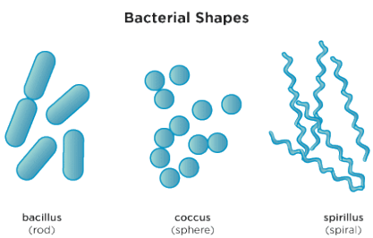
The environment can be affected by biotechnologies, both positively and adversely. Vallero and others have argued that the difference between beneficial biotechnology (e.g. bioremediation to clean up an oil spill or hazard chemical leak) versus the adverse effects stemming from biotechnological enterprises (e.g. flow of genetic material from transgenic organisms into wild strains) can be seen as applications and implications, respectively.^{[65]} Cleaning up environmental wastes is an example of an application of environmental biotechnology; whereas loss of biodiversity or loss of containment of a harmful microbe are examples of environmental implications of biotechnology.

Bacteria:
Tiny, single-celled organisms.
Simplest form of life.
Occur in 3 main shapes:

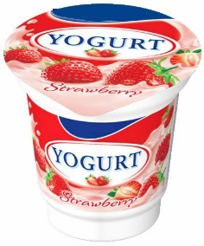
Examples of bacteria:
- Lactobacillus acidophilus found in yogurt.
- Staphylococcus aureus found on our skin.
- Escherichia coli found in our gut to aid in digestion.
- Staphlyococcuspneumoniae which causes pneumonia.
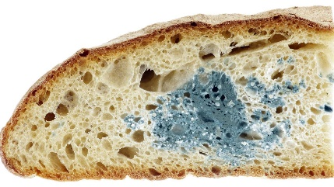
- Clostridium botulinum which can contaminate canned goods and cause botulism.
Fungi
- Yeasts – unicellular, baker's yeast,
- Molds – multicellular, fuzzy growths
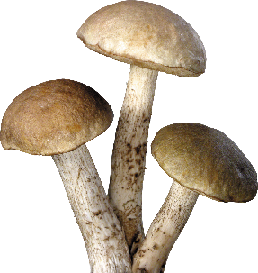
  - Harmful and beneficial (mold was used to produce the antibiotic penicillin, cheese)
  - old bread, and decaying fruit.
  - Mildew is a mold growth that is visible on plants, walls, leather, paper, cloths, and damp areas.
- Mushrooms – multicellular, some edible, others poisonous

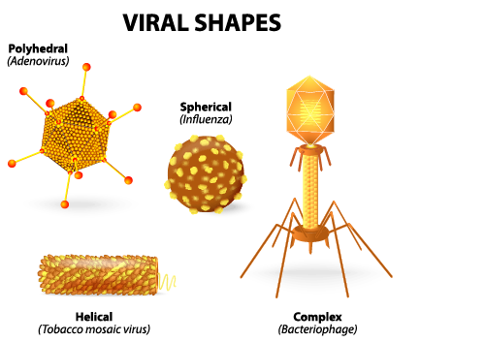
Viruses
- Measles
- flu
- common cold
- Most biologists consider viruses to be microbes, even though according to many definitions, viruses are not true “living” organisms:
  - they contain no cells,
  - they do not eat,
  - they do not perform many of the functions that living things perform,
  - They do not have the ability to reproduce on their own – need host
  - Viruses are basically infectious agents that have the ability to take over cells' functions
In order to reproduce, a virus must be exposed to a host cell. Once a virus is introduced to the body, they inject their DNA into a host cell. This injection causes the host cell to abandon its previous function and perform the same functions of the virus. When you have a virus, you usually show some type of symptoms, e.g. coughing and a runny nose. Symptoms are a result of cells being taken over by the virus. Once a virus begins to take over cellular activity, it is very hard to stop. Examples (good and bad)

