Sci8 Name:

Topic 1.1 | Is it Alive? | BLM 1.1-5

1. Complete the table by answering “yes” or “no” to the characteristics for the different examples given .

Things  Characteristics | Human  (example) | Campfire | Tree | Computer | Car | Cut flowers | Icicle | Fossil
Made of cells | yes
Take in nutrients | yes
Use energy | yes
Produce waste | yes
Respond to stimuli | yes
Grow | yes
Reproduce | yes
Living (L) or Non-living (N) | L

2. You are a multicellular organism. At this moment, there are millions of unicelular bacteri in and on your body. List five things that you have in common with a bacterium.

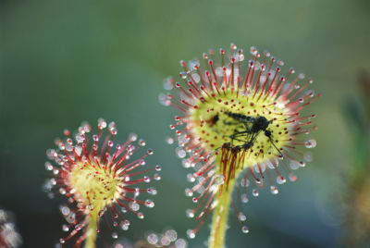
3. Sundew plants grow in northern BC. They make their own food like other plants do, but they also capture tiny insect with stickly droplets on their leaves. Nutrients from the rotting insects help the plant to grow. How would you classify a sundew: producer? Consumer? Something else? Explain your reasoning.

4. Scientists have deined several characteristics of living things. What evidence can you offer to demonstrate that you body displays the following characteristics?
a) your cells are dividing

b) you respond to stimuli

c) you use energy to carry out life processes

5. Imagine that you live in a future where robots take in nutrients, use energy, and produce waste. They also respond to stimuli. Each robot is made of artificial cells that can increase in number, allowing the robot to grow. Finally , the robots are able to reproduce by building new robots. Explain why you would or would not consider the robots to be living things.

6. Explain how sweating can be a response to either an internal stimulus or external stimulus.

