What is Cancer?
Neoplasia: new, uncontrolled cell growth

NORMAL CELL PROLIFERATION:
- during fetal, childhood, and adolescent growth
- in tissues requiring rapid cell turnover (blood cells, skin, GI epithelial cells)
- during tissue repair or regeneration
- synthesis of sperm cells

Normal Cell Division is regulated by:
- growth promoting factors
- space (contact inhibition)
- growth inhibiting factors (apoptosis regulating genes if DNA is damaged)
- limited lifespan - programmed death of aged, damaged, or excess cells

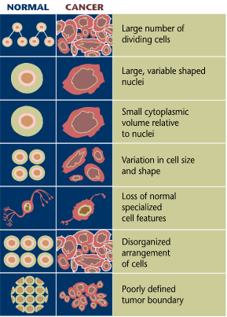
CANCER CELLS LOOK DIFFERENT THAN NORMAL CELLS:

Undifferentiated
Abnormal nuclei:
- enlarged,
- may contain abnormal number of chromosomes. Chromosomes may be mutated (duplicated/deleted, extra copies of certain genes)

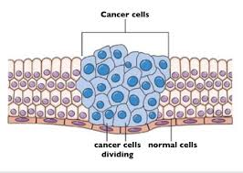

CANCER CELLS BEHAVE DIFFERENTLY THAN NORMAL CELLS:

Normal | Cancer
- require positive signals from growth factors or signalling proteins  - obey inhibitory signals, may undergo apoptosis if DNA is damaged  - Have limited life span (telomeres)  - Stay in one place  - Contact inhibition:  Adhere to neighbours,  Stop dividing  - Differentiate to perform a specific function | - Reduced need for stimulatory growth factors  - no longer respond to inhibitory growth factors  - can keep dividing (produce telomerase)  - don’t stick together very well and can spread to other parts of the body metastasis  - Lack contact inhibition - will pile on top of each other.  - do not perform any function like surrounding tissue  - Angiogenesis- release growth factors causing neighbouring vessels to branch into cancerous tissue

Tumours are classified in two ways:
- Clinical classification (features and outcome)
  - benign
  - malignant
- Histologic classification
  - named according to the tissue and cell type from which they arise

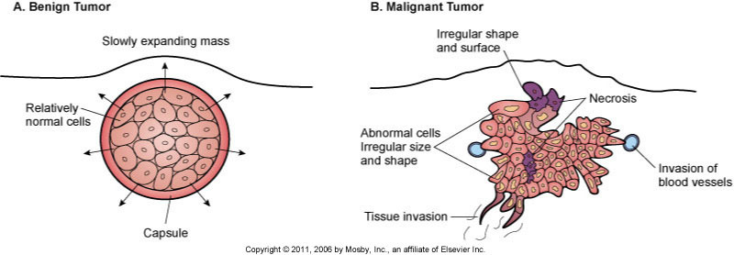

Difference between Benign and Malignant:

 | benign | malignant
Morphology  (appearance) | - encapsulated by connective tissue –defined border  - clearly separated from surrounding tissue  - cells are well-differentiated  - resemble the tissue of origin  - uniform in size and shape | - not encapsulated  - lack sharp borders  - cells are poorly differentiated (anaplasia)  - do not resemble cells of origin  - cells and nuclei are variable in size and shape
Functional | - slower growing  - stay in one place  - (do not metastasize)  - usually not life-threatening. | - Faster growing  - invade nearby tissues  - can spread to other parts of the body (metastasis).  - Potential for causing death

Naming: 5 Main Categories named for site of origin
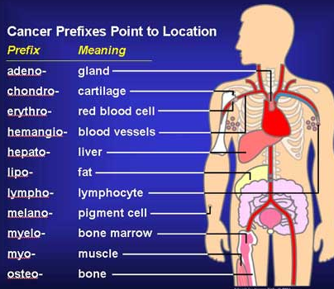
- Carcinoma – begins in tissues that line or cover internal organs.
- Adenocarcinoma - glandular structures in epithelial tissue.
- Sarcoma – begins in the connective or supportive tissues such as bone, cartilage, fat, muscle, or blood vessels
- Leukemia – starts in blood forming tissue eg. bone marrow
- Lymphoma and myeloma – begin in the cells of the immune system (lymphatic tissue)
- lung cancer that has spread to the brain is called metastatic lung cancer,
Carcinoma in situ – in place of origin- has not spread.

GENETICS OF CANCER
Cancer is Caused by Cumulative Gene Mutations:
- inherited or
- spontaneous/acquired (caused by repeated exposure mutagens):
  - errors in DNA replication (mutated genes assoc with cancer)
  - External Factors:
    - Smoking
    - Diet - high fat, low fibre diet, lacking in fruits and veg (antioxidants)
    - excessive alcohol consumption
    - Radiation – UV, X-rays,
      - leukemia in Hiroshima and Nagasaki
      - thyroid cancer after the Chernobyl nuclear disaster
    - Chemicals from occupational hazards (asbestos –>lung and colon cancer)
    - Viruses (HPV, Hep B)

GENES ASSOCIATED WITH CANCER:

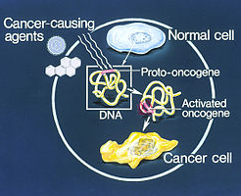
DNA repair genes - become damaged/mutated no repair damage DNA replicated, mutations may not be repaired and will build up.
Proto-oncogenes - Code for growth factors, or signalling proteins (promote growth)
- stimulate cell division or
- inhibit apoptosis.
- Normally inactive
- When Activated by mutagen become oncogenes. (activated) accelerate growth
Tumor suppressors
- inhibit cell division
- trigger apoptosis.
- Mutated become inactivated uncontrolled growth
- Nearly 50% of all cancers are thought to involve a damaged or missing tumour suppressor gene.
- TP53, a tumour suppressor gene that triggers cell death, is commonly damaged or missing in many types of cancer.
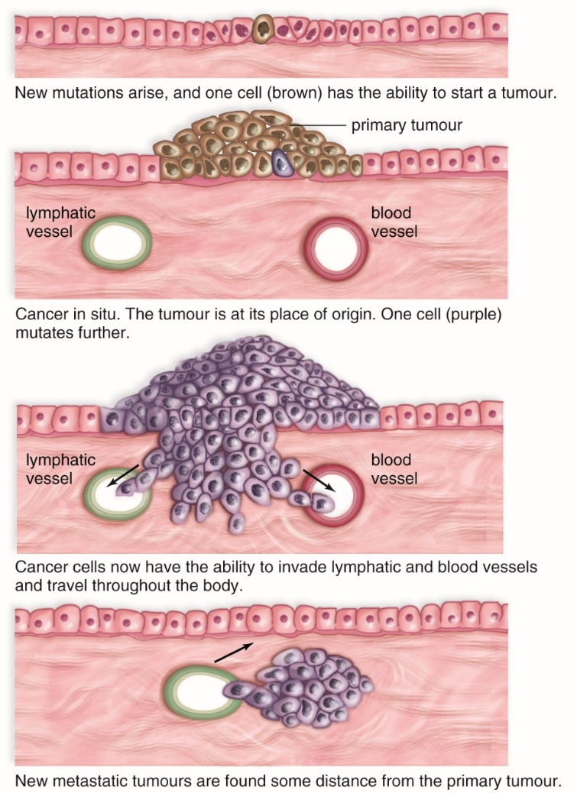
HOW DOES CANCER SPREAD?
Invasion- tumor grows into surrounding tissue
Metastasis-
- Degrade basement membrane,
- invade underlying tissue,
- break away from the tumour,
- enter the bloodstream or lymphatic system and
- travel to a new location in the body.

(Basement membrane is thin, fibrous, extracellular matrix separating epithelium from connective tissue.)

STAGING
- based on location, size, number, spread to nearby lymph nodes.
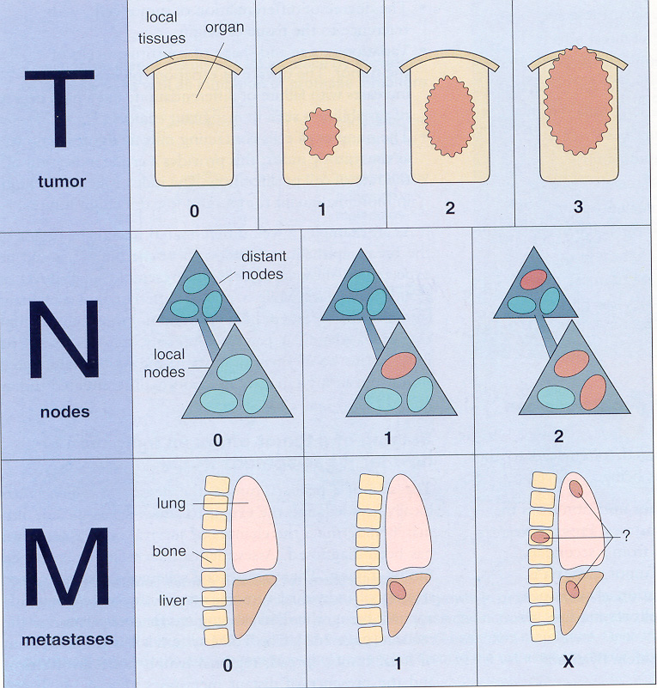
- TNM classification:
T = tumour size and local invasion;
T0 = carcinoma in situ (no local invasion),
T1-T4 increasing in size
N = regional lymph node involvement.
N0 = no nodes,
N1-N3 in increasing number of nodes

M = distant metastases;
M0 = no metastasis,
M1 = metastasis
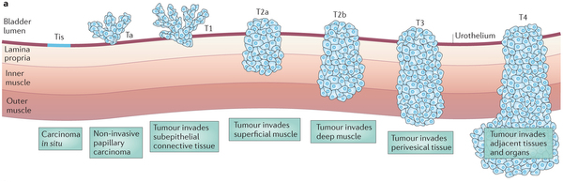
GRADING:
- degree of differentiation in the tumour cells (1,2,3,4)
- Grade 1: cells and the organization appear close to normal, grow and spread slowly.
- Grade 3 and Grade 4: tumors do not look like normal cells or surrounding tissue (less differentiated), grow rapidly and spread faster (more aggressive) than tumors with a lower grade.

Grading an Unspecified tumor:
- GX: Grade cannot be assessed (undetermined grade)
- G1: Well differentiated (low grade)
- G2: Moderately differentiated (intermediate grade)
- G3: Poorly differentiated (high grade)
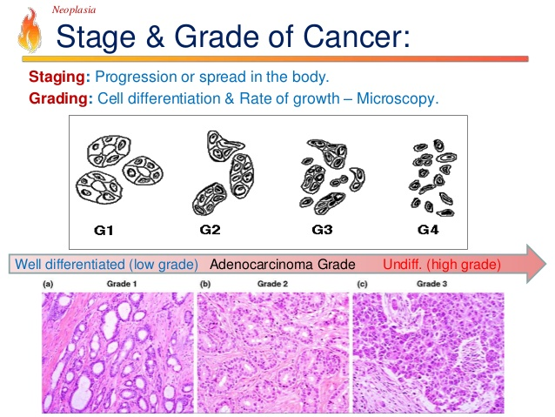
- G4: undifferentiated (high grade)

CANCER DEVELOPMENT
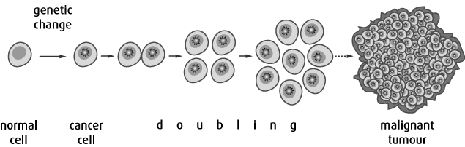
- Initiation: Mutations/Failed repairs/Carcinogens (initiators)
a. Activate oncogenes: Mutation of proto oncogenes can cause them to become oncogenes uncontrolled cell division
b. Inactivate Tumor Suppressor genes active cell division
- Promotion:
  - Further and repeated damage may be caused by hormones / drugs (promoters).
  - Abnormal cells actively divide
- Progression (transformation of normal cell causes it to behave, grow and function quite differently and turn into a cancer cell.
- Angiogenesis
- Metastasis – when tumor becomes malignant, cancer cells break away from tumour and travel via lymphatic system to other areas of body to form a secondary tumour.
PROGNOSIS (Probably Outcome) depends on:
- Invasion of surrounding tissue
- Lymph node involvement
- Metastasis

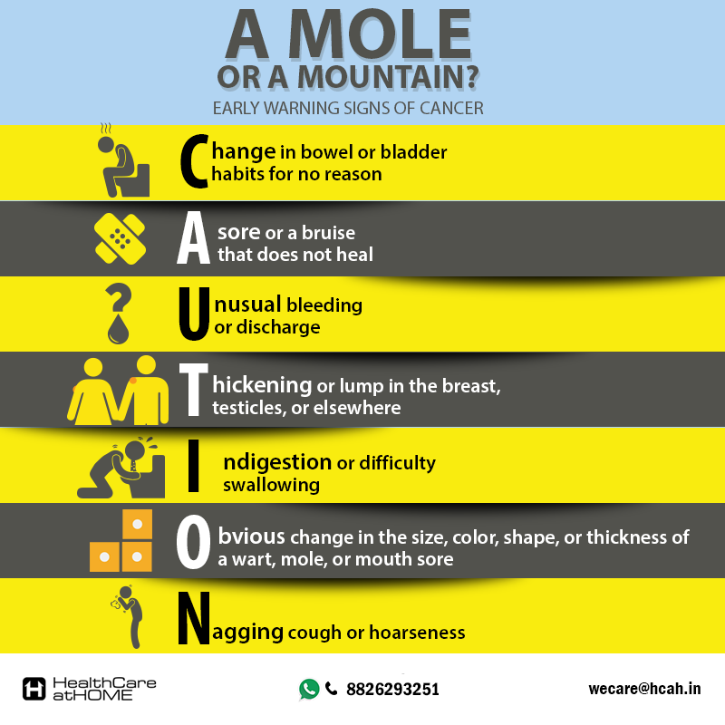
WARNING SIGNS OF CANCER:

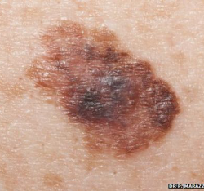

A – assymetry
B – border irregularity
C – colour
D – diameter

DETECTION
- monthly breast self-examinations and regular mammography and Pap tests
- regular self-examination of the testes for young men,
- older men: examination of the prostate gland
- Colonoscopy
TREATMENT
- surgery (localized)
- chemotherapy (system-wide)
- radiation therapy (localized) (X rays and gamma rays)
- therapeutic vaccines (agents that stimulate the immune system to attack cancerous cells)
- Drug therapy - inhibits certain kinase receptors that become hyperactive in cancer cells, resulting in the cells' rapid reproduction

CHARACTERISTICS OF CANCER
- Abnormal Cell morphology
- Lack of Contact Inhibition
- Growth in absence of growth signals:
- Insensitivity to growth inhibitors
- Avoid detection
- Evade apoptosis
- Limitless replicative potential- Activate telomerase
- Stimulate angiogenesis
- Tissue invasion and metastasis
RETROVIRUSES AND CANCER
Retrovirus RNA copied into DNA which then is inserted into host genome.
4 ways viral DNA can cause cancer:
- Virus could carry oncogene directly
- Viral DNA causes a normal host gene to translocate elsewhere
- Viral DNA causes over expression of a gene causing overproduction of a protein
- Viral DNA causes normal gene to mutate or change so it no longer functions

Gleason 1-5
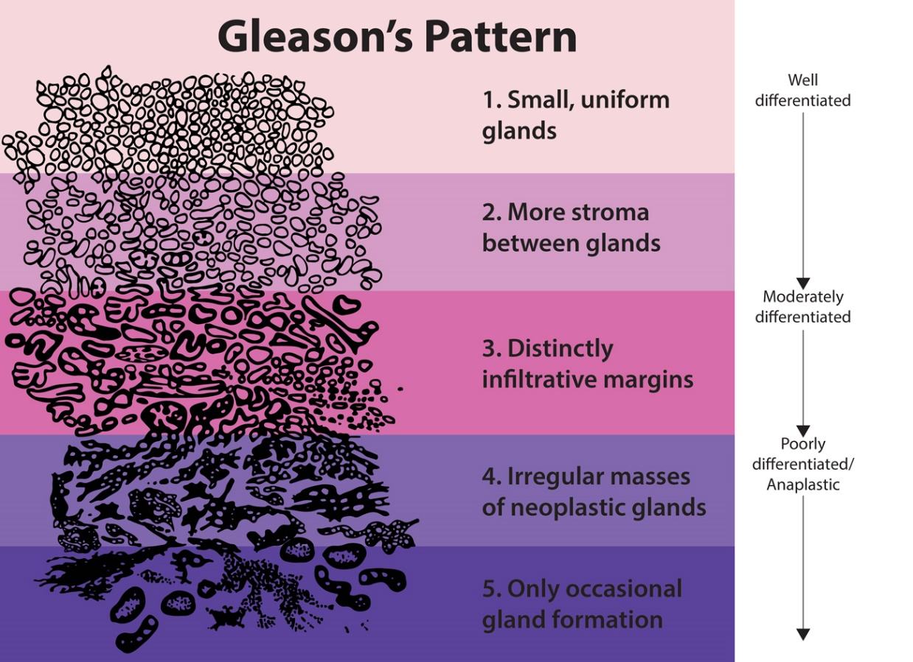
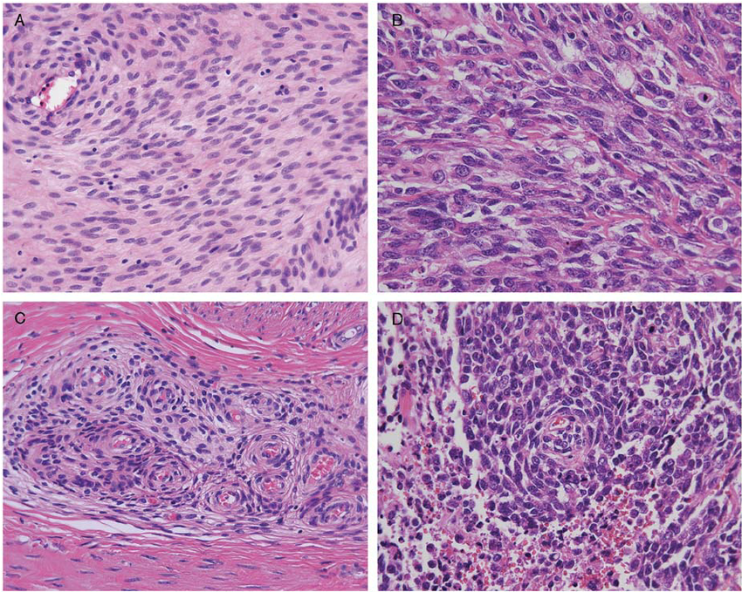
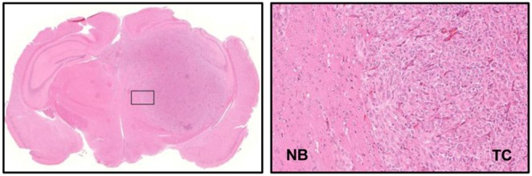
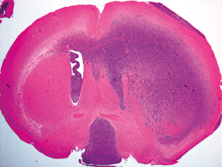
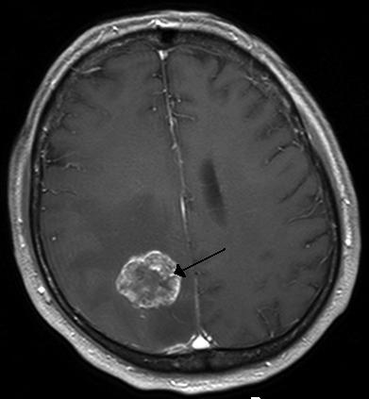
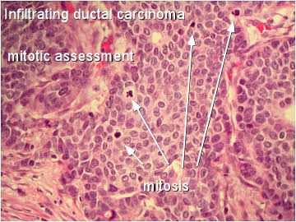

Incidence and mortality
Incidence is the total number of new cases of cancer.
Mortality is the number of deaths due to cancer.
An estimated 202,400 new cases of cancer and 78,800 deaths from cancer will occur in Canada in 2016. (does not include non-melanoma skin cancer cases.)n(2016 pop is 36.4 million)
Cancer is the leading cause of death in Canada and is responsible for 30% of all deaths.
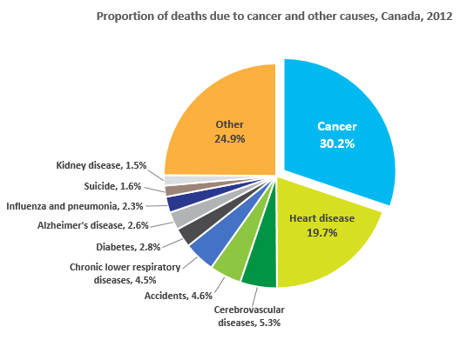
Read more: http://www.cancer.ca/en/cancer-information/cancer-101/cancer-statistics-at-a-glance/?region=on#ixzz4TfsB5941

