Bio 12 Circulatory System Learning Goals (Chapter 13, pg239-260)
By the end of this chapter you should be able to:
- label a diagram of a vessel
- compare and contrast the different types of blood vessels with respect to shape, size, walls, and function
- explain the blood flow in capillaries, arteries, and veins & compare the speed and direction of flow
- describe the external anatomy of the heart (myocardium, pericardium, septum, atria, ventricles, valves, chordae tendineae… etc)
- Define relationship between structure and function of the heart.
- explain the passage way of blood through the heart (from the body and from the lungs)
- know when blood is oxygenated and where it is coming from
- know when blood is deoxygenated and where it is coming from
- know why the pulmonary arteries and veins are exceptions from other arteries and veins
- understand the cardiac cycle (heartbeat) and how the intrinsic and extrinsic control are involved
- know the pathway of electric impulses and the importance of the different nodes (SA, AV, Purkinje fibres)
- know how a pacemaker works
- explain systolic and diastolic readings, and why one is higher than the other & can provide rationale as to why a systolic reading of 140 is high
- recognize and explain an ECG diagram (normal vs. abnormal reading)
- explain the differences between systemic and pulmonary vascular pathways
- understand and can explain one cardiovascular disease with confidence (symptoms, treatments, and cause)
- know the major vascular pathways for the heart, lungs, liver, kidneys and digestive system
- if given a diagram, trace the pathway of blood from the heart, to the foot, and back to the heart
- describe the components of blood (plasma, RBCs, WBCs, platelets)
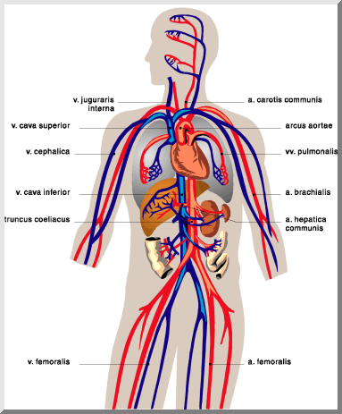
- compare and contrast red blood cells, white blood cells and platelets (origin, “life span”, function, and size)

