Fetal Pig Dissection: External Anatomy

External Anatomy
1. Determine the sex of your pig by looking for the urogenital opening. On females, this opening is located near the anus. On males, the opening is located near the umbilical cord.
If your pig is female, you should also note that urogenital papilla is present near the genital opening. Males do not have urogenital papilla.
Both males and females have rows of nipples, and the umbilical cord will be present in both. What sex is your pig? _________
2. Make sure you are familiar with terms of reference: anterior, posterior, dorsal, ventral. In addition, you'll need to know the following terms
Medial: toward the midline or middle of the body
Lateral: toward the outside of the body
Proximal: close to a point of reference
Distal: farther from a point of reference
3. Open the pig's mouth and locate the hard and soft palate on the roof of the mouth. Can you feel your own hard and soft palates with your tongue?
Note the taste buds (also known as sensory papillae) on the side of the tongue. Locate the esophagus at the back of the mouth. Feel the edge of the mouth for teeth. Does the fetal pig have teeth? ________
Are humans born with teeth? ________
Locate the epiglottis, a cone-shaped structure at the back of the mouth, a flap of skin helps to close this opening when a pig swallows. The pharynx is the cavity in the back of the mouth - it is the junction for food (esophagus) and air (trachea).
4. Gestation for the fetal pig is 112-115 days. The length of the fetal pig can give you a rough estimate of its age.
11mm - 21 days | 17 mm - 35 days | 2.8 cm - 49 days
4 cm - 56 days | 22 cm - 100 days | 30 cm -- birth
5. Observe the toes of the pig. How many toes are on the feet? _____________________
Do they have an odd or even number of toes? _________________________________
6. Observe the eyes of the pig, carefully remove the eyelid so that you can view the eye underneath. Does it seem well developed? Do you think pigs are born with their eyes open or shut? _____________________________________
7. Carefully lay the pig on one side in your dissecting pan and cut away the skin from the side of the face and upper neck to expose the masseter muscle that works the jaw, lymph nodes, and salivary glands. The salivary glands kind of look like chewing gum, and are often lost if you cut too deeply.

The Anatomy of the Fetal Pig (internal)
In this activity, you will open the abdominal and thoracic cavity of the fetal pig and identify structures. Remember, that to dissect means to "expose to view" - a careful dissection will make it easier for you to find the organs and structures. Be sure to follow all directions.

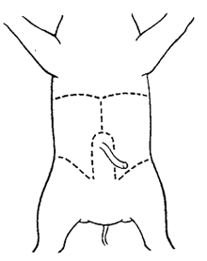
The Incision
Place your fetal pig in the dissecting pan ventral side up. Use string to "hog-tie" your pig so that the legs are spread eagle and not in your way. Use scissors to cut through the skin and muscles according to the diagram. Do not remove the umbilical cord. In the first section, you will only examine the abdominal cavity (the area below the ribcage).
After completing the cuts, locate the umbilical vein that leads from the umbilical cord to the liver. You will need to cut this vein in order to open up the abdominal cavity.
Your pig may be filled with water and preservative, drain over the sink if necessary and rinse organs. Locate each of the organs below, check the box
1. Diaphragm. This muscle divides the thoracic and abdominal cavity and is located near the ribcage.
The diaphragm aids in breathing.
2. Liver. This structure is lobed and is the largest organ in the body. The liver is responsible for making bile for digestion.
3. Gall bladder. This greenish organ is located underneath the liver; the bile duct attaches the gall bladder to the duodenum. The gall bladder stores bile and sends it to the duodenum, via the bile duct.
4. Stomach. A pouch shaped organ that rests just underneath and to the pig's left. At the top of the stomach, you'll find the esophagus. The stomach is responsible for churching and breaking down food.
5. At each end of the stomach are valves that regulate food entering and leaving the stomach. At the esophagus is the cardiac sphincter valve, and at the duodenum is the pyloric sphincter valve. View the inside of the stomach by slicing it open lengthwise.
6. The stomach leads to the small intestine, which is composed of the duodenum (straight portion just after the stomach) and the ileum (curly part).
7. The ileum is held together by mesentery. In the small intestine, further digestion occurs and nutrients are absorbed through the arteries in the mesentery. These arteries are called mesenteric arteries.
8. Pancreas: a bumpy organ located along the underside of the stomach, a pancreatic duct leads to the duodenum. The pancreas makes insulin, which is necessary for the proper uptake of sugars from the blood.
9. Spleen: a flattened organ that lies across the stomach and toward the extreme left side of the pig. The spleen stores blood and is not part of the digestive system. On the underside of the spleen, locate the splenic artery.
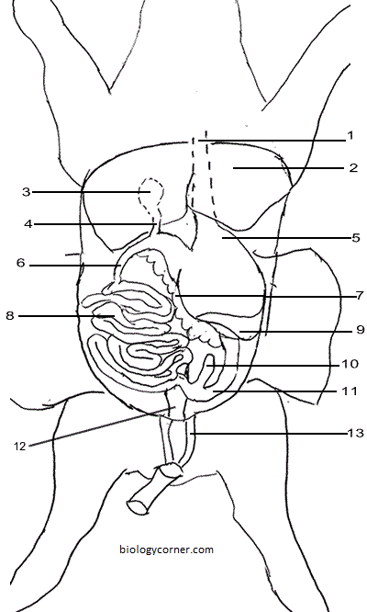
10. At the end of the ileum, where it widens to become the large intestine, a "dead-end" branch is visible. This is the cecum. The cecum helps the pig digest plant material.
11. The large intestine can be traced to the rectum. The rectum lies toward the back of the pig and will not be moveable. The rectum opens to the outside of the pig, or the anus. The large intestine reabsorbs water from the digested food, any undigested food is stored in the rectum as feces.
12. Lying on either side of the spine are two bean shaped organs: the kidneys. The kidneys are responsible for removing harmful substances from the blood, these substances are excreted as urine. (more on this later)
13. Two umbilical vessels can be seen in the umbilical cord, and the flattened urinary bladder lies between them.

Identify the structures on the diagram.
1. __________________________________
2. __________________________________
3. __________________________________
4. __________________________________
5. __________________________________
6. __________________________________
7. __________________________________
8. __________________________________
9. __________________________________
10. _________________________________
11. _________________________________
12. _________________________________
13. _________________________________

Identify the organ (or structure)
14. _____________________________ Opening (valve) between stomach and small intestine.
15. _____________________________ Stores bile, lies underneath the liver.
16. _____________________________ A branch of the large intestine, a dead end.
17. _____________________________ Separates the thoracic and abdominal cavity
18. _____________________________ Membrane that holds the coils of the small intestine.
19. _____________________________ The straight part of the small intestine, after stomach.
20. _____________________________ Empties bile into the duodenum from the gall bladder.
21. _____________________________ The last stretch of large intestine
22. _____________________________ Bumpy structure under the stomach; makes insulin
23. _____________________________ Lies between the two umbilical vessels.

Urinary and Reproductive Systems
1. Locate the kidneys; the tubes leading from the kidneys that carry urine are the ureters. The ureters carry urine to the urinary bladder - located between the umbilical vessels.
2. Lift the bladder to locate the urethra, the tube that carries urine out of the body.
3. Note the vessels that attach to the kidney - these are the renal vessels
Male
1. Find the scrotal sacs at the posterior end of the pig (between the legs), testis are located in each sac. Open the scrotal sac to locate the testis.
2. On each teste, find the coiled epididymis. Sperm cells produces in the teste pass through the epididymis and into a tube called the vas deferens (in humans, a vasectomy involves cutting this tube).
3. The penis can be located by cutting away the skin on the flap near the umbilical cord. This tube-like structure eventually exits out the urogenital opening, also known as the urethra.
Female
4. In the female pig, locate two bean shaped ovaries located just posterior to the kidneys and connected to the curly oviducts.
5. Trace the oviducts toward the posterior to find that they merge at the uterus. Trace the uterus to the vagina. The vagina will actually will appear as a continuation of the uterus.

LABEL THE DIAGRAMS
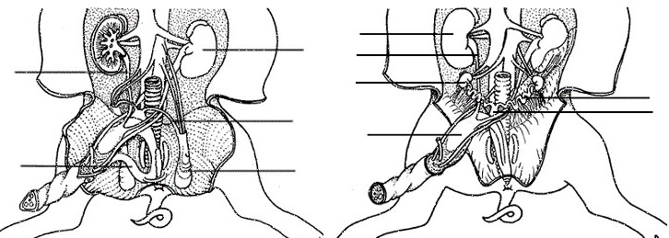

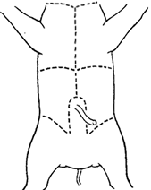
Dissection of the Thoracic Cavity
You may need to cut through the pig's sternum and expose the chest cavity (thoracic cavity) to view. Identify each of the following organs.
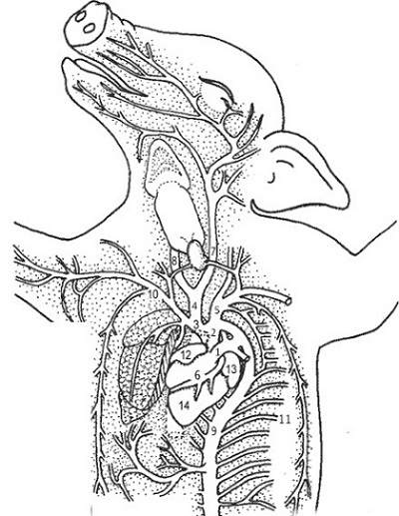
1. Find the diaphragm again. Remember that the diaphragm separates the abdominal cavity from the thoracic cavity and it aids in breathing. Above the diaphragm, center of chest, is the heart.
2. Remove the pericardium, which is a thin membrane that surrounds the heart .
3. The structures visible on the heart are the two atria (12,13), the ventricle (14) which has two chambers not visible from the outside.
4. The most obvious vessel on the front of the heart is the pulmonary trunk (1) . It curves upward and joins the aorta (2) - a vessel which arches from the heart and curves around to go to the lower part of the body -where it is called the abdominal (dorsal) aorta (9). The aorta supplies the body with blood.
5. The aorta will curve back and then branch in two spots - the right brachiocephalic (3) and the left subclavian (5)
6. The right brachiocephalic then branches into arteries - the common carotid (4) and the right subclavian (10) The subclavians supply blood to the arms and follow the clavicle bone
7. The common carotid (4), which will branch into the left (7) and right carotid arteries (8). The carotid arteries supply blood to the head and neck.
8. Observe the coronary vessels (6) on the outside of the heart - these vessels supply blood to the muscle of the heart.
9. Easy arteries to find are the ones that run near the ribs. These are the intercostal arteries (11).
10. Lift the heart to look on its dorsal side (toward the back), you should be able to see the anterior and posterior vena cava, which brings blood from the body back to the heart. In addition, you should also be able to find the left and right jugular veins that drain blood from the head and run parallel to the carotids.
11. Push the heart to the side to locate two spongy lungs located to the left and right side. The lungs are connected to bronchial tubes (not visible) which connect to the trachea (forming a Y).
12. The trachea is easy to identify due to the cartilaginous rings, which help keep it from collapsing as the animal inhales and exhales. The trachea should be located in the chin area above the heart.
13. Lying atop the trachea, locate the pinkish-brown, V shaped structure called the thyroid gland. This gland secretes hormones that control growth and metabolism.
14. At the anterior (toward head) of the trachea, you can find the hard light colored larynx (or voice box). The larynx allows the pig to produce sounds - grunts and oinks.

Identify by number:
Aorta ____ Dorsal Aorta ____ Pulmonary Trunk ___
Common carotid ____ Left & Right Carotid ____
Coronary vessels ___ Left Subclavian_____
Right Subclavian _____ Right Brachiocephalic _____
Right Atrium _____ Left Atrium _____
Intercostal _____ Ventricle _____

Identify the structure.
1. ___________________________ Membrane over the heart.
2. ___________________________ Airway from mouth to lungs
3. ___________________________ Blood supply to head
4. ___________________________ Lower heart chambers
5. ___________________________ Blood supply to lower body
6. ___________________________ Muscle to aid breathing
7. ___________________________ Returns blood to heart
8. ___________________________ Large vessel at top of heart
9. ___________________________ Used to make noises
10. ___________________________ Arteries on heart surface.

Fetal Pig - Dissection of the Lower Arteries
1. Trace the abominal aorta (also called the dorsal aorta) to the lower part of the body, careful tweezing of the tissue will reveal several places where it branches, though some of the arteries may have been cut when you removed organs of the digestive system.
2. The hepatic artery leads to the liver. (may not be visible)
3. The splenic artery leads to the spleen (may not be visible)
4. The renal arteries lead to the kidney.
5. The mesenteric artery leads to the mesentery and branches into many smaller vessels. Look in the small intestine to find this artery.
6. Trace the abominal aorta and note where it joins the umbilical arteries. You will need to cut the muscle in the leg to trace the next vessels. Use a pin to carefully tease away the surrounding muscle and tissue.
7. The abominal aorta splits into two large vessels that lead to each leg - the external iliac arteries will turn into the femoral arteries as they enter the leg
8. Follow the umbilical artery toward the pig, you'll find that it branches and a small artery stretches toward the posterior of the pig - this is the ilio-lumbar artery.
9. Follow the external iliac into the leg (carefully tease away muscle), it will branch into two arteries: the femoral (toward the outside of the leg) and the deep femoral (toward the back of the leg)
. 