**Sci 8 Matter Notes Name: ___________**

**What is Matter?**

**Matter** is everything around you.

Matter is anything that has **mass** and **takes up space**. It is the **amount of stuff in an object**.

There are **five main states of matter** (sometimes called **phases)**.

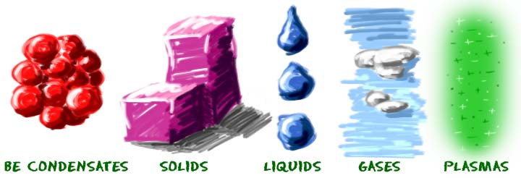

**How can we describe Matter?**

**Matter can be described by its physical characteristic**s **(or properties).**

* **Physical property** – characteristic of matter that can be observed or measured without changing its chemical identity (type of matter it is).
* **Qualitative description** (no instruments) of physical properties (red, sweet, shiny, squishy)
* **Quantitative descriptions** can be **measured**. (mass, volume, density, melting point, solubility, hardness of wood, viscosity of molasses, boiling point of water

**Physical Characteristics of Some States (Phases) of Matter**:

**Solids**

* **solids hold their shape** (because their molecules are tightly packed together)
* can be hard like a rock, soft like fur, a big rock like an asteroid, or small rocks like grains of sand.   
    
  "Is baby powder a solid?

**Liquids**

* are fluidy, and can move around a little
* can **fill the shape of any container they are in**
* atoms in liquids are **spread out a little more than in solids**.
* shape depends on **gravity.**
* **Eg** liquids at room temperature include water (H2O), blood, and even honey

**Gases**

* Gases can fill a container of any size or shape.
* molecules are really spread out (more than in liquid), full of energy, and constantly moving around in random ways.
  + If a gas has an odor, you’ll be able to smell it before you can see it.
* Eg. atmosphere.
* Not dependent on **gravity**, unlike liquids.

**Measuring Properties of Matter**

**Mass** is the **quantity of matter** a substance or object contains.

* + 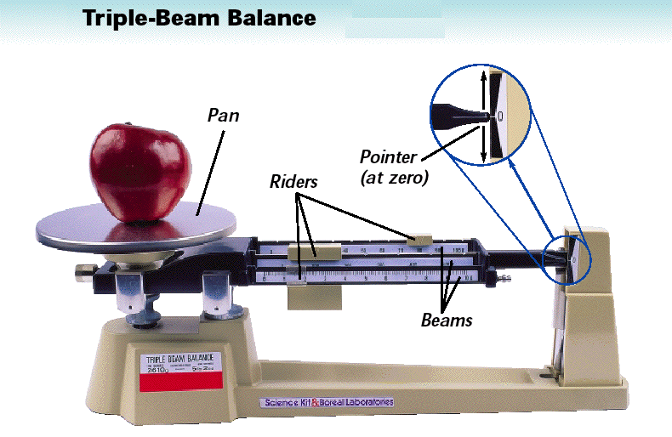Mass is usually measured in **grams** (g) or **kilograms** (kg).
  + Mass can be measured with a **triple beam balance**

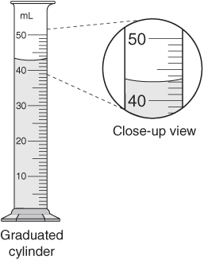**Volume** is the **amount of space taken up by a substance or object.**

* + Volume is usually measured in millilitres (mL), litres (L), or cubic centimetres (cm3).
  + Volume of a **liquid** can be measured with a **graduated cylinder**
  + Volume of a **regular-shaped solid** can be measured with a **formula**:

V= L x W x H V=  r2 h

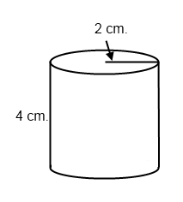

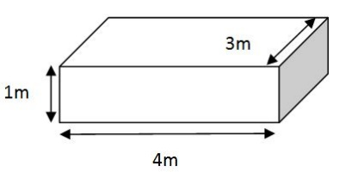

* + Volume of an irregular-shaped solid can be measured with the displacement method:

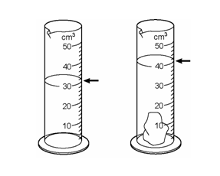

**Density**

Density is another physical property of matter. It is the amount of matter per unit of volume. It is measured in g/ml or g/cm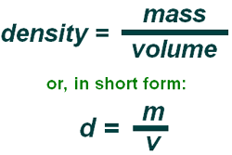3.

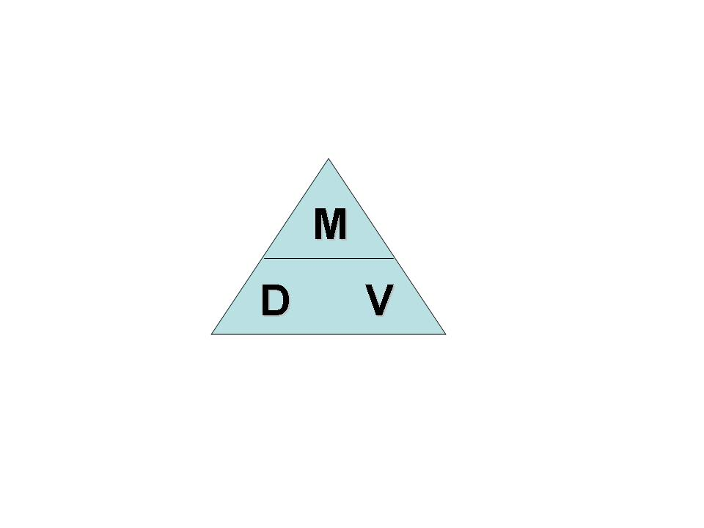

**Particle Model of Matter**

1. All matter is made of small particles that are too small to see.
2. There are spaces between the particles. The amount of space varies depending upon the state.
3. The particles are always moving.
4. The particles are attracted to one another.

 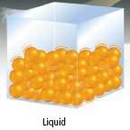 

[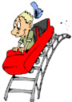](http://www.clipart.com/en/close-up?o=3785480&a=c&q=roller%20coaster&k_mode=any&s=64&e=84&show=&c=&cid=&findincat=&g=&cc=1276:29:279:12:20:241:382&page=4&k_exc=&pubid=&color=&b=k&date=)

**The Kinetic Molecular Theory**

* Kinetic energy is the energy due to **motion.**
* The Kinetic Molecular Theory (KMT) explains what happens to matter when the **kinetic energy of the particles changes.**
  + A **theory** provides a scientific explanation based on the results of experimentation.

As the rollercoaster’s speed increases, its kinetic energy also increases.

**The main points of the kinetic molecular theory include:**

1. All matter is made of very small particles.
2. There is empty space between particles.
3. Particles are constantly moving. The particles are  
   colliding with each other and the walls of their container.

**Energy** makes particles move.

The more energy the particles have, the **faster they move** and **further apart** they get.

**Solid:** **Liquid:** **Gas:**

Particles are so tightly Particles are farther Particles are very far

packed together they apart and they can move apart and move

cannot move freely. by sliding past each other. around quickly.

They canonly vibrate.

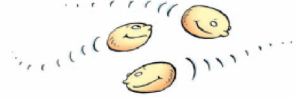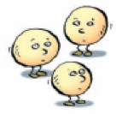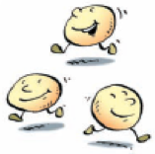

**CHANGING STATES OF MATTER (PHYSICAL CHANGE)**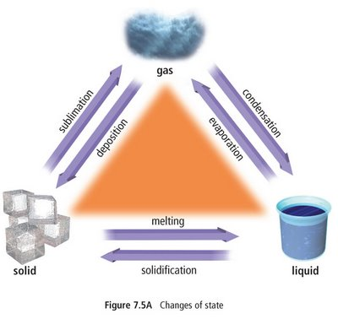

The **state of matter** can be changed by **adding or subtracting energy** (like increasing the temperature or freezing something)

Molecules can move from one **physical state** to another (**phase change**) and not change their basic **structure**. **Chemical properties do not change**.

Eg. Water can be frozen or heated and turned to steam (gas). But is still H2O.

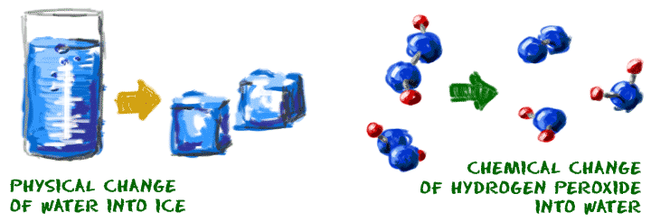

<https://www.youtube.com/watch?v=xg5NiOwf_Zw>

|  |  |
| --- | --- |
| **CHEMISTRY TERM** | **PHASE CHANGE** |
| Fusion/Melting Freezing Vaporization/Boiling Condensation Sublimation Deposition | Solid to Liquid Liquid to Solid Liquid to Gas Gas to Liquid Solid to Gas Gas to Solid |

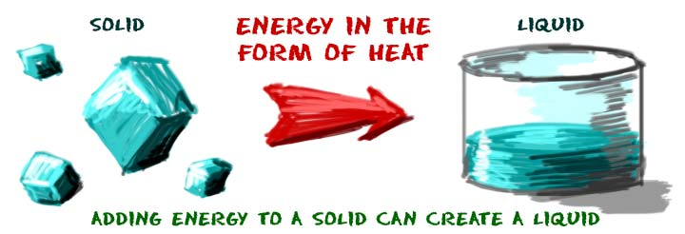**Melting point** - special temperature for every substance when a solid becomes a liquid.

What is the melting point for water?  
Do salt, sugar, or rock have higher or lower melting point than water?

**Freezing: liquid --> solid**

* The reverse of the melting process.
* Liquid water freezes and becomes solid ice when the molecules lose energy.

**Sublimation:** **solid 🡪 gas**

**Eg. Dry ice** is solid carbon dioxide (CO2). When you leave dry ice out in a room, it just turns into a gas.

Eg. Coal does not melt at normal atmospheric pressures but will sublimate at very high temperatures.

Marshmallow video <https://www.youtube.com/watch?v=HzPEkdaOv3c>

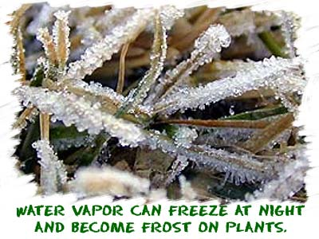  
**Deposition**: **gas --> solid** without going through the liquid state of matter.

Eg. **frost** crystals build up when water vapor from the air becomes a solid on outdoor surfaces.

**Evaporation:** **liquid 🡪 gas**. Occurs when individual liquid molecules gain enough energy to escape the system and become a gas. **Boiling Point** is the temperature at which a liquid turns to a gas

Adding energy to a material increases kinetic energy

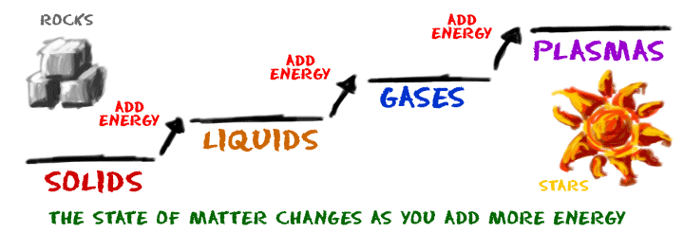

**Thermal Expansion**: matter **expands** when its temperature **increases.**

**Thermal Contraction**: matter **contracts** (shrinks) when particles take up **less space** when they **lose energy**.

Different materials **expand/contract with temperature at their own rate.**

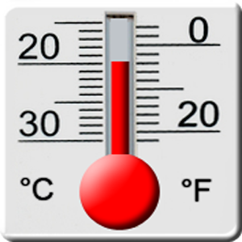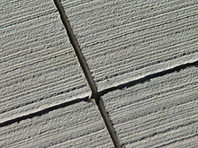**Examples of Thermal Expansion:**

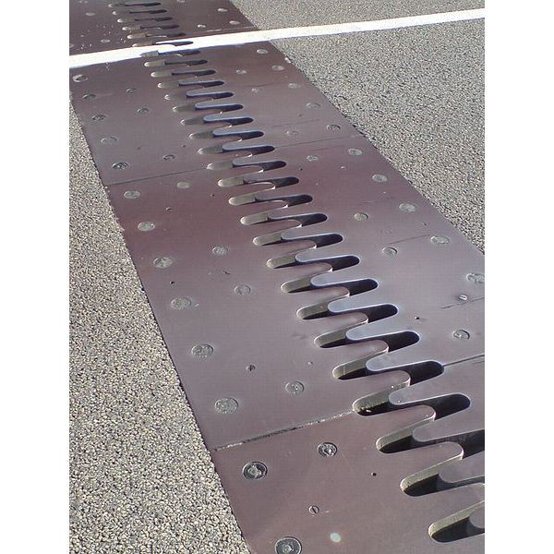Hot drinking glass shatters when cold water poured in.

Thermometer Gaps in Sidewalk or Bridge

**Difference between Heat and Temperature**

**Thermal Energy** – total amount of energy of particles.

When two substances of different thermal energies come in contact, energy will flow from high 🡪 low thermal energy.

**Heat** is the energy transferred from one material to another as a result of a difference in temperature or change in state.

**Temperature** – measurement of amount of kinetic energy of a substance

What happens to the temperature of water as it changes states?

**CHEMICAL CHANGE**  
Chemical changes occur when the [bonds](http://www.chem4kids.com/files/atom_bonds.html) between atoms in a molecule are created or destroyed. eg pure water. H2O 🡪hydrogen peroxide (H2O2). No longer water.

New substance formed, color, smell, temperature.

Reference: Chem4Kids.com