Male Reproductive System
- Label the parts of the male reproductive system
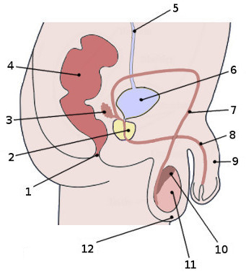

- Complete the chart
Organ | Function
 | Produce sperm and sex hormones
Vasa deferentia

 | Conduct and store sperm
Prostate gland

 | Conducts sperm to outside
 | Contribute mucoid fluid to semen
 | Organ of sexual intercourse

