**What is Matter?**

* **Matter** is everything around you.
* Matter is anything that has **mass** and **takes up space**. It is the **amount of stuff in an object**.

**What isn’t Matter?**

* Energy – because it has no mass

There are **five main states of matter** (sometimes called **phases)**:

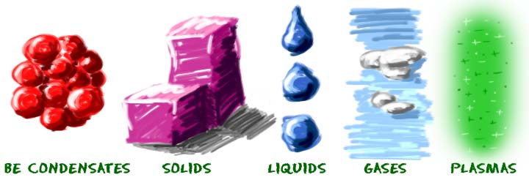

**Bose**-**Einstein condensate** (**BEC**), a state of matter in which separate atoms or subatomic particles, cooled to near absolute zero (0 K, − 273.15 °C)

**HOW CAN WE DESCRIBE MATTER?**

**MATTER CAN BE DESCRIBED BY ITS PHYSICAL PROPERTIES.**

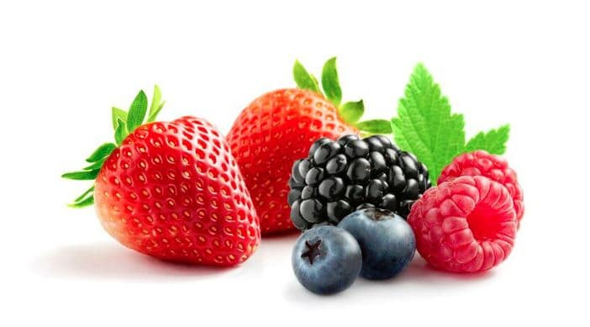**Physical property** – characteristic of matter that can be **observed** or **measured** without changing its chemical identity (type of matter it is).

* + **Qualitative description** –eg. Flavor, colour, texture.
  + 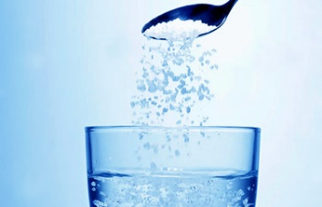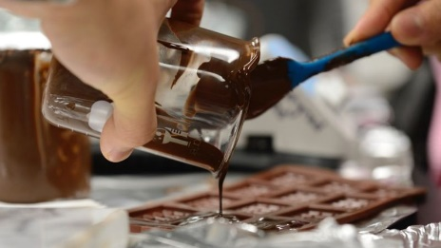**Quantitative descriptions** can be **measured**. (mass, volume, density, melting point, solubility, hardness of wood, viscosity of molasses, boiling point, ductility, malleability)

**MATTER CAN BE DESCRIBED BY ITS CHEMICAL PROPERTIES:**

* **A chemical property is the ability of matter to react with another substance to form one or more new substances with different properties.**
* **Eg. Combustibility**
* **Eg. Flammability**
* 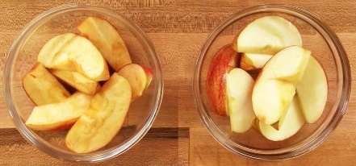**Eg. Reactivity**

***What is the main difference between physical and chemical properties?***

**MATTER CAN BE DESCRIBED BASED ON ITS PHYSICAL AND CHEMICAL CHANGES:**

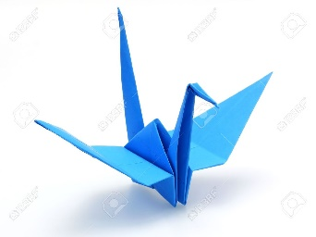**Physical Change – a change that alters a substance without changing its chemical identity or composition. Eg. folding paper**

* + **Eg. change of state (freezing)**

**Chemical Change (chemical reaction) – a new substance is produced.** [**Bonds**](http://www.chem4kids.com/files/atom_bonds.html) between atoms in a molecule are **created** or **destroyed** (chemical reaction).

* eg pure water. H2O 🡪hydrogen peroxide (H2O2). No longer water.
  + **Evidence of a chemical change (new substance created):** 
    - **Change colour,**
    - **Change in texture,**
    - **Change in odour,**
    - **gas produced (bubbles),**
    - **Energy is given of or absorbed (change in temperature)**
  + **Eg. Burnt toast, rotting food, rusting metal**

***What is the main difference between a physical change and a chemical change?***

**MATTER EXISTS IN DIFFERENT STATES (PHASES)**:

**Solids**

* **solids hold their shape** (because their molecules are tightly packed together)
* can be hard like a rock, soft like fur, a big rock like an asteroid, or small rocks like grains of sand.   
    
  "Is baby powder a solid?

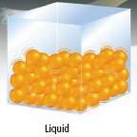**Liquids**

* are fluidy, and can move around a little
* can **fill the shape of any container** they are in
* atoms are **spread out a little more** than in solids.
* shape depends on **gravity.**
* **Eg. water** (H2O), **blood**, **honey**

**Gases**

* Gases can **fill a container** of any size or shape.
* molecules are **really spread out** (more than in liquid), full of energy, and constantly moving around in random ways.
  + 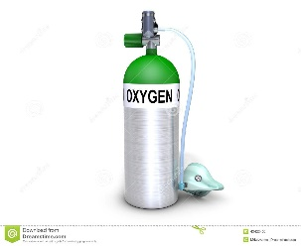If a gas has an odor, you’ll be able to smell it before you can see it.
* Eg. Atmosphere, oxygen
* Not dependent on **gravity**, unlike liquids.

*Give two examples of solids, liquids, and gases.*

**HOW CAN WE EXPLAIN STATES OF MATTER?**[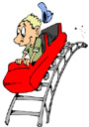](http://www.clipart.com/en/close-up?o=3785480&a=c&q=roller%20coaster&k_mode=any&s=64&e=84&show=&c=&cid=&findincat=&g=&cc=1276:29:279:12:20:241:382&page=4&k_exc=&pubid=&color=&b=k&date=)

**Energy** makes particles **move**.

**Kinetic energy** is the energy due to **motion**. The more energy the particles have, the **faster they move** and **further apart** they get.

The Kinetic Molecular Theory (KMT) explains what happens to matter when the **kinetic energy of the particles changes.**

* + A **theory** provides a scientific explanation based on the results of experimentation.

As the rollercoaster’s speed increases, its kinetic energy also increases.

**The Kinetic Molecular Theory**

1. All matter is made of very small particles.
2. There is empty space between particles.
3. Particles are constantly moving. The particles are  
   colliding with each other and the walls of their container.

**Solid:** **Liquid:** **Gas:**

Particles are so tightly Particles are farther Particles are **very far**

packed together they apart and they can move **apart** and move

cannot move freely. by **sliding past each other**. around **quickly**.

They canonly **vibrate**.

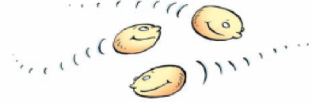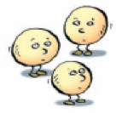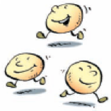

**CHANGING STATES OF MATTER**

The **state of matter** can be changed by **adding or subtracting energy** (like increasing the temperature or freezing something)

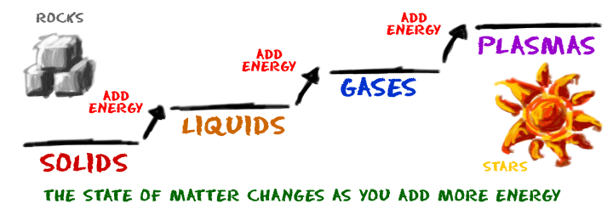

Change of State is a Physical Change:

As molecules move from one **physical state** to another (**phase change**), they do not change their basic **structure**.

Eg. Water can be frozen or heated and turned to steam (gas). Its chemical properties do not change because it is still H2O.

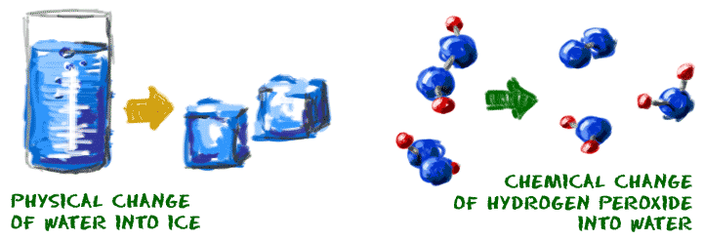

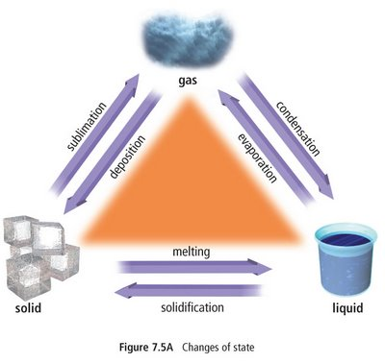**WHAT ARE THE TERMS FOR THE CHANGING STATES OF MATTER?**

|  |  |
| --- | --- |
| **CHEMISTRY TERM** | **PHASE CHANGE** |
| Fusion/Melting Freezing Vaporization/Boiling Condensation Sublimation Deposition | Solid 🡪 Liquid Liquid 🡪 Solid Liquid 🡪 Gas Gas 🡪 Liquid Solid 🡪 Gas Gas 🡪 Solid |

*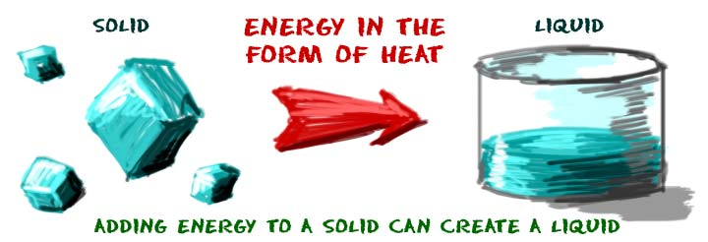***Freezing: liquid --> solid**

* The reverse of the melting process.
* Eg. Liquid water freezes and becomes solid ice when the molecules lose energy.

**Sublimation:** **solid 🡪 gas**

**Eg. Dry ice** is solid carbon dioxide (CO2). When you leave dry ice out in a room, it just turns into a gas.

Eg. Coal does not melt at normal atmospheric pressures but will sublimate at very high temperatures.

Marshmallow video <https://www.youtube.com/watch?v=HzPEkdaOv3c>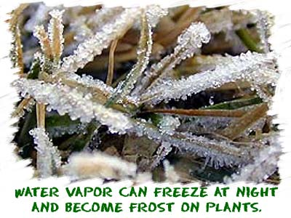  
**Deposition**: **gas --> solid** without going through the liquid state of matter.

Eg. **frost** crystals build up when water vapor from the air becomes a solid on outdoor surfaces.

**Evaporation:** **liquid 🡪 gas**. Occurs when individual liquid molecules gain enough energy to escape the system and become a gas.

**Boiling Point** is the **temperature** at which a liquid turns to a gas

**Melting point** - special **temperature** for every substance when a solid 🡪 liquid.

*What is the melting point for water?  
Do salt, sugar, or rock have higher or lower melting point than water?*

**EXPLAINING THERMAL EXPANSION**

* Adding heat to a material increases its **kinetic energy**, causing the particles to **move faster and farther apart,** causing **expansion when heated** or contraction (shrinking) when cooled.
* The hotter a substance gets, the more its volume increases.
* **Thermal Expansion** is the expansion of heated materials.
* **Thermal Contraction**: matter **contracts** (shrinks) when particles take up **less space** when they **lose energy**.
* Eg. Engineers must consider thermal expansion when building bridges. Repeated expansion and contraction can weaken building materials such as concrete which can cause buckling, cracks and breaks. Expansion joints (shown below) allow material to expand and contract as the temperature changes without damaging the structure.
* Liquids expand more than solids, because their particles move more freely and can move farther apart.
* 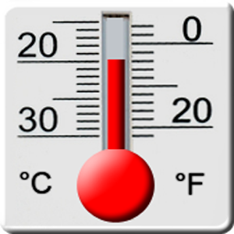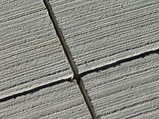**Examples of Thermal Expansion:**

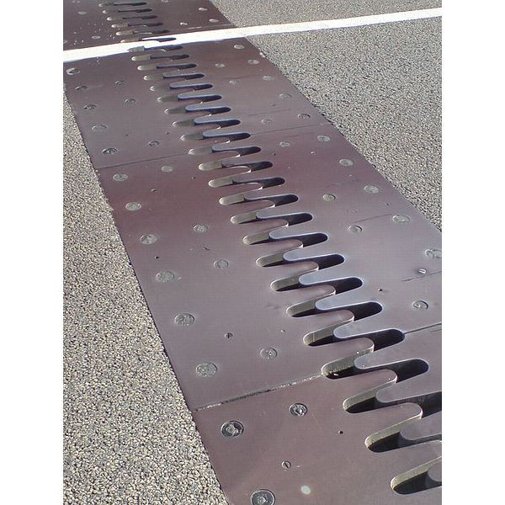

Hot drinking glass shatters when cold water poured in.

Thermometer Gaps in Sidewalk or Bridge Expansion joints in bridge

**Demo**

Can crush

<https://www.youtube.com/watch?v=xg5NiOwf_Zw>

**Difference between Heat and Temperature**

**Thermal Energy** – total amount of energy of particles.

When two substances of different thermal energies come in contact, energy will flow from high 🡪 low thermal energy.

**Heat** is the energy transferred from one material to another as a result of a difference in temperature or change in state.

**Temperature** – measurement of amount of kinetic energy of a substance

What happens to the temperature of water as it changes states?

**LAW OF CONSERVATION OF MATTER**

Matter cannot be **created** nor **destroyed**.

Mass of reactants = mass of products

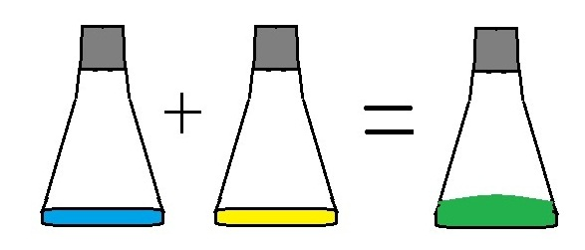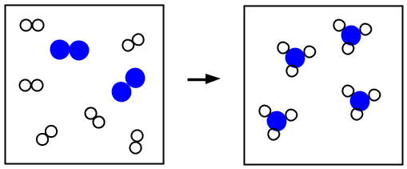

*Ted Ed video*

<https://www.youtube.com/watch?v=2S6e11NBwiw>

**MATTER CAN BE CLASSIFIED AS EITHER PURE SUBSTANCES OR MIXTURES**

**Pure Substances**

* 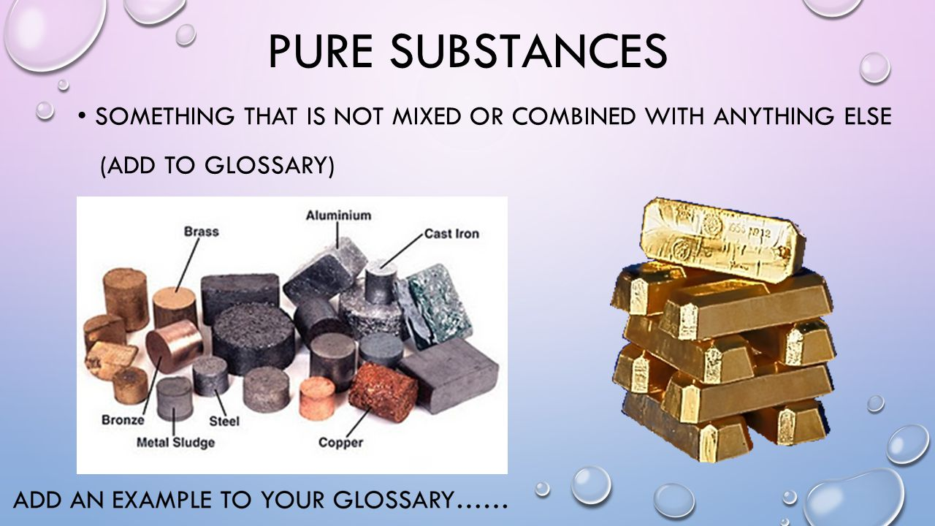Made of only **one type of atom** or molecule (a molecule is a group of atoms bonded together). The measure of whether a substance is pure is known as **purity**.

Examples: tin, sulfur, diamond, water, pure sugar, table salt, and baking soda.

* Pure substance can be further classified into **elements** and **compounds**.
  + **Elements - pure substances that contain only one type of atom.** 
    - 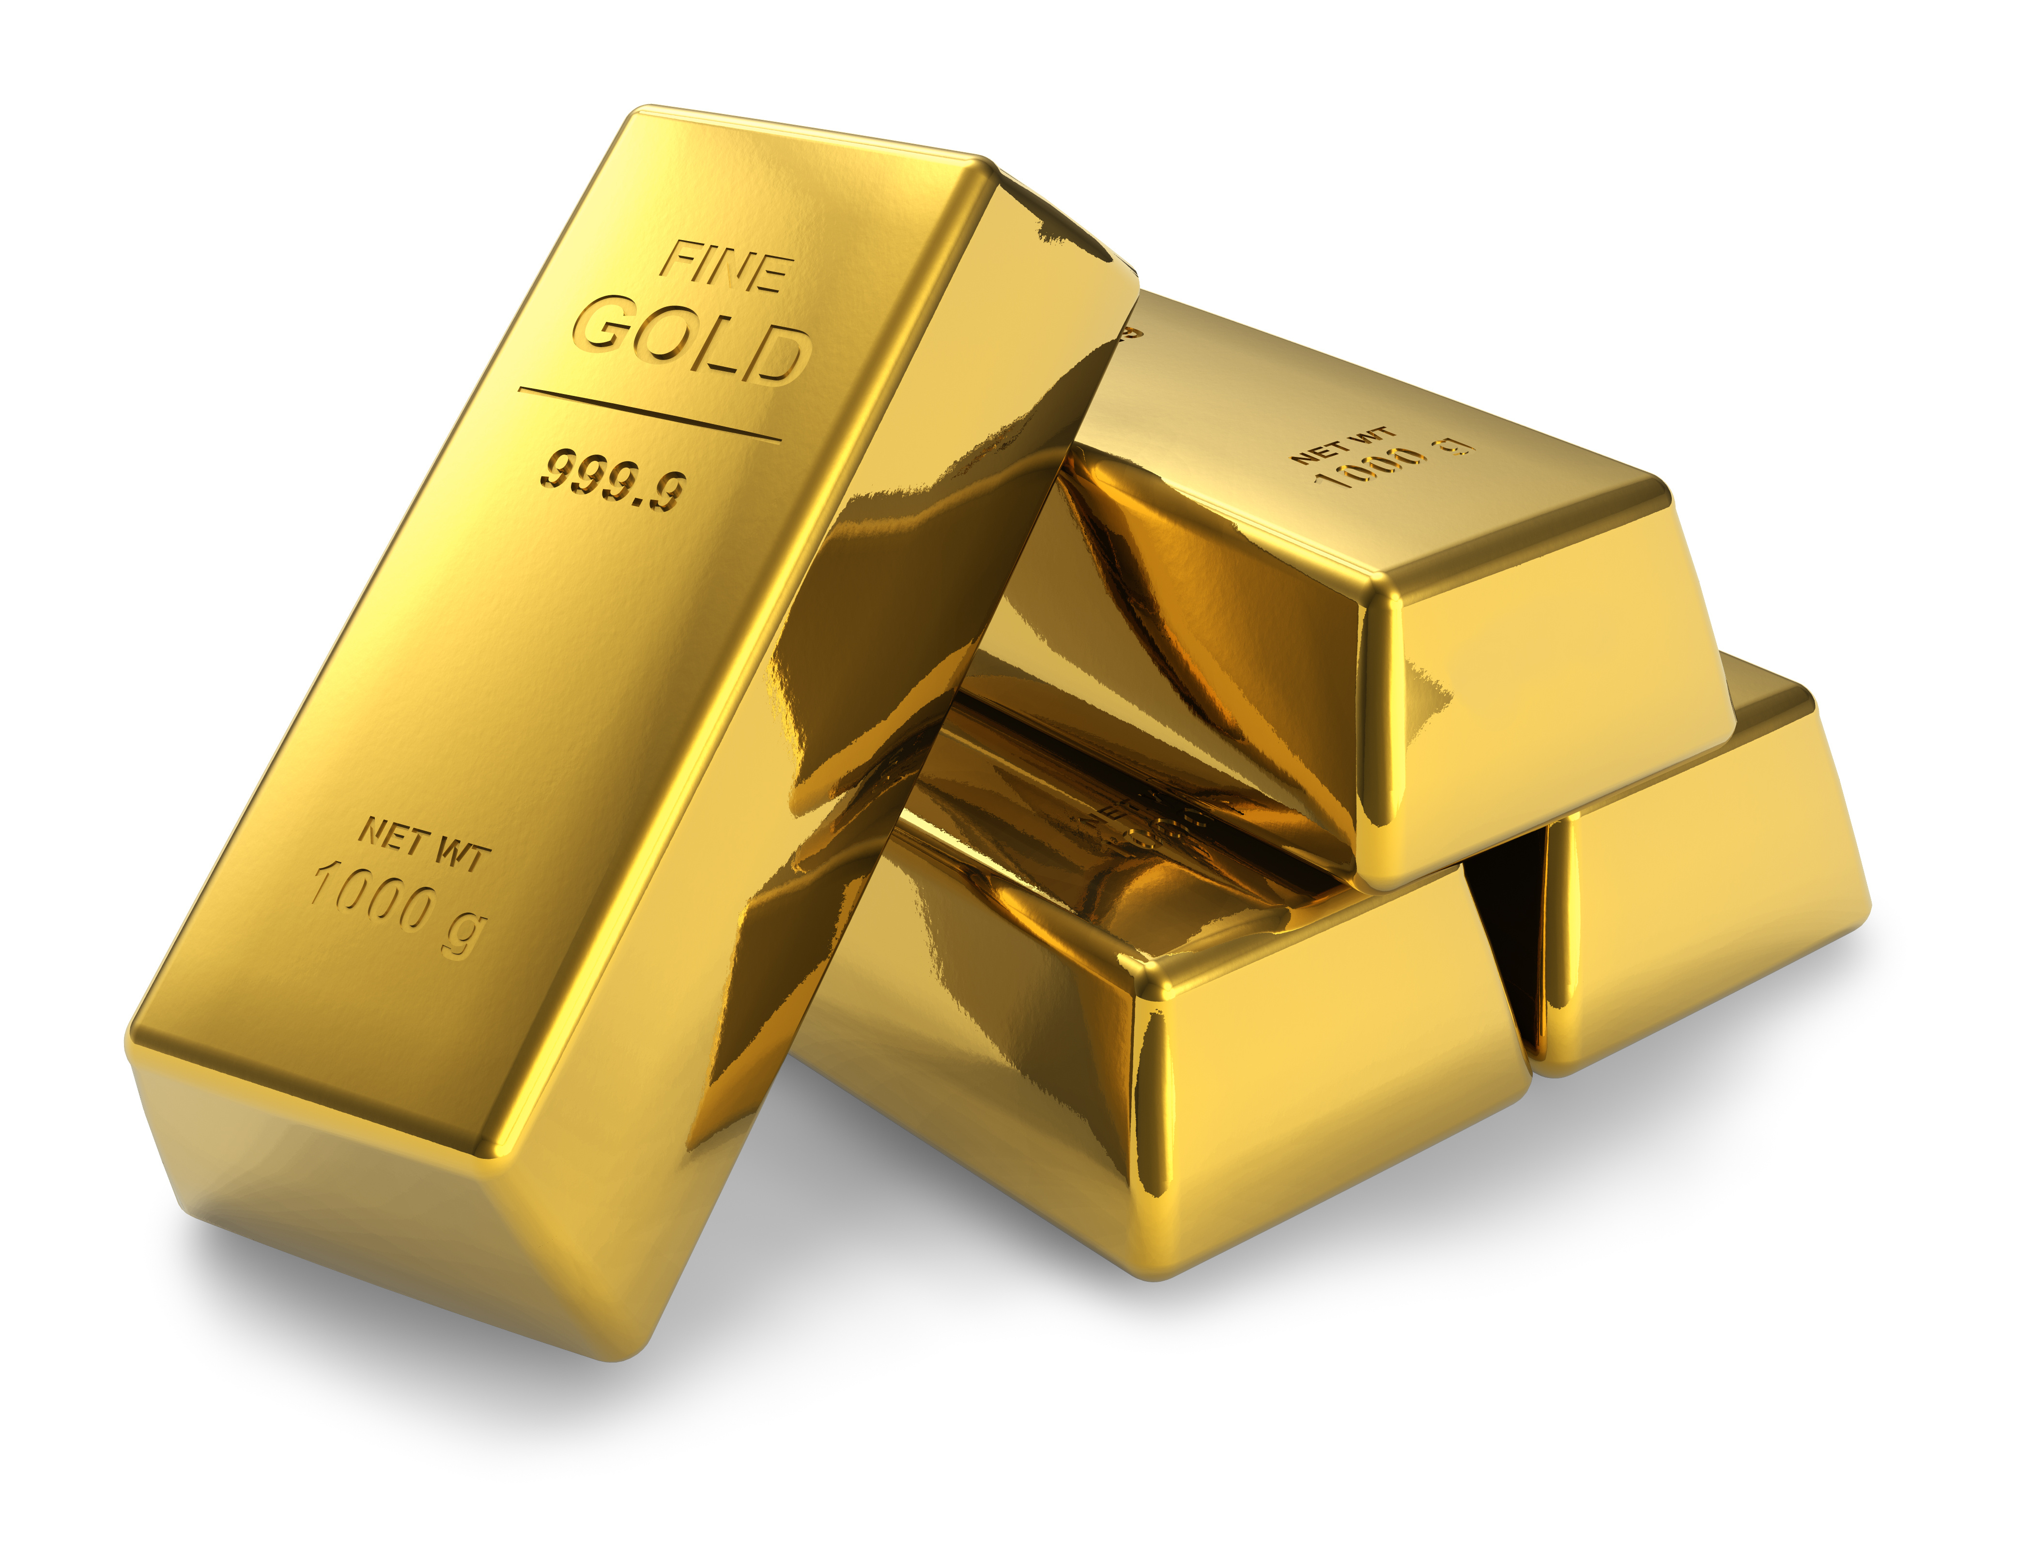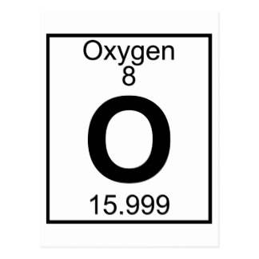Any element from the periodic table
    - cannot be broken down into simpler substance
    - Eg. The element Oxygen, element gold
  + **Compounds** – pure substance that contains at least two types of atoms chemically bonded together.
    - Any combination of elements from the periodic table
    - Can be separated using chemical means
    - 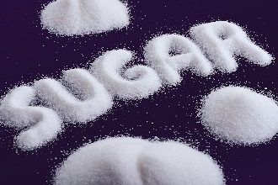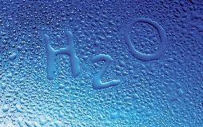Eg. Water (H20), salt (N aCl), sugar
    - 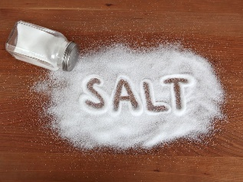

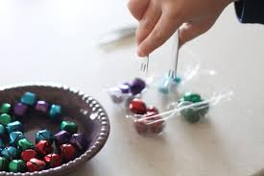**Mixtures**

* are made from **two or more** substances that are chemically **different**.
* Not pure substances
* can be **separated** into their **original components** by physical means
  + 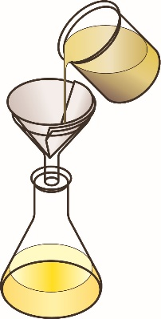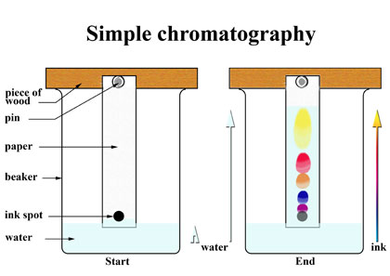using your fingers
  + 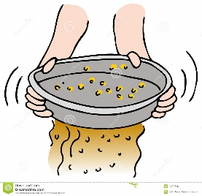evaporating the water
  + filtering
  + chromatography
  + magnet

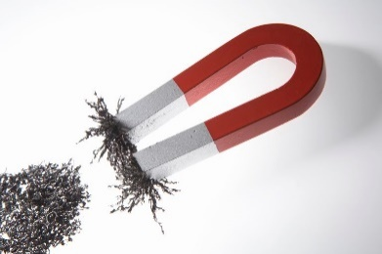

* 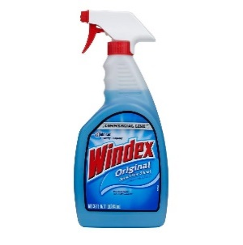**Homogeneous Mixture** is uniform throughout, aka a solution (something dissolved in something else) eg. Koolaide, salt water, windex.

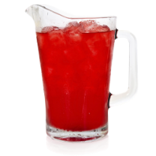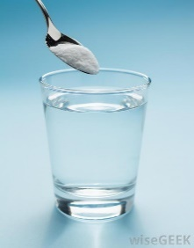

* **Heterogeneous Mixture** – not uniform throughout. (dirt,

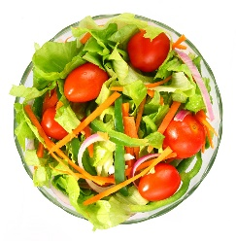 Example: Ocean water, dirt, water and oil, salad, granola, and concrete.

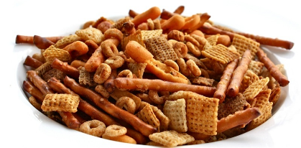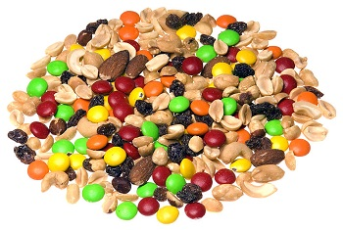

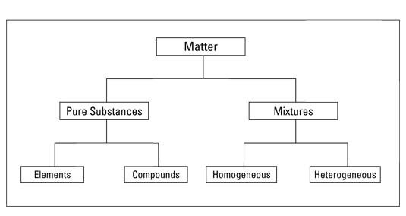

Classifying matter jeopardy

<https://www.superteachertools.us/jeopardyx/jeopardy-review-game.php?gamefile=502546#.Wb2aKbKGPak>

**Classifying matter:**

1. Can it be separated by physical means?
2. Does it contain only one type of atom?
3. Is it uniform throughout?

**USING KMT TO EXPLAIN DIFFUSION**

demo

**MEASURING MATTER**

**MASS** is the **amount of** **matter** a substance is made of.

* + measured in **grams** (g) or **kilograms** (kg).
* Mass is different than WEIGHT

**WEIGHT**: Force of **gravity** pulling on an object.

* Measured in **newtons (N)**
* The weight of object is **LOWER** on the moon since the moon’s gravity is 1/6 that of the Earth’s

MASS CAN BE MEASURED WITH A **TRIPLE BEAM BALANCE**:

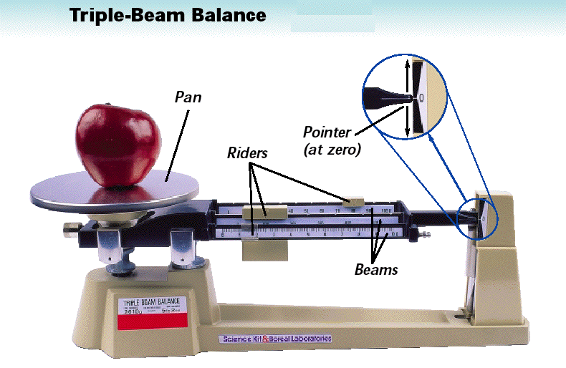

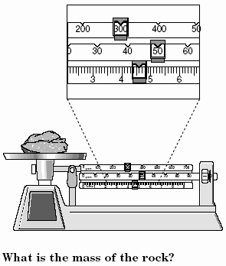

**Measuring Mass of Solids -** Solids can be placed directly on the pan

*What is the mass of the rock?*

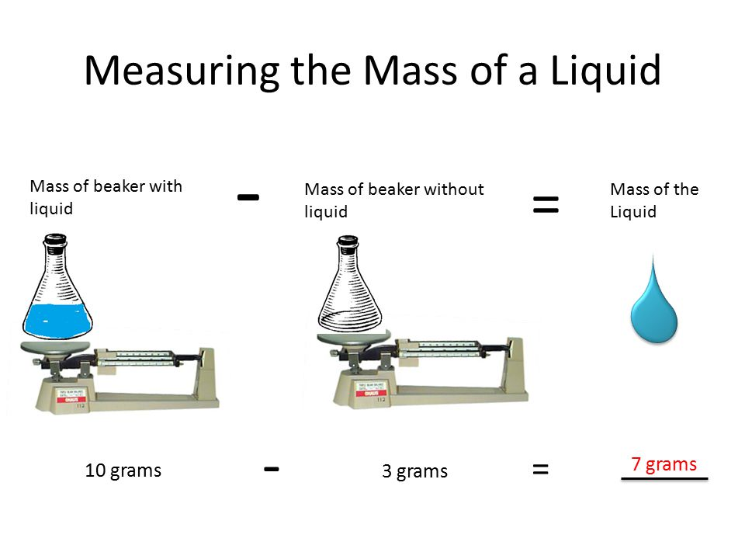**Measuring Mass of a Liquid**

**VOLUME:**

**Volume** is the **amount of space** an object takes up**.**

* + measured in millilitres (mL), litres (L), or cubic centimetres (cm3).
  + 1ml = 1 cm3 1 m3 = 1000L

**Volume** of a **regular-shaped solid**:

V= L x W x H V=  r2 h

* 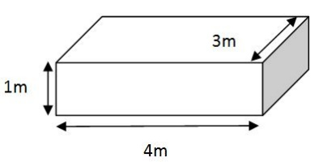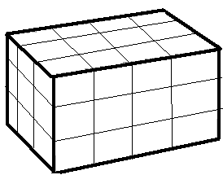1 cm 3 = 1 ml
* *What are the volumes of these objects?:*

V = L x W x H

V =

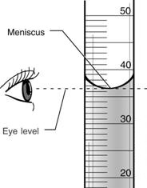

**Volume of a liquid**:

* use a graduated cylinder:

1. Must be on a flat surface
2. Read at eye level
3. Read from bottom of meniscus

*What is the volume in the diagram?*

**Volume of an irregular-shaped** solid can be measured with the **displacement method**:

1. 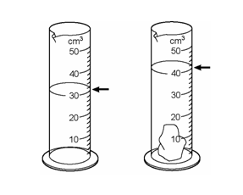Measure a specific **volume of water**
2. Measure volume of water **with object submerged in it**
3. **Subtract volumes** to find volume of object

* *What is the volume of the rock?*

**DENSITY**

* Density is another physical property of matter.
* Density describes how **tightly packed the particles are in a material.**
* It is the amount **of mass per unit of volume**.
* It is measured in g/ml or g/cm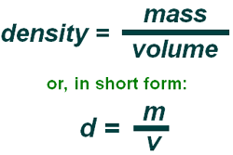3.

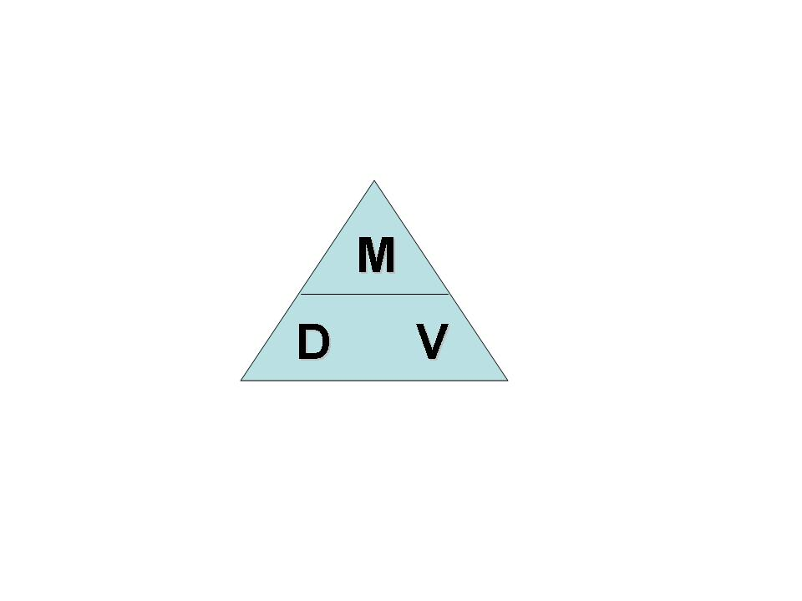

*In the diagram, describe the* ***spacing*** *of the particles in the solid block, the liquid and in the gas*

Solid: _________________________________

Liquid: _______________________________

Gas: ________________________________

Most substances are **more dense** in their **solid** form than in their **liquid** form

* Knowing this, how do you think temperature and density are related?

­­­­­­­­­­­­­­­­­­­­­­­­­­­­________________________________________________________

* Can you think of an exception?

­­­­­­­­­­­­­­­­­­­­­­­­­­­­_____________________________________________________

Density can be used to Predict whether an object will **float or sink** in a fluid.

**P.O.E. - Soda Style**

|  |  |
| --- | --- |
| 1. **A can of regular coke is dropped into water.**   Prediction : ________________________________  Observation: _______________________________  Explanation (Why did this happen)? _____________________________________________  _____________________________________________ | 1. **A can of diet coke is dropped into water.**   Prediction: ________________________________  Observation: ______________________________  Explanation (Why did this happen)?  __________________________________________  __________________________________________ |

**P.O.E. WACKY WATER**

|  |  |
| --- | --- |
| 1. **Oil is combined with water.**   Prediction : ________________________________  Observation: _______________________________  Explanation (Why did this happen)? _____________________________________________  _____________________________________________ | 1. **Salt water is combined with fresh water.**   Prediction: ________________________________  Observation: ______________________________  Explanation (Why did this happen)?  __________________________________________  __________________________________________ |

**Fluids that do not mix will form layers based on density.**

* Fluids with a **lower** density “float” on top of fluids with a **higher** density.
* If a fluid has a density less than water (1 g/cm3), it will **float**.

**P.O.E. PEEL ME A GRAPE**

|  |  |
| --- | --- |
| 1. **Grape (peeled and unpeeled) in Sugar Water**   Prediction : ________________________________  Observation: _______________________________  Explanation (Why did this happen)? _____________________________________________  _____________________________________________ | 1. **Grape (peeled and unpeeled) in Regular water**   Prediction: ________________________________  Observation: ______________________________  Explanation (Why did this happen)?  __________________________________________  __________________________________________ |

**BLM Worksheet**

**CALCULATING DENSITY**

Density = Mass/volume

**Sample Problems:**

1. The mass of a rock is 75g and its volume is 3cm3. Determine the density of the rock.

**Step 1**: list the known and unknown quantities

Mass =

Volume =

Density =

**Step 2:** Use algebra to solve for the missing variable

**Step 3:** Make a final written statement (including correct units).

1. A bottle of orange juice has a volume of 100ml and a mass of 250 grams. Calculate the density of the orange juice in g/ml.
2. A rock is dropped into a can of water and causes 25ml of water to be displaced. The mass of the rock is 150g. Calculate the density of the rock in g/cm3.
3. The dimensions of a rectangular block of wood are 5 cm for width, 10cm for length and 2 cm for height.
   * 1. Find the volume of the block.
     2. if the mass is 65g, what is the density of the block?

c) will the block float or sink in water? Give a reason for your answer.