**Measuring Matter - Notes**

**MASS** is the **amount of** **matter** a substance is made of.

* Is measured in **grams** (g) or **kilograms** (kg)
* Mass is different then WEIGHT

**WEIGHT**: Force of **gravity** pulling on an object.

* Measured in **newtons (N)**
* The weight of object is **LOWER** on the moon since the moon’s gravity is 1/6 that of the Earth’s

**Measuring Mass using a triple beam balance**

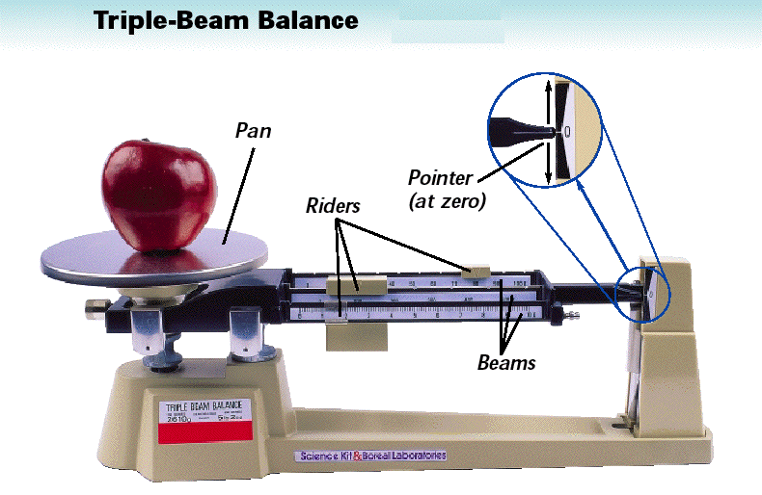

**Solids can be placed directly on the pan**

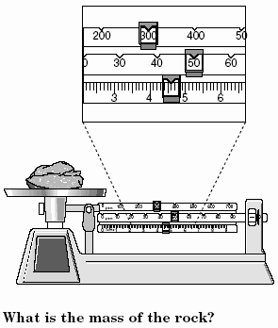

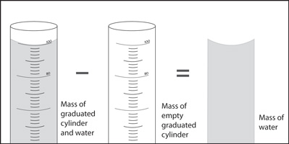

**Measuring Mass of a Liquid**

What is the mass of 100ml of water?

**VOLUME:**

Volume is the amount of space an object takes up.

* Measured in cm 3, ml, m 3, litres 1ml = 1 cm3 1 m3 = 1000L

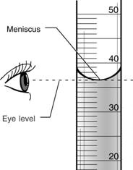**Measuring Volume:**

1. **Volume of a liquid**:

* use a graduated cylinder
* Read at eye level
* Read from bottom of meniscus
* What is the volume in the diagram?

1. 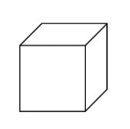**Volume of Rectangular Objects:**

* Volume = Length x width x height
* 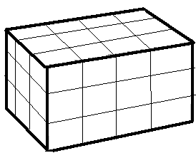1 cm 3 = 1 ml
* Practice: Find the volume of this object:

V = L x W x H

V =

1. **Volume of Irregular Shaped Object:**

* **Use Displacement Method:**
  1. **Measure a specific volume of water**
  2. **Measure volume of water with object submerged in it**
  3. 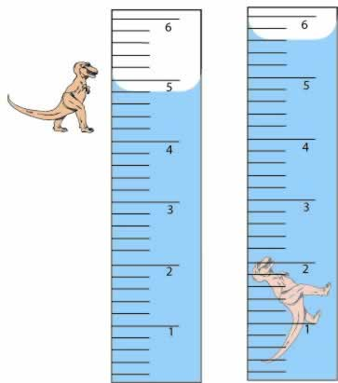**Subtract volumes to find volume of object**
* Practice: What is the volume of the dinosaur?
* 1 cm 3 = 1ml

**DENSITY**

**P.O.E. - Soda Style**

|  |  |
| --- | --- |
| 1. **A can of regular coke is dropped into water.**   Prediction : ________________________________  Observation: _______________________________  Explanation (Why did this happen)? _____________________________________________  _____________________________________________ | 1. **A can of diet coke is dropped into water.**   Prediction: ________________________________  Observation: ______________________________  Explanation (Why did this happen)?  __________________________________________  __________________________________________ |

**Density** describes how **tightly packed the particles are in a material.**

It is the **mass per unit of volume.**

In the diagram, describe the **spacing** of the particles in the solid block, the liquid and in the gas

Solid: _________________________________

Liquid: _______________________________

Gas: ________________________________

Most substances are more dense in their solid form than in their liquid form

* Knowing this, how do you think temperature and density are related?

­­­­­­­­­­­­­­­­­­­­­­­­­­­­________________________________________________________

* Can you think of an exception?

­­­­­­­­­­­­­­­­­­­­­­­­­­­­_____________________________________________________

Density can be used to Predict whether an object will float or sink in a fluid.

**P.O.E. WACKY WATER**

|  |  |
| --- | --- |
| 1. **Oil is combined with water.**   Prediction : ________________________________  Observation: _______________________________  Explanation (Why did this happen)? _____________________________________________  _____________________________________________ | 1. **Salt water is combined with fresh water.**   Prediction: ________________________________  Observation: ______________________________  Explanation (Why did this happen)?  __________________________________________  __________________________________________ |

**Fluids that do not mix will form layers based on density.**

* Fluids with a **lower** density “float” on top of fluids with a **higher** density.
* If a fluid has a density less than water (1 g/cm3), it will **float**.

**P.O.E. PEEL ME A GRAPE**

|  |  |
| --- | --- |
| 1. **Grape (peeled and unpeeled) in Sugar Water**   Prediction : ________________________________  Observation: _______________________________  Explanation (Why did this happen)? _____________________________________________  _____________________________________________ | 1. **Grape (peeled and unpeeled) in Regular water**   Prediction: ________________________________  Observation: ______________________________  Explanation (Why did this happen)?  __________________________________________  __________________________________________ |

**Calculating Density**

Density = Mass/volume

**Sample Problems:**

1. The mass of a rock is 75g and its volume is 3cm3. Determine the density of the rock.

**Step 1**: list the known and unknown quantities

Mass =

Volume =

Density =

**Step 2:** Use algebra to solve for the missing variable

**Step 3:** Make a final written statement (including correct units).

1. A bottle of orange juice has a volume of 100ml and a mass of 250 grams. Calculate the density of the orange juice in g/ml.
2. A rock is dropped into a can of water and causes 25ml of water to be displaced. The mass of the rock is 150g. Calculate the density of the rock in g/cm3.
3. The dimensions of a rectangular block of wood are 5 cm for width, 10cm for length and 2 cm for height.
   * 1. Find the volume of the block.
     2. if the mass is 65g, what is the density of the block?

c) will the block float or sink in water? Give a reason for your answer.