Biology 12 Respiration Learning Goals: (Chapter 15 p281-299)

By the end of this chapter you should be able to:
- Label and explain the function of the following structures: nasal cavity, pharynx, larynx, trachea, bronchi, bronchioles, alveoli, diaphragm and ribs, pleura membranes, thoracic cavity

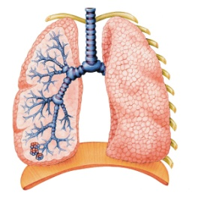
- Compare and contrast inhalation and exhalation

- Trace the pathway of oxygen into the respiratory system

Explain the roles of cilia and mucus in the respiratory tract

- describe how the structure of the alveoli allow their unique function

- Explain the movement of the diaphragm and the ribs during inspiration and expiration

- Explain the function of the pleural membrane in the lungs

- Know the difference between trachea and esophagus

- Know the difference between the primary, secondary bronchi and the bronchioles (shape, thickness, and cartilage amount)

- Locate and describe the part of the brain responsible for controlling respiration

- Explain the roles of CO₂ and H+ ions in stimulating the respiratory center of the medulla oblongata

- Explain the roles of O₂, CO₂ and H+ ions in stimulating the carotid and aortic bodies

- Explain what happens to oxygen once it is in the alveoli

- Describe the process of internal and external respiration (exchange of O₂ and CO₂)

- Explain the different mechanisms of breathing (tidal volume, vital capacity, inspiratory reserved, expiratory reserved, and residual)

- Compare and contrast among the different mechanisms of breathing

- Interpret a graph that depicts mechanisms of breathing

- Explain the roles of oxyhemoglobin, carbaminohemoglobin, reduced haemoglobin, bicarbonate ions, and carbonic anhydrase in the transport of carbon dioxide in the blood

- Write and explain the chemical equations for internal and external respiration

- Explain the term binding capacity, and how it relates to hemoglobin
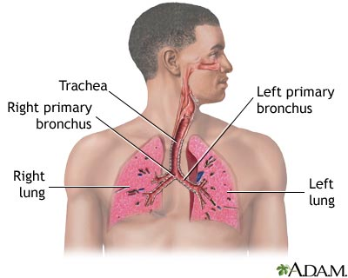
- Interpret a diagram that depicts gas exchange in the body

- Describe in detail one type of upper respiratory tract infection

- Describe in detail one type of lower respiratory tract infection

- Explain why smoking has negative consequences

