Sci 9 Name:
What would happen if Earth's spheres did not interact?
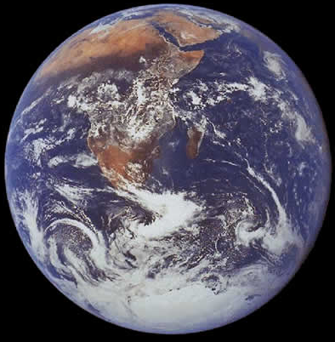
Search: Exploring Earth Investigations – ClassZone
Select the first link: Chapter 1: Earth as a System How are Earth’s Spheres Interacting?
Move through the pages and use the information to answer the questions below.
- Looking at the image of the Earth, what are the major parts of our planet that can interact as a system?

- Describe each of Earth's four spheres. List several examples of features in each sphere.
Sphere | Examples of features

- Do you think clouds should be classified as part of the atmosphere, or part of the hydrosphere? Explain why.

- For each image below,
- Look for evidence of materials and energy moving among the spheres.
- List the major features in the image and tell which sphere each one represents.
- Describe sphere interactions you can infer from the scene.
- Whenever possible, follow the results of an interaction through all four spheres.
a)
b)
c)
d)
a)
b)
c)
d)

a)
b)
c)
d)
a)
b)
c)
d)
a)
b)
c)
d)

a)
b)
c)
d)

- What effect do you have on the Earth system? As a part of the biosphere, think of some ways that you change the atmosphere, hydrosphere, or geosphere.

- Describe some human activities that are contributing to global-scale interactions among Earth's spheres.

