Bio 12 Urinary System Learning Goals (Text p301-314)

- Recognize and explain the functions of the following parts:
Kidney, nephron, renal cortex, renal medulla, renal pelvis, ureter, urinary bladder, urethra

- Label the following parts of a nephron on a diagram & can explain their functions:
Glomerulus, Bowman’s capsule, afferent and efferent arterioles, peritubular capillary network, proximal and distal convoluted tubules, collecting duct, loop of Henle
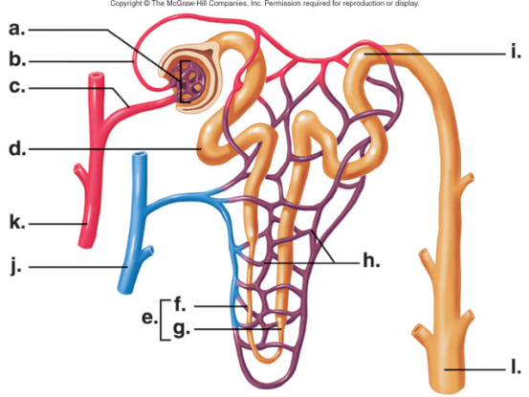
- Describe 3 ways in which the body strives to maintain blood pH

- Describe how urine is produced with reference to pressure filtration and selective reabsorption

- Understand the osmotic gradient in a nephron and can explain where water will travel

- List metabolic wastes that are excreted from our body through the urinary system (ex. Nitrogenous waste, urea, ammonia)

- Know where ADH is produced and what effect it has on urination (esp. water levels)

- Know where aldosterone is produced and what effect it has on sodium and blood volume levels

- Know the difference between diuretics and antidiuretics

- Explain why a diet high in salt can lead to hypertension and high blood pressure

- Describe what kidney stones are, how they form, and how to prevent & treat them
