Charging by Friction
Remember: Charging an object can only occur by the ________________________ of electrons from one object to another.
How does friction help with electron transfer?
What is friction? _______________________________________________________
______________________________________________________________________

How does this help with electron transfer? ____________________________________
______________________________________________________________________

Electrostatic Series
What is the electrostatic series? _________________________________________
___________________________________________________________________

What can we tell from looking at the electrostatic series? ____________________________________________________________________
____________________________________________________________________
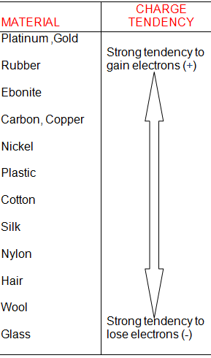
Use the chart to answer the following questions:
- What type of charge does rubber acquire when it’s rubbed with a nylon cloth? ______________________

- What type of charge does the nylon cloth acquire? _______________________________________

- How does the size of the charge on the rubber compare to the size of the charge on the cloth? ____________________________________________

Rules for Charged Objects:
Like charges will ___________________
Opposite charges will _______________________

REVIEW:
- Explain how an object becomes charged by friction. Use a diagram as part of your answer:

- Use a diagram to show what happens when a negatively charged object touches an uncharged (neutral) pith ball.

Insulators and Conductors:
Use page 282 in your text to complete the table:
Description | Insulators | Conductors
Definition

Electron transfer

Examples

Homework: Static Charge History – Main Players
Read through Section 9.1 (p.274-275 and 285-286). Also look for some information about these scientists online. How did each of the following contribute to information on static charge?

- Benjamin Franklin

- Charles de Coulomb

- Robert Van de Graaf

Rank them in order of most important to least important and explain/justify your answer. (There is no right answer!)

