Candy Dichotomous Key Assignment Name: _________________
- Create your own dichotomous key to classify the 10 different candies below.
- After the key is complete, name each candy with binomial nomenclature (look at your taxonomy rules – Genus species). Be creative and funny – often these names reflect characteristics of the species:)
Don’t forget – some candy might have the same genus! This will be worth 5 – half a mark for each name
Things to consider
- Each question OR statement should have two answers or pathways that send us to different questions to continue our identification process.
- One mark for each candy being correctly integrated into the key. Total of 10

Candy:

Skittles
M & M’s
Hershey’s Kisses
Sour Keys
Chocolate drops
Gummy Bears
Quality Street Chocolate
Hi Chews
Mini M &M’s
Fuzzy Peaches

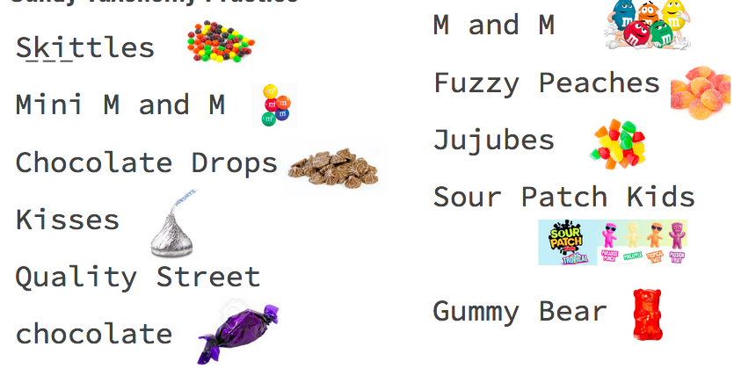
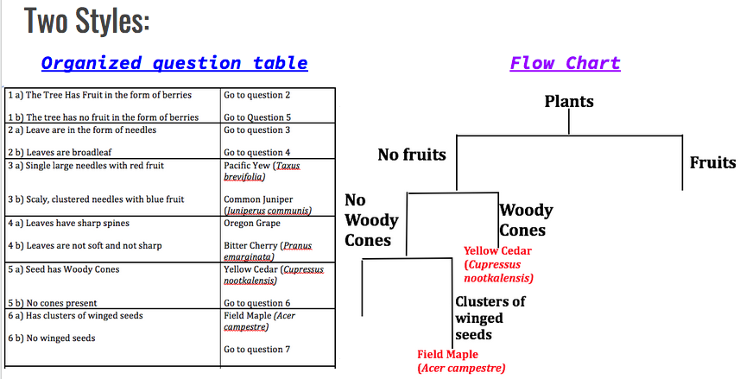

Marks:
- Each candy correctly integrated into a logical key – [10]
- Each candy named with a common name and scientific name using binomial nomenclature – [5]
- Neatness and organization – [2]
- Total = /17
