Cell Worksheet (Use your notes and text p87-98 to answer the following questions)
- Many people once believed in spontaneous generation; a theory that living organisms develop from nonliving matter. Explain how Cell Theory discounts the idea that flies spontaneous arise from rotting meat.

- What are nuclear pores? State their function.

- Describe the difference between cell wall and cell membrane.

- What is meant by a selectively permeable membrane?

- Which organelles have double membranes?

- Name all the structures containing microtubules.

- Name all the structures involved in transport.

- What is the difference between a vacuole, lysosome, vesicle, and plastid?

- What is the importance of a vacuole in a plant cell?

- What type of cell would have a lot of pigment? (p106)

- Cells that are motile may have a lot of ________________________ on the outside of their membrane.

- Compare and contrast plant cells and animal cells.

- Fill in the blank using the Word Bank: modified, vesicles, exocytosis, Ribosomes, Golgi Body, Rough Endoplasmic Reticulum.

Proteins are made by _________________. These proteins get passed on to the ______________________ that looks like a network of channels. Here the proteins are _________________ and then sent to the _____________________ by way of ________________. Proteins destined for export outside the cell exit by a process called _____________________.

- Label the cell diagram below. Be able to describe the function of each structure.

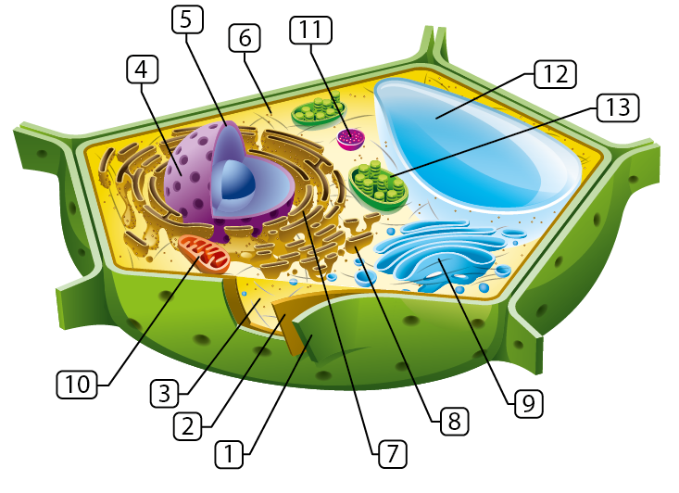

- Is this cell a prokaryotic or eukaryotic cell? What is the evidence?

- Is this a plant cell or animal cell? Name 3 pieces of evidence.

