Cell Worksheet (Use your notes and text p87-98 to answer the following questions)

- Label the cell diagram below. Be able to describe the function of each structure.

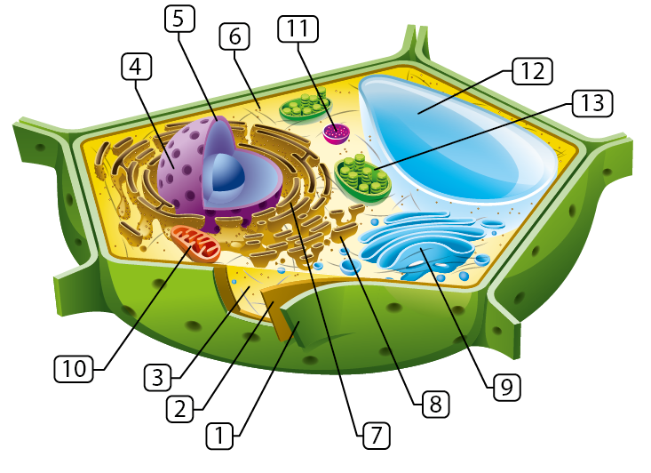

 | Name | Function
1
2
3
4
5
6
7
8
9
10
11
12
13

- Is the cell above a prokaryotic or eukaryotic cell? What is the evidence?

- Is the cell above a plant cell or animal cell? Name 3 pieces of evidence.

- Describe the difference between cell wall and cell membrane in terms of function.

- What is meant by a selectively permeable membrane? Why do we have it?

- What is the difference between a vacuole, lysosome, vesicle, and plastid?

- What is the importance of a vacuole in a plant cell?

- What type of cell would have a lot of pigment? (p106)

- Name all the organelles involved in transport.

- Name the organelles that are used for motility.

Extra:

- Fill in the blank using the Word Bank: modified, vesicles, exocytosis, Ribosomes, Golgi Body, Rough Endoplasmic Reticulum.

______________________ are the organelles that make proteins. The proteins get passed on to the _________________________ that looks like a network of channels. Here the proteins are _________________ and then sent to the _____________________ by way of small transport units called ________________. Proteins destined for export outside the cell exit the cell by a process called _____________________ .

- List the three points of Cell Theory.

- Many people once believed in spontaneous generation; a theory that living organisms develop from nonliving matter. Explain how Cell Theory discounts the idea that flies spontaneously arose from rotting meat.

- Which organelles have double membranes?

- Name all the structures containing microtubules.

- What are nuclear pores? State their function.

- Compare and contrast Prokaryotic Cells and Eukaryotic Cells.
- Compare and contrast plant cells and animal cells.

