Sci 9 Changing States of Matter Name: _____________

Changes of State
- Label the diagram below using ALL of the following terms: condensation, deposition, vaporization, melting, freezing, and sublimation.
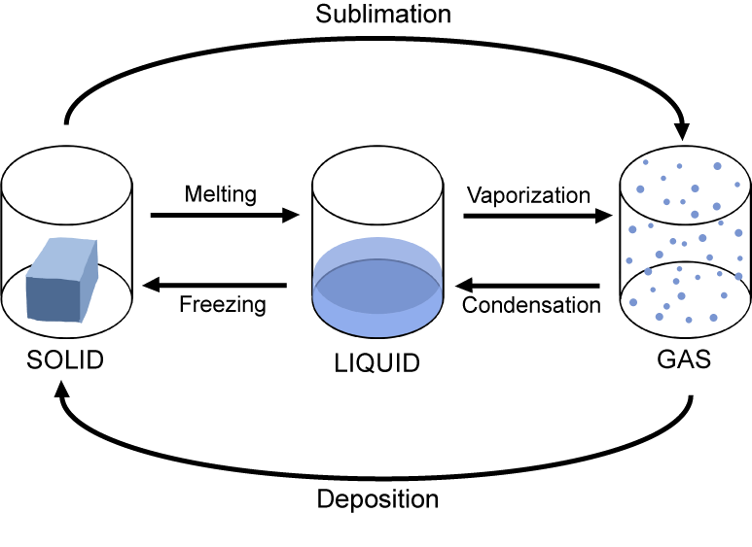

- When a LIQUID changes to a SOLID, what happens to
- The amount of energy? _______________________________________
- Spaces in between particles? _______________________________________
- The movement of particles? _______________________________________
- The attraction of the particles? _______________________________________
- The volume of the substance? _______________________________________
- When a LIQUID changes to a GAS, what happens to
- The amount of energy? _______________________________________
- Spaces in between particles? _______________________________________
- The movement of particles? _______________________________________
- The attraction of the particles? _______________________________________
- The volume of the substance? _______________________________________
- Complete the following table by indicating the initial and final states of matter and whether kinetic energy is added or removed. Give an example of each of the changes of state.
State Change | State of Matter  Initial State Final State |  | Kinetic Energy Added or Removed | Example
Melting
Freezing
Deposition
Sublimation
Vaporization
Condensation | Gas | Liquid |  | Water droplets form on a bathroom mirror after a hot shower

