Sci 9 Circuit Symbols and Diagrams Practice Name:
- Complete the chart with the appropriate symbols:
Switch (open) | Switch (closed) | Cell | Battery | Lamp

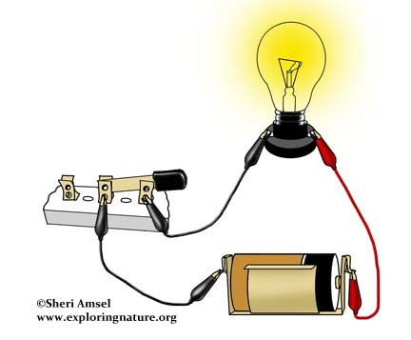
- Draw a schematic of this image using proper symbols:

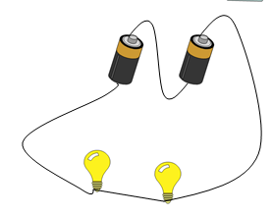
- Draw a circuit diagram of the image on the right. Are the bulbs in series or parallel?

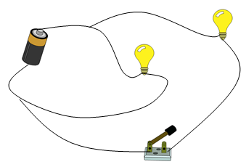
- Draw a circuit diagram of the image on the right. Are the bulbs in series or parallel? What happens when the switch is opened?

- Draw a circuit diagram that has 1 cell, 1 switch and 2 lamps. It connects in such a way that the current can only flow from the cell through all the equipment on a single pathway (in series).

- Draw a new circuit, using the same equipment as above, but this time after current goes through the switch, the current can flow to EITHER lamp. (Lamps are in parallel).

- Draw another circuit, using the same equipment as above, but this time the current can flow through either lamp, but the switch is placed such that it can only control one lamp and the other is not affected.

- Draw a circuit that has 3 lamps in parallel, 1 switch that turns off all the lamps and 2 cells which are connected in series.

- Draw a circuit that has 3 lamps in parallel, 3 switches that turn each lamp off separately and independently and 2 cells which are connected in parallel.

