Mosses Package
Fill in the blanks using the word bank below:

Light
Bryophytes
Minimize
Tracheophytes
Reproduce
Water
Transport
Leaves

List 5 requirement for life on land
- Constant supply of __________________
- Support for ____________________ to maximize exposure to ________________
- ____________________________ nutrients from cell to cell
- ____________________________ water loss
- ____________________________ without water
- What are the names of the two main phyla of land plants?
a) __________________________ - moss, liverworts and hornworts
b) __________________________ - ferns and flowering plants

Bryophytes

 | Moss | Liverworts | Hornworts
Dominant Generation | Gametophyte
Characteristics/ Features
Sketch

1. What are two adaptations that enable bryophytes to live on land?

2. Bryophytes are small plants that are easily overlooked; however, they are important because they were the first plants to live on land.
a) Using our own words, explain how reproduction in bryophytes is similar to that in algae. Describe places you would most likely find bryophytes growing. Why are these places good for bryophytes?

b) What is different about the moss life cycle from algae?

c) Describe a place in which you would probably not find bryophytes growing.
Explain why bryophytes would not grow in this place.

3. Label the structures using the word bank

Zygote
Sperm
Capsule
Archegonium
Antheridium
Sporangium
protonema
Gametophyte
Sporophyte
Spores
Developing sporophyte
Germinating spore

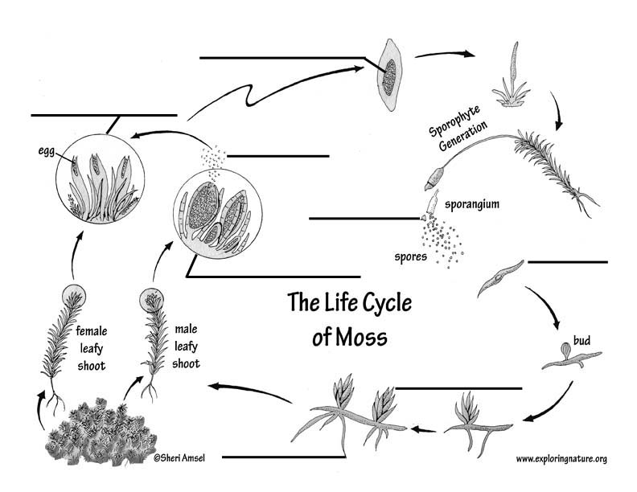
________________
________________

4. Put the statements below in correct order: D______________________

A - Zygote develops in archegonium
B - capsule releases spores
C - Sperm produced in antheridium
D - Mature gametophyte possesses reproductive structure at its tips
E - Sperm swims to archegonium and fertilizes egg 2N zygote
F - Mature sporophyte grow on gametophyte, n spores develop in capsule
G - Spores lands and develops into a protonema gametophyte
H - Zygote sporophyte ( in archegonium)

