SAFETY RULES
- Behave Responsibly:
- No _________________
- Arrive __________________
- No ________________________ experiments
- Be Safe:
- Wear protective equipment (Wear ____________ when working with ______________, _______________, ___________
- Know the ____________________of safety equipment (fire extinguisher, fire blanket, fire pull station, emergency shower, eye wash station, broken glass receptacle, etc)
- _________________ accidents
- Dress Appropriately: (secure long hair, clothing, jewellery. No open-toed shoes.
- Glassware Safety:
- Never use ___________________ glassware
- ____________ broken glassware and place in ___________________ container.
- Electrical Safety
- Do not use cords that are ________________. Pull on plug, not cord.
- Chemical Safety
- Treat all chemicals as if they are ______________
- ____________ chemical spills on skin with ___________
- Always check with teacher how to dispose of used chemicals: eg. designated container, not down sink.
- ____________ if you need to detect odor

- Fire Safety
- Never leave Bunsen burner _________________
- Point open glassware _______________ from you and others.
- Do not ____________ over flame
- Tie back long hair and loose clothing.
- Sharps Safety: Place sharps in designated container
- Food Safety: No ___________, drinking, applying make up during experiments!
- Clean up when finished:
- _________________ materials and equipment.
- _________________ of chemical waste properly (designated container).
- _________________ counter.
- _________________ hands
SAFETY SYMBOLS
HHPS Symbols - Used for products in the _______________ .
H______________________
H______________________
P______________________
S______________________
Type of Danger:

WHMIS SYMBOLS – For products at work

What’s the difference?
WHMIS symbols identify a wider range of hazards than HHPS symbols
- WHMIS symbols for hazardous products in the workplace.
- WHMIS symbols identify a _______________________ of hazards than HHPS symbols
- Only ______________ shape around the symbol.

WHMIS Labels have a lot of information on them. Most importantly they:
- Alert the user to the ___________________ of the product​
- State what ________________________ to take when handling the product.​
- Refer the user to a _________________ ______________data sheet (MSDS) for more detailed information about the product.
Hazardous waste cannot be disposed like normal trash in landfills but must go to designated facilities.
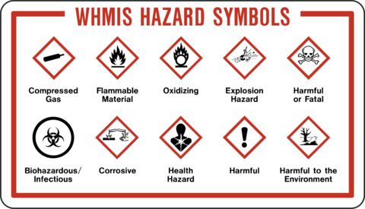

Safety Symbol Assignment Name:
- Now that you have learned about what the product safety symbols mean, list some of the most common safety precautions you will take when handling chemicals in the lab.

- What kinds of products do you think you will use in this science until that may fall under the title of hazardous products?

- What does WHMIS stand for?

- What does HHPS stand for?

- Draw the WHMIS symbol for:
- Flammable Material b) Corrosive Material c) Oxidizing Agent

- Look around your household. What material can you find that have either WHMIS or HHPS symbols. List the products and what their symbols mean:

Product | Drawing of Symbol | Symbol Meaning | Precautions

