7-4 Changes of State of Water Name: _______________________
Partner: _____________________

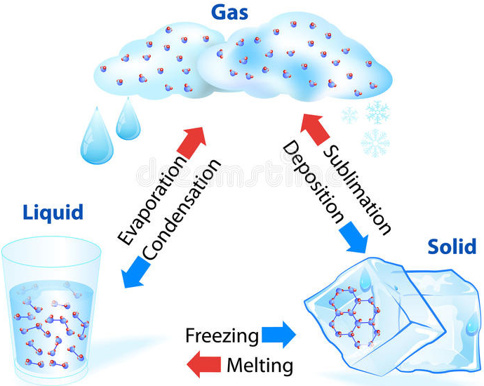
Question: What happens to the temperature of water as it changes state?

Hypothesis:

- If solid ice changes to liquid water, the temperature will _________________________________.
- If liquid water boils into gas, the temperature will __________________________________

Materials:
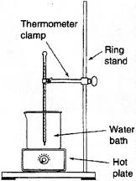
Large beaker (400ml or 600ml), ice, water, hot plate, beaker, thermometer, thermometer clamp, lab stand, beaker tongs.

Procedure:

- Put approximately 200 ml of water and 2-3 cubes of ice into the beaker. Add a thermometer.
- When the thermometer stabilizes, record the temperature in the chart below in the space for 0 min.
- Secure the thermometer into the clamp and secure the clamp to the stand. Place the beaker on the hot plate and lower the clamped thermometer into the water (make sure it does not touch the bottom of the beaker). See image on the right.
- Turn the hot plate to medium high (7 or 8).
- Record the temperature every minute in the chart below.
- Make notes when the ice disappears AND when the water begins to boil.
- KEEP RECORDING TEMPERATURE every minute for 5 MORE minutes AFTER the water begins to boil.
- Turn off and unplug the hot plate. Let everything cool before putting it all away.

Observations: Data Table

Time (min) | Temperature (°C) | Time (min) | Temperature (°C) | Time (min) | Temperature (°C)
0 |  | 11 |  | 21
1 |  | 12 |  | 22
2 |  | 13 |  | 23
3 |  | 14 |  | 24
4 |  | 15 |  | 25
5 |  | 16 |  | 26
6 |  | 17 |  | 27
7 |  | 18 |  | 28
8 |  | 19 |  | 29
9 |  | 20 |  | 30
10

Analysis: Graphing

Create a line graph of temperature versus time with the data you collected.
- The Dependent Variable goes on the y-axis. (Hint: does the temperature depend on the time or does time depend on temperature?)
- Include a title and label each axis with units (minutes, °C).
- Label the point on the line graph where the ice began melting.
- Label the point on the line graph where the water began boiling.

Analysis Questions

- Identify the variables in this experiment:
Independent Variable: _________________________________
Dependent (Responding) Variable: _________________________________

- Describe the shape of your graph: Perfectly straight? Or does it have some little bumps in it?

- If it has some little bumps, is anything special happening in your beaker when the bumps occur?

- Looking at your graph, describe the rate of change of the temperature while the ice was melting. (Did the temperature rise consistently or somewhat slower?)

- Looking at your graph, describe rate of change of the temperature for the 5 minutes during when the water was boiling. Did it keep rising or level off? Was this expected?

- Summarize what happens to the temperature of water during times when it changes state.

- Challenge: Given what you know about KMT, give a reason why temperature behaves slightly differently during phase changes even though the hot plate was not adjusted.

Title: ________________________________________________

Graph Checklist:
- I gave my graph a title
- I labelled each axis with units
- My scale is consistent
- My graph takes up at least half the page
- I labelled the parts where the ice was melting and when it started to boil.

