ES 11 Zeer Pot Activity Name:
Introduction:
In communities without electricity, a zeer pot is a simple refrigeration technique that can be used to preserve food for a longer time and keep the insects away. The zeer pot is a simple fridge made of local materials. It consists of one earthenware pot set inside another, with a layer of wet sand in between. As the moisture evaporates it cools the inner pot, keeping up to 12kg of fruit and vegetables fresher for longer.
Purpose: To demonstrate cooling effects of evaporation using a zeer pot.

Materials: two clay terracotta pots of different sizes, sand, water.
Procedure:

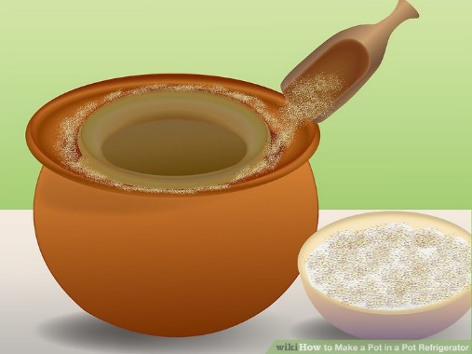
- Seal any holes in the pots with duct tape.
- Fill base of larger pot with coarse sand. About 2.5cm deep. Ensure top of smaller pots sits even with top of larger pot.
- Place smaller pot inside larger, making sure any hole in smaller one is sealed.
- Fill space in between two pots with sand, leaving a small gap at the top.
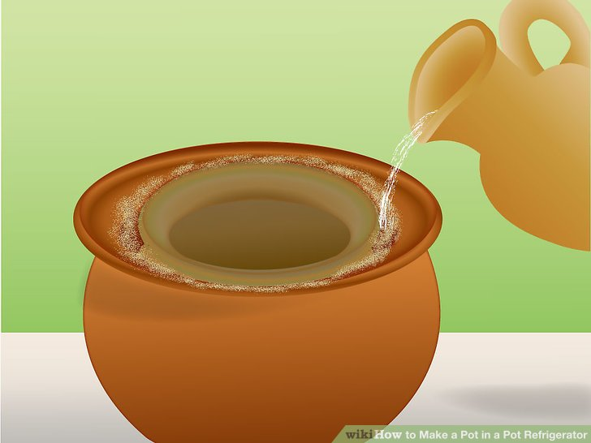
- Gradually pour cold water over the sand, allowing time for terracotta to absorb water. Keeping the sand moist all the time enables evaporation to cool the produce kept inside the inner pot.
- Cover top of inner pot with a damp cloth.
- After 20 min, measure temperature inside.

Questions:
Before | After
- Record the temperature inside the inner pot before and after the experiment.

- Define condensation and evaporation (p499).

- What causes water to evaporate more rapidly when the temperature is warmer?

- Using scientific terminology, explain why the zeer pot is more effective in dry climates. (If you are not sure, watch the animation again)

- How are temperature and water vapor capacity related? (p500)

- Define specific humidity. (p500)

- When is air saturated?

- What is relative humidity? Explain how it is calculated.

- What factors would have an affect on the efficiency of the zeer pot?

