Evidence of Evolution
Background
When Charles Darwin first proposed the idea that all new species descend from an ancestor, he performed an exhaustive amount of research to provide as much evidence as possible. Today, the major pieces of evidence for this theory can be broken down into the fossil record, embryology, comparative anatomy, and molecular biology.

Fossils
This is a series of skulls and front leg fossils of organisms believed to be ancestors of the modern-day horse.

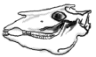 | 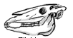 | 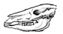
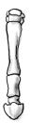

Equus  (modern horse) | Pilohippus | Merychippus | Mesohippus | Eohippus  (Dawn Horse)
Source: http://www.iq.poquoson.org
1. Give two similarities between each of the skulls that might lead to the conclusion that these are all related species.

2. What is the biggest change in leg and skull anatomy that occurred from the dawn horse to the modern horse?

Embryology
Organisms that are closely related may also have physical similarities before they are even born! Take a look at the six different embryos below:
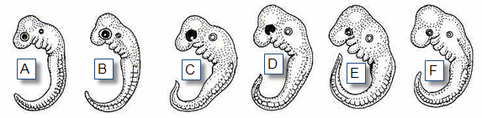
Source: http://www.starlarvae.org

These are older, more developed embryos from the same organisms.
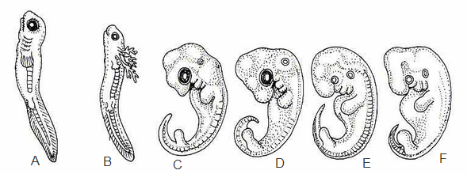

These are embryos at their most advanced stage, shortly before birth.
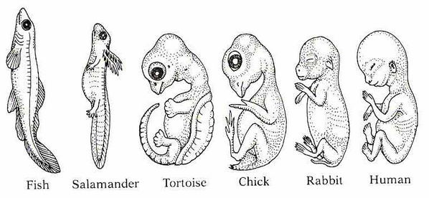

1. Describe the patterns you see. What physical similarities exist between each of the embryos?

2. Does this suggest an evolutionary relationship? Explain how these embryos can be used as evidence of a common ancestor between each of these six organisms.

Comparative Anatomy
Shown below are images of the skeletal structure of the front limbs of 6 animals: human, crocodile, whale, cat, bird, and bat. Each animal has a similar set of bones. Color code each of the bones according to this key:

Humerus [ ]  Ulna [ ]  Radius [ ] | Carpals [ ]  Metacarpals [ ]  Phalanges [ ]
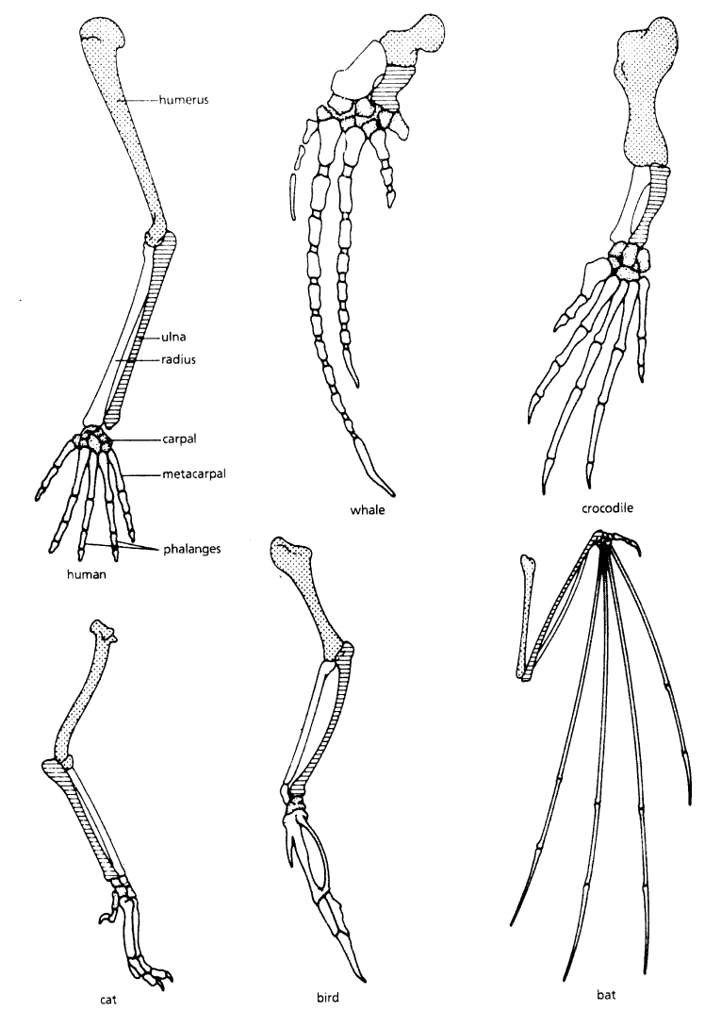
For each animal, indicate what type of movement each limb is responsible for.

Animal | Primary Functions
Human | Using tools, picking up and holding objects
Whale
Cat
Bat
Bird
Crocodile

ANALOGOUS STRUCTURES
Compare the anatomy of the butterfly and bird wing below.

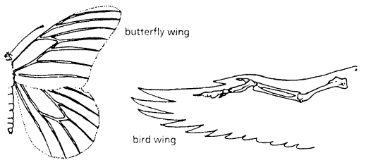

- What is the definition of Analogous Structures?

- What is the function of each of these structures?

- How are they different in form? Give specific differences.

VESTIGIAL STRUCTURES

Compare the overall body structure of the cave fish and the minnow below.

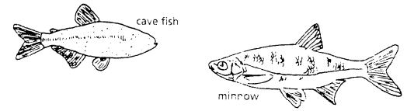

- What is the biggest, most obvious difference between the body structure of these two fish?

- Assume the two fish came from the same original ancestor. Why might the cave fish have evolved without eyesight?

Structure | Possible function?
Wisdom teeth
Muscles for moving the ear
Body hair
Tailbone
- What kind of sensory adaptation would you hypothesize the cave fish has to allow it to navigate in a cave, including catching and eating food?

- Below are some vestigial structures found in humans. For each, hypothesize what its function may have been.

Molecular Biology
Cytochrome c is a protein found in mitochondria. It is used in the study of evolutionary relationships because most animals have this protein. Cytochrome c is made of 104 amino acids joined together.
Below is a list of the amino acids in part of a cytochrome protein molecule for 9 different animals. Any sequences exactly the same for all animals have been skipped.

For each non-human animal, take a highlighter and mark any amino acids that are different than the human sequence. When you finish, record how many differences you found in the table on the next page.

 | 42 | 43 | 44 | 46 | 47 | 49 | 50 | 53 | 54 | 55 | 56 | 57
Human | Q | A | P | Y | S | T | A | K | N | K | G | I
Chicken | Q | A | E | F | S | T | D | K | N | K | G | I
Horse | Q | A | P | F | S | T | D | K | N | K | G | I
Tuna | Q | A | E | F | S | T | D | K | S | K | G | I
Frog | Q | A | A | F | S | T | D | K | N | K | G | I
Shark | Q | A | Q | F | S | T | D | K | S | K | G | I
Turtle | Q | A | E | F | S | T | E | K | N | K | G | I
Monkey | Q | A | P | Y | S | T | A | K | N | K | G | I
Rabbit | Q | A | V | F | S | T | D | K | N | K | G | I

 | 58 | 60 | 61 | 62 | 63 | 64 | 65 | 66 | 100 | 101 | 102 | 103 | 104
Human | I | G | E | D | T | L | M | E | K | A | T | N | E
Chicken | T | G | E | D | T | L | M | E | D | A | T | S | K
Horse | T | K | E | E | T | L | M | E | K | A | T | N | E
Tuna | V | N | N | E | T | L | R | E | K | A | T | S | -
Frog | T | G | E | E | T | L | M | E | S | A | C | S | K
Shark | T | Q | Q | E | T | L | R | I | K | T | A | A | S
Turtle | T | G | E | E | T | L | M | E | D | A | T | S | K
Monkey | T | G | E | D | T | L | M | E | K | A | T | N | E
Rabbit | T | G | E | D | T | L | M | E | K | A | T | N | E

Animal | Number of Amino Acid Differences Compared to Human Cytochrome C | Animal | Number of Amino Acid Differences Compared to Human Cytochrome C
Horse |  | Shark
Chicken |  | Turtle
Tuna |  | Monkey
Frog |  | Rabbit

Molecular Biology – Summary Questions
1. Which organism is most closely related to humans? What is the evidence?

Summary

- What are 5 things we can learn from fossils?

- How does embryology support the idea of common ancestry?

- Explain why the homologous structures in are evidence of evolutionary relationships.

- Explain the evolutionary relationship between the fin of a fish and the flipper of a whale.

- How are vestigial structures an example of evidence of evolution?

- With all the evidence why do you think Evolution is still considered a theory?

